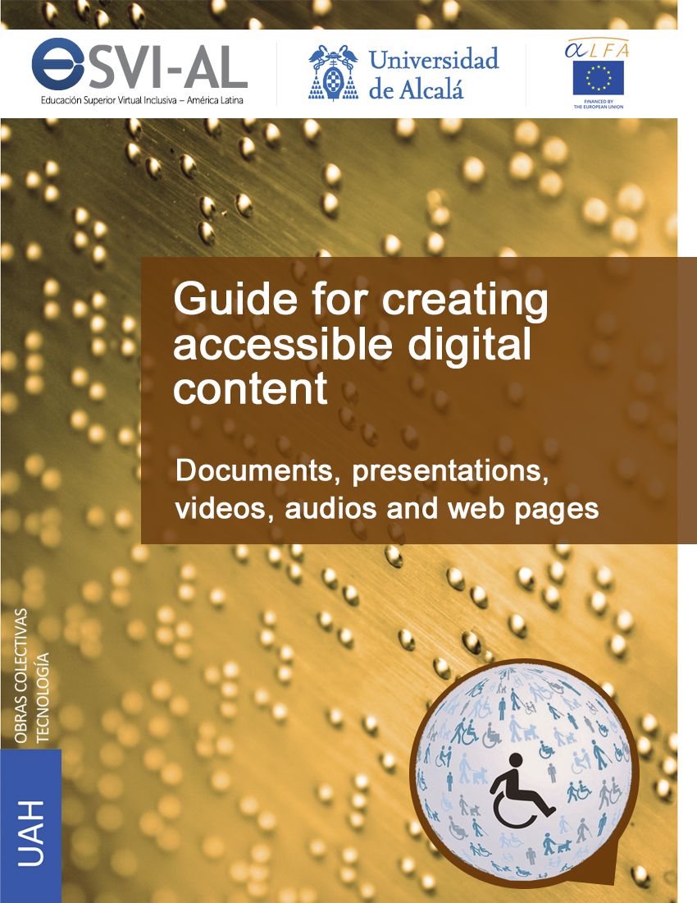

Guide for creating accessible digital content

Documents, presentations, videos, audios and web pages
José Ramón Hilera González
Elena Campo Montalvo
Eva García López
Antonio García Cabot
(Editors)

Guide for creating accessible digital content: Documents, presentations, videos, audios, and web pages by José Ramón Hilera González, Elena Campo Montalvo, Eva García López & Antonio García Cabot (Eds.) is licensed under a Creative Commons Attribution - Non Commercial - Share Alike 4.0 International License.

Copyright of all trademarks, trade names, logos and images are the property of their respective owners.

Publications Office of the University of Alcalá, 2015
ISBN: 978-84-15834-82-3
Digital version available at: www.esvial.org.
The suggested citation is:
J.R. Hilera González, E. Campo Montalvo, E. García-López, A. García Cabot (Eds.) (2015). Guide for creating accessible digital content: Documents, presentations, videos, audios, and web pages (1st ed.). Alcalá de Henares, Spain: University of Alcalá.

This publication is the result of “Educación Superior Virtual Inclusiva – América Latina (ESVI-AL) Project”, funded within European Union ALFA III Program (DCI-ALA/19.09.01/11/21526/279-146/ALFA III(2011)11).
The content of this publication does not reflect the official opinion of the European Union. Responsibility for the information and views expressed lies entirely with the authors.

In this publication have collaborated European and Latin American authors from partners universities in ESVI-AL Project.

Editors:
Hilera González, José Ramón
Campo Montalvo, Elena
García López, Eva
García Cabot, Antonio

Authors (alphabetical order):
Águila Chávez, Óscar de Jesús
Bengochea Martínez, Luis
Cabrera Loayza, María del Carmen
Chicaiza Espinosa, Janneth
Diez Folledo, Teresa
Domínguez Alda, María José
Fernández Sanz, Luis
Pagés Arévalo, Carmen
Preciado Mesa, Yolanda Patricia
Quintanilla Flores, Rocío Alicia
Valencia Chaverra, María Patricia

Partners in ESVI-AL Project:
European:
Universidad de Alcalá (UAH), Spain (Administrative Coordination).
Helsinki Metropolia University of Applied Sciences (UMET), Finland.
Universidade de Lisboa (ULI), Portugal.
Latin American:
Universidad Galileo (UGAL), Guatemala (Technical Coordination).
Fundación Universitaria Católica del Norte (UCN), Colombia.
Universidad Continental (UC), Perú.
Universidad de la República (URU), Uruguay.
Universidad Nacional de Asunción (UNA), Paraguay.
Universidad Politécnica de El Salvador (UPES), El Salvador.
Universidad Técnica Particular de Loja (UTPL), Ecuador.

International cooperating organizations:
Disabled People's International (DPI).
International Social Security Association (ISSA).
Virtual Educa (VE).
Unión Latinoamericana de Ciegos (ULAC).

Foreword
When digital content is created in any type of format (textual, graphic, audio or multimedia), it is necessary to keep in mind that users of such content may be people with physical, sensory or cognitive limitations, who could find barriers to access the information.
In fact, at some point in our lives, we all probably will have limitations that can affect our access to digital content. This is evident if we have a permanent disability. Nevertheless, even if we do not have it, it does not mean we are out of this issue. On the contrary, it is very likely that several times our physical, sensory or cognitive abilities will be temporarily reduced by any event or accident, or simply by the conditions of our environment. For example, we might ever need to hear a story in a noisy environment that prevents us from clearly hearing what the speaker is telling.
And, of course, we lose our capacities as we are aging. It is more difficult for us to access information, and we need assistive products. The clearest example is the need for corrective lenses to read small text.
In general, the use of assistive products for accessing digital content is something we all use regularly. These are often called "assistive technologies" and can be software or hardware. We do not realize that we are often using these aids. For example, when we zoom to better view the content on a screen, we are using assistive software, in this case a program to increase the size of content, which is integrated into the operating system itself.
This book will often refer to assistive technologies, which can be simple and commonly used as the zoom of the screen. However, they can be much more advanced, such as screen readers, commonly used by people with visual disabilities to hear the description of visual content that they cannot see on the screen.
Therefore it is very important that the authors of digital content take into account minimum standards to ensure that content can be used by the widest audience. It must be accessible content.
In this context, accessibility is a characteristic that makes digital content perceivable, understandable and usable by anyone, regardless of whether he or she has a disability. It is very difficult to get fully accessible content, but following some simple tips, it is easy to reach an acceptable level of accessibility, which allows interested persons to access the information without trouble.
The guidelines set out in this book are not new. In general, they are common sense recommendations, and many are suggestions proposed by the creators of content editing tools, which for some years have provided mechanisms to generate accessible content, but are often unknown by authors. Most of the guidelines are independent of the technology used in the creation of content. For example, the recommendation of “content in video format must include subtitles” is generic and applicable to any video editing technology.
This book is intended to be a practical guide. Therefore, in addition to providing guidance, examples of how to perform them using some of the most used editors of digital content are presented. Among others, Microsoft Office suite to create documents (with Word) and slide presentations (with PowerPoint) are used, because they offer advanced mechanisms that help the author to create and revise the accessibility of content.
This guide is useful for creating accessible digital content, even if the reader does not use the editing tools showed in the practical cases, because requirements can be found for such content, and it is easy to locate the features in another editor. For example, to meet the requirement that every image in a document or presentation should have a text that describes it, this guide explains how to do it in a few editors, but any current editor allows the author to enter that description, and the user only has to find such functionality in the editor used.
The book consists of five chapters, which try to cover the widest variety of digital content formats. Each chapter has been created by different authors, who come from a total of four different countries: Colombia, Ecuador, El Salvador and Spain.
The first chapter is about how to create accessible documents with a text processor. This chapter provides general guidelines that can be applied using any text processor. These guidelines start with the requirement of establishing the language of the document, which is important because the screen reader used by a blind person generates the audio in the same language of the document. After that, many other recommendations are described for getting accessible documents. Finally, the way to use the tools for checking the accessibility of a document is described.
The second chapter shows general guidelines for creating accessible presentations, as well as practical cases using PowerPoint. Many of the recommendations introduced in the first chapter are showed again in this chapter, although they are adapted to a presentations editor. Moreover, one section describes how to check the accessibility using tools such as PowerPoint.
The third chapter is dedicated to the accessibility of files and documents in PDF format. In this case, if the PDF document is obtained using an accessible source document we could confirm that the resulting PDF is accessible. However, in some situations there are non-accessible PDF documents published in the web, and therefore the source version is not available. Because of this, this chapter shows how to use the tools for automatically checking the accessibility of a PDF document, as well as the way to solve some accessibility issues directly in a PDF document.
The fourth chapter is based on accessible audiovisual content. It is divided into two main sections: the first part is based on accessibility in videos, which explains how to easily create videos with subtitles and an audio description; and the second part is about audiobooks, which shows how to convert a text document into voice and into an audiobook format, compatible with the main players.
The fifth chapter is about accessibility in webpages. Much of the digital content currently used is showed in a webpage format, so it is important to provide accessible web content. In this field, World Wide Web Consortium (W3C) is the organization responsible of providing the standards supported in websites, such as HTML or CSS languages. The aim of this organization is also to promote accessibility in webpages, by providing recommendations. This chapter is oriented to describe the guidelines about accessible web content, known as Web Content Accessibility Guidelines (WCAG). These guidelines have to be taking into account when creating webpages or web content. This chapter also shows how to check the accessibility of a webpage using automatic tools.
Finally, a bibliography section has been included, where the reader can find references to other documents and guides for obtaining more information about these aspects of accessibility.
The aim of this guide is being a starting point for authors of digital contents. These authors have to be aware of the accessibility issues that can be in digital resources: documents, presentations, videos, books or webpages. This guide also provides practical examples for easily showing the guidelines and recommendations for improving the accessibility of these resources.
This book has been created as part of ESVI-AL project, in cooperation between Latin American and European universities, funded by the European Union through ALFA III program. Participants of another ALFA III project called USo+I have contributed with their experience to this project and this book. Both ALFA III projects have been coordinated by the University of Alcala: USo+I project was coordinated by Professor Elena Campo Montalvo, and ESVI-AL project was coordinated by Professor José Ramón Hilera González. The aim of these projects and the ALFA III program is contribute to improve higher education.
The tools proposed in this guide can help to obtain accessible digital content, progressing towards a more inclusive and therefore better and fairer education, without barriers for disabled students.
The guide in electronic format, as well as other resources can be found on the web www.esvial.org.

Alcalá de Henares, Spain, January 2015
José Ramón Hilera González
Elena Campo Montalvo
Eva García López
Antonio García Cabot

Table of contents
Chapter 1. Creating accessible text documents using Word 1
1.1 Guidelines for creating accessible contents in Microsoft Word 2
1.1.1 Simple text 2
1.1.2 Document language 2
1.1.3 Font characteristics 5
1.1.4 Titles 6
1.1.5 Paragraphs and section breaks 7
1.1.6 Lists, numbering and bullets 13
1.1.7 Columns and tables 14
1.1.8 Figure captions 18
1.1.9 Table captions 19
1.1.10 Tables of contents 19
1.1.11 Page numbers 23
1.1.12 Alternative texts 23
1.1.13 Accessible graphs 25
1.1.14 Using flashing elements 25
1.1.15 Multimedia elements 26
1.1.16 Using color 26
1.1.17 Navigation links 28
1.1.18 Converting to a PDF document 30
1.2 Accessibility evaluation tools 31
1.2.1 Checking accessibility in Office 2010 31
1.2.2 AccessODF 33
1.2.3 Usability testing 34
1.2.4 Document conversion to other formats for validation 34
Chapter 2. Creating accessible presentations with PowerPoint 37
2.1 Creating accessible PowerPoint presentations 38
2.1.1 Tips for creating an effective presentation 38
2.1.2 Good practices for designing and creating accessible presentations 40
2.1.3 Tips for presenting in an accessible way 55
2.2 Checking the accessibility of a PowerPoint presentation 56
2.2.1 Executing the accessibility checker 56
2.2.2 Additional information about the problems found 57
2.2.3 Checklist 60
2.3 Keyboard shortcuts 62
2.3.1 Navigating the ribbon 62
2.3.2 Common tasks while running a presentation 63
2.3.3 Media during presentation 65
2.3.4 Working with shapes, text boxes, and WordArt 66
2.3.5 Working with SmartArt graphics 67
2.3.6 Working with the caption editor of add-in STAMP 69
Chapter 3. Creating accessible PDF documents 71
3.1 Accessibility in PDF documents. Basics 72
3.1.1 What is an accessible PDF and how do people with disabilities access to the content of a PDF? 72
3.1.2 Characteristics of an accessible PDF 73
3.1.3 Accessibility standard WCAG 2.0. Principles applicable to PDF documents 76
3.1.4 Tools for analysis and correction 82
3.2 Creating accessible PDF documents 85
3.2.1 Requirements previous to design, layout and content of the source document 85
3.2.2 Creating PDF files from existing documents 85
3.3 Creating PDF files from existing accessible presentations 92
3.4 Evaluating accessibility of a PDF document 93
3.4.1 Initial checking 94
3.4.2 Complementary checking 97
3.5 Initial technical checking for detecting issues that require modifying the original document 98
3.6 Correcting accessibility issues in a PDF file 101
3.6.1 Document 102
3.6.2 Content page 108
3.6.3 Alternative text 112
3.6.4 Tables 113
3.6.5 Lists 117
3.6.6 Headers 118
3.7 Reading a PDF document using a screen reader 118
Chapter 4. Creating accessible audiovisual content 121
4.1 What should an accessible video have? 123
4.1.1 Transcript 124
4.1.2 Captions 125
4.1.3 Audio description 126
4.1.4 Interpretation in sign language 128
4.1.5 Tools for creating accessible audiovisual content 132
4.2 Creating accessible video tutorials 134
4.2.1 Video tutorials as educational content 134
4.2.2 Best practices for creating effective video tutorials 138
4.2.3 Basics of video editing 142
4.2.4 Creating video tutorials by capturing screen actions 144
4.2.5 Using YouTube as a platform to publish, edit and subtitle videos 150
4.3 Educational content with accessible audio 158
4.3.1 Using audio elements in learning 158
4.3.2 Audiobooks as accessible educational content 159
4.3.3 Creating audiobooks from Word documents 163
4.3.4 Creating audiobooks using the tool Balabolka 169
4.3.5 Inserting audio in PDF documents 173
4.4 Checking accessibility in audio and video files 176
4.4.1 Accessibility checklist for audio documents 177
4.4.2 Accessibility checklist for videos 178
Chapter 5. Creating accessible web pages 181
5.1 Guidelines to create accessible web contents 182
5.2 Developing an accessible website 184
5.2.1 Language of the website 184
5.2.2 Descriptive title of the webpage content 185
5.2.3 Information structure 186
5.2.4 Presentation of the webpage 190
5.2.5 Access via keyboard 195
5.2.6 Embedded objects and scripts 197
5.3 Accessibility of the webpage elements 199
5.3.1 Images 199
5.3.2 Multimedia (audio, video, presentations) 202
5.3.3 Forms 203
5.3.4 Navigation mechanisms 208
5.3.5 Tables 213
5.3.6 Frames 216
5.3.7 Lists 217
5.4 Overall accessibility evaluation of the webpage 218
5.4.1 Device independence 218
5.4.2 Functionality of the webpage using a screen reader 219
5.4.3 Detailed automatic accessibility validation of a webpage according to WCAG 2.0. 219
5.4.4 Obtaining an overall rating of the accessibility of the webpage 220
Bibliography 221
Optional bibliography 223
Glossary 227

Index of figures
Figure 1-1. Language selection menu. 3
Figure 1-2. Window for setting the language. 4
Figure 1-3. Selecting the language from the status bar, a quick but not accessible way. 4
Figure 1-4. Screen magnifier that allows low vision users to read a document. 5
Figure 1-5. Example of contents scheme. 6
Figure 1-6. Applying styles to normal text and headings 1, 2 and 3. 7
Figure 1-7. Example of a not accessible text. 9
Figure 1-8. Example of an accessible text. 9
Figure 1-9. Comparison between paragraphs separated by indentation (left) and paragraphs separated by blank lines (right). 11
Figure 1-10. How to set line and paragraph spacing. 11
Figure 1-11. How to set section breaks and page breaks. 12
Figure 1-12. Correct way to create lists. 13
Figure 1-13. How to create text columns. 14
Figure 1-14. Text columns should be separated by ample blank spaces. 15
Figure 1-15. Direction in which an assistive device reads the content of a table. 15
Figure 1-16. Repeat the header row in each page. 18
Figure 1-16. How to set figure captions. 19
Figure 1-17. How to set table captions. 20
Figure 1-18. How to create a table of contents. 20
Figure 1-19. How to update the fields of tables of contents. 21
Figure 1-20. Creating a table of figures using a keyboard. 22
Figure 1-21. Creating a table of figures using a mouse. 22
Figure 1-22. How to set page numbers. 23
Figure 1-23. How to set the format to a picture. 24
Figure 1-24. How to set an alternative text to the figure. 25
Figure 1-25. Foreground and background color combinations. 28
Figure 1-26. How to insert navigation links. 29
Figure 1-27. How to convert a document to PDF. 30
Figure 1-28. Accessibility options for conversion to PDF. 31
Figure 1-29. Location of tool “Check Accessibility”. 32
Figure 2-1. How to set alternative text for an object. 41
Figure 2-2. Outline view, showing some slides and their elements. 43
Figure 2-3. Examples of incorrect tables’ structures. 45
Figure 2-4. STAMP add-in installed. 47
Figure 2-5. How to create captions for a video in a PowerPoint presentation. 48
Figure 2-6. How to edit captions for a video in a PowerPoint presentation. 49
Figure 2-7. Selection pane showing the reading order. 51
Figure 2-8. Showing the three values of a RBG color. 53
Figure 2-9. Options for saving a document as a PDF. 55
Figure 2-10. How to run the Accessibility Checker. 57
Figure 2-11. Results of an examination by the Accessibility Checker. 58
Figure 3-1. Elements that define a PDF document properly structured. 74
Figure 3-2. Structure of a PDF with bookmarks. 74
Figure 3-3. Form example. 76
Figure 3-4. Options to export as PDF in Open Office. 87
Figure 3-5. Accessibility options in Word for saving as PDF. 88
Figure 3-6. Options of converting Word documents in Adobe Acrobat Professional. 90
Figure 3-7. PDFMaker in Microsoft Word 2003. 90
Figure 3-8. Accessibility evaluation process of a PDF document. 93
Figure 3-9. Advanced check settings window of Adobe Acrobat. 95
Figure 3-10. Accessibility checker pane. 96
Figure 3-11. Results of a checking performed by PAC. 98
Figure 3-12. Assignation of a target to a bookmark. 108
Figure 3-13. Content pane. Create artifact. 109
Figure 3-14. Retouch reading order. Tag content. 111
Figure 3-15. Dialog box "Set alternative text" for a figure. 113
Figure 3-16. Example of a table with its elements. 114
Figure 3-17. Options of “Read out loud” feature. 119
Figure 4-1. MIT YouTube channel. 135
Figure 4-2. Video lecture “Introduction to MATLAB Programming”, developed by MIT OpenCourseWare, which meets some of the accessibility characteristics. 136
Figure 4-3. Open source initiative – UNED Abierta. 137
Figure 4-4. Video tutorial of the initiative UNED Courses COMA. 137
Figure 4-5. Creating video by capturing screen actions with QuickTime. 145
Figure 4-6. Starting recording the actions on the screen with QuickTime. 146
Figure 4-7. Warning message while recording the actions on the screen with QuickTime. 146
Figure 4-8. Recording the actions on the screen with QuickTime: button to stop recording 147
Figure 4-9. Selecting option “Save as…” to save the video file obtained from capturing screen actions with QuickTime. 147
Figure 4-10. Format types that QuickTime supports to save the video tutorial. 148
Figure 4-11. Selecting option “Save for web…” in QuickTime. 148
Figure 4-12. Selecting formats in QuickTime for web distribution. 149
Figure 4-13. Editing video using QuickTime. 149
Figure 4-14. Editing video using option of limiting in QuickTime. 150
Figure 4-15. Options to create a video. 151
Figure 4-16. Selecting the option to upload a video. 152
Figure 4-17. Adding improvements to a video using YouTube. 153
Figure 4-18. Incorporating audio to a video using YouTube. 153
Figure 4-19. Create annotations in a video using YouTube. 154
Figure 4-20. Adding captions to a video using YouTube. 155
Figure 4-21. Configuring captions in a video using YouTube: captions menu. 156
Figure 4-22. Configuring captions in a video using YouTube: captions configuration option. 157
Figure 4-23. Showing the transcript of a video using YouTube. 158
Figure 4-24. Audacity graphical interface. 162
Figure 4-25. Saving as MP3 file an audio edited. 163
Figure 4-26. DAISY add-in installation dialogue. 165
Figure 4-27. New options menu in Microsoft Word: “Accessibility”. 165
Figure 4-28. Options to save as DAISY in Word. 165
Figure 4-29. Selecting a voice for Windows narrator. 166
Figure 4-30. Save file as “Full DAISY”. 167
Figure 4-31. Options dialog and metadata for converting to DAISY. 168
Figure 4-32. Process of creating an audiobook. 168
Figure 4-33. Reading an audiobook synchronizing text and audio. 169
Figure 4-34. Graphical interface of the application Balabolka. 170
Figure 4-35. Selecting the voice of the speech. 170
Figure 4-36. Creating an audio file. 171
Figure 4-37. Options to divide the output file in various audio tracks. 172
Figure 4-38. The audiobook created can include ID3 tags. 172
Figure 4-39. Tool for inserting audio in a PDF file. 173
Figure 4-40. Drawing the activation zone of the audio. 174
Figure 4-41. Identification of the audio file and selection of playback options. 174
Figure 4-42. When the audio inserted is played, a playback controller is showed. 175
Figure 4-43. Enabling option for adding audio comments in a PDF document. 175
Figure 4-44. The PDF reader can include voice comments. 176
Figure 4-45. All the comments performed will be visible in the PDF document as icons. 176
Figure 4-46. PEAT Tool which allows evaluating the potential danger of a video. 180
Figure 5-1. Site map. 189
Figure 5-2. Disable automatic refresh in Web Developer Toolbar. 194
Figure 5-3. Show tab order in Web Accessibility Toolbar. 197
Figure 5-4. Disabling JavaScript with Web Accessibility Toolbar. 198
Figure 5-5. Disabling ActiveX with Wed Accessibility Toolbar. 199
Figure 5-6. Image with the logo of the University of Alcalá. 202
Figure 5-7. Labels highlighted in a form using Web Accessibility Toolbar. 203
Figure 5-8. Form control label placed before it. 204
Figure 5-9. Button indicating that a change will occur on the screen. 205
Figure 5-10. Showing the tab order in Web Accessibility Toolbar. 208
Figure 5-11. Showing the list of links. 210
Figure 5-12. Report obtained about the links of a website. 211
Figure 5-13. Search function in a website. 212
Figure 5-14. Activation of association using scope. 215
Figure 5-15. Labels identifying a list and its items. 218
Figure 5-16. Evaluation of browsers and technologies with SortSite. 219

Index of tables
Table 1-1. Table structure for users with normal vision. 16
Table 2-1. Accessibility Checker, errors detection. 59
Table 2-2. Accessibility Checker, warnings detection. 59
Table 2-3. Accessibility Checker, tips. 60
Table 2-4. Keyboard shortcuts for navigating the ribbon. 63
Table 2-5. Keyboard shortcuts for common task while running a presentation. 65
Table 2-6. Keyboard shortcuts for media during presentation. 65
Table 2-7. Keyboard shortcuts for working with shapes, text boxes, and WordArt. 67
Table 2-8. Keyboard shortcuts for working with SmartArt graphics. 69
Table 2-9. Keyboard shortcuts for working with the caption editor of add-in STAMP. 69
Table 3-1. Accessibility guidelines and types of disability. 79
Table 3-2. Success criteria by conformance level. 82
Table 3-3. Tools for accessibility checking. 82
Table 3-4. Accessibility checking provided by Acrobat. 84
Table 3-5. Initial accessibility checking in a PDF document that involves manual correction in the source document. 101
Table 3-6. Errors discovered in category document. 107
Table 3-7. Accessibility checks on a table and how to correct them. 116
Table 3-8. Sample lists. 118

Creating accessible text documents using Word

Translators:
Eva García López
Antonio García Cabot
University of Alcalá, Spain
Authors:
Yolanda Patricia Preciado Mesa
Universidad Católica del Norte, Colombia
Rocío Alicia Quintanilla Flores
Óscar de Jesús Águila Chávez
Technical University of El Salvador, El Salvador

Considering that most of the learning resources published in a virtual educational environment are designed in a text format. Microsoft Word becomes one of the most known and used applications for creating written documents.
This chapter contains a set of guidelines about the accessibility requirements and the essential criteria for creating educational contents based on the principles of universal design or design for all, in order to incorporate the principles into the design and production of educational resources that will facilitate the process of teaching and learning of students with and without disabilities.

Guidelines for creating accessible contents in Microsoft Word
When learning content (as well as any type of document) is created, a good level of readability of the content should be ensured, regardless of the disabilities or a temporary disability, age or language. It is important to make people aware that poorly-designed or difficult to understand content not only affects people with disabilities or people with limited communication, mobility or understanding but also general users.
For creating accessible educational content, it is important to make three aspects understandable: content, structure and format. Following, are described the main criteria to consider.

Simple text
The content should be written in brief and simple language, without using complex grammatical structures. The message to be conveyed should be concrete and direct, avoiding where possible abstract terms which could be confusing.
A document does not become more valuable even if it is longer. Unnecessarily long sentences should be avoided, the document should not be full of redundant expressions such as «it is known», «it is generally accepted that», «in my personal opinion», «and so on», and «As A and B both think». Whenever possible, use simple words, try to divide sentences into shorter ones, but remember to include linking words («but», «so», «although») for consistency (European Commission & Directorate-General for Translation, 2011).

Document language
Visually impaired users use screen readers that convert document texts into spoken audio. Therefore, indicating the language is fundamental so that these devices are able to correctly transmit information.
When using words in another language, the change to a different language should be marked, except for proper names, technical terms, words of indeterminate language and words not belonging to the general language of the document but the use of which is widespread.
Instructions for establishing or checking the document language.
- Option 1: using a mouse:
Select the “Review” tab. Click “Language” and select the “Set proofing language” option.
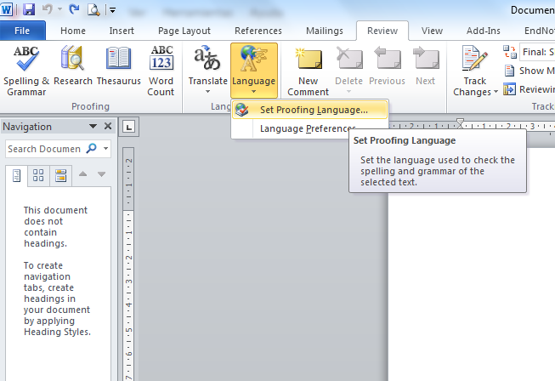
Figure 1-1. Language selection menu.
- Option 2: using a keyboard:
Press the “Alt + R” keys to activate the “Review” tab, and then press the “W” key and the “Language” menu will appear. Press the “N” key to select “Set proofing language”.
When one of the two options is performed, the “Language” window will appear. The language preference can be selected by using the arrow keys up and down, and then pressing the “Enter” key (Figure 1-2).
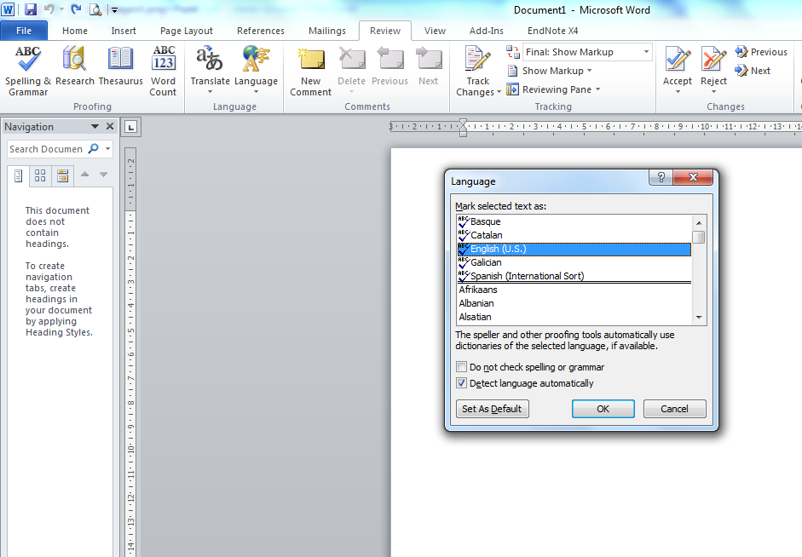
Figure 1-2. Window for setting the language.
A quick way:
The document language can be selected in a quick way by clicking on the language in the status bar (Figure 1-3). The status bar is located under the edit box of the document, but it is not possible to access it through any key combination in Windows. Therefore, it is not an accessible option.

Figure 1-3. Selecting the language from the status bar, a quick but not accessible way.

Font characteristics
As mentioned at the beginning of this section, contents should be as clear and simple as possible in order to be accessible, but the font used in texts can assist or impede the complete understanding of information.
The most commonly used font is of the “serif” type, which has small ornaments usually located at the end of the character lines. Fonts Times, Georgia and Garamond are some examples of this kind. “Sans serif” (without serif) fonts lack the ornaments.
The difference between these two font types is in their readability: the “serif” type shows a very high print resolution on a printed page, so the small ornaments in the letters are well defined. On the contrary, the resolution is not very high on a computer screen, which produces effects on the letters that make reading difficult (Gracia Murugarren, n.d.).
Comparison of the “serif” and “sans serif” fonts, plain format, size 12:
Serif (Garamond, 12) Sans Serif (Verdana, 12)
Because of this, using “Sans Serif” fonts such as Arial and Verdana is recommended, in a no smaller size than 12 points, avoiding where possible the use of italics and moderately using bold to highlight texts.
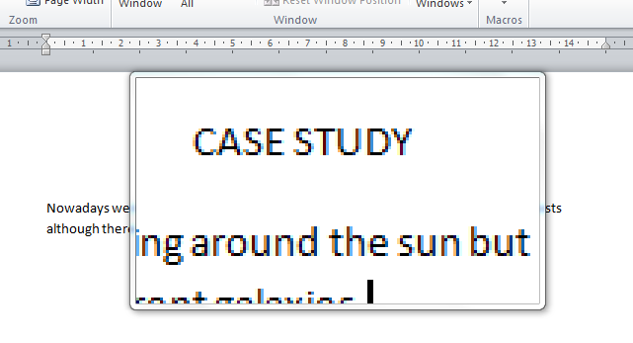
Figure 1-4. Screen magnifier that allows low vision users to read a document.
Low vision users have some problems with focus or clarity, hyperopia, myopia and tunnel vision. While reading documents, it is very likely that these users benefit from high contrast color schemes, large fonts and large icons with the help of screen magnifiers (Figure 1-4). Although these devices can set the presentation options for the computer, using a font too small should be avoided. As a general rule, the smallest font size to be used is 10 points (Office, n.d.-b).

Titles
Before starting writing a document it is necessary to define its structure, which should be logical and coherent.
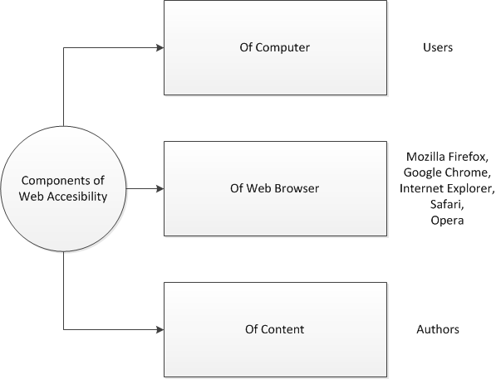
Figure 1-5. Example of contents scheme.
It is important to define the groups and titles of the main contents in levels 1, 2 and 3 which form the main title. A scheme may be used for organizing and guiding about how to structure the document. An example of such a scheme is shown in
Figure 1-5, which contains the main title “Components of Web Accessibility”, which is divided into three secondary titles: “Of Computer” (with an item called “Users”), “Of Web Browser” (with items “Mozilla Firefox”, “Google Chrome”, “Internet Explorer”, “Safari” and “Opera”), and “Of Content” (with an item called “Authors”).
Instructions for creating main titles and subtitles.
- Option 1: using a mouse:
The desired format for the document text is set in the “Styles” section/group on the “Home” tab (Figure 1-6).
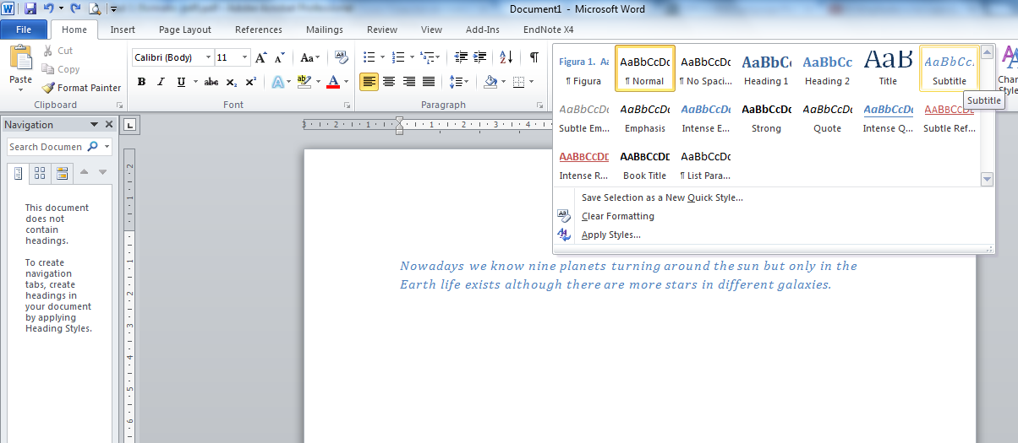
Figure 1-6. Applying styles to normal text and headings 1, 2 and 3.
- Option 2: using a keyboard:
The text style is selected by simultaneously pressing the following keys combinations (Office, s.f.-c):
Normal style: “Ctrl + Shift + A”.
Heading 1: “Ctrl + !”.
Heading 2: “Ctrl + “.
Heading 3: “Ctrl + Shift + 3”.

Paragraphs and section breaks

Paragraphs
Users with cognitive impairments or even with low vision cannot perceive the text and/or get lost while reading if the text is presented in a way that is difficult to read. That is why attention should be paid to paragraphs by considering three important aspects: text alignment, margins and line spacing and paragraph spacing.

Text alignment
When creating documents, the text alignment to the left is the default configuration, although alignment to the center, to the right or justified alignment can also be used. Many people prefer to read a justified text but some studies have demonstrated that texts aligned to the left are easier to read (Luján Mora, n.d.). Therefore, the text should not be justified.
In the guide to understanding and implementing Web Content Accessibility Guidelines (WCAG) 2.0 (World Wide Web Consortium, 2014) about making it easier for users to see and hear content (guideline 1.4), success criteria 1.4.8 [Visual Presentation], it is suggested that people with certain cognitive disabilities have problems reading text that is both left and right justified. The uneven spacing between words in fully justified text can cause “rivers of white” space to run down the page making reading difficult and in some cases impossible. Text justification can also cause words to be spaced closely together, so that it is difficult for people with cognitive disabilities to locate word boundaries (World Wide Web Consortium, 2014).
Instructions to align paragraphs to the left.
- Option 1: using a mouse:
Select the “Home” tab, the “Paragraph” section/group and then the “Align text left” option.
- Option 2: using a keyboard:
Simultaneously press the “Ctrl + Q” keys.

Margins
The success criterion 1.4.8 indicates that users with some reading or vision disabilities may have trouble keeping their place and following the flow of long lines of text, which can become a significant barrier. They have trouble keeping their place and following the flow of text. Having a narrow block of text makes it easier for them to continue on to the next line in a block, so lines should not exceed 80 characters (World Wide Web Consortium, 2014).
Figure 1-7 shows a screenshot of a non-accessible text having narrow margins, and line and paragraph spacing of 1.5 points.
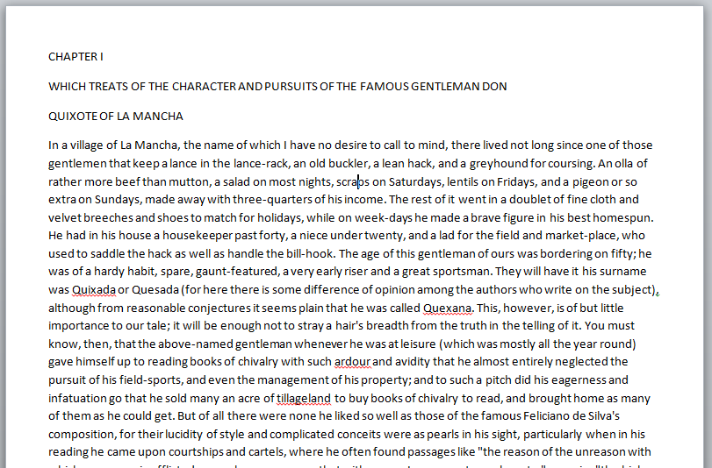
Figure 1-7. Example of a not accessible text.
Figure 1-8 shows a screenshot of an accessible text that contains maximum of 80 characters per line, line spacing of 1.5 points and paragraph spacing of 20 points.
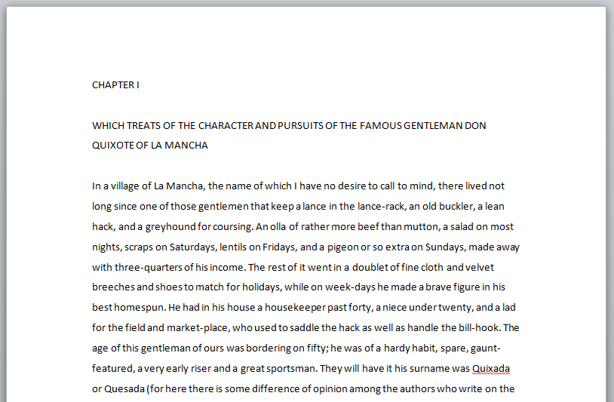
Figure 1-8. Example of an accessible text.
Instructions for creating accessible margins:
- Option 1: using a mouse:
Select the “Page layout” tab, the “Margins” option and then choose/select “Normal” or “Wide”.
- Option 2: using a keyboard:
Press “Alt + C” to activate the “Page layout” tab, press “E” to select the “Margins” option and select “Normal” or “Wide” by using the arrow keys up and down, and then pressing the enter key.

Line spacing and paragraph spacing
People with some cognitive disabilities find it difficult to track text where the lines are close together, and they are not able to track the next line and do not recognize the end of a paragraph. It is recommended to use space-and-a-half for line spacing, i.e. that the top of the one line is 150% further from the top of the line below it (World Wide Web Consortium, 2014).
According to Luján Mora (n.d.), paragraphs should be easily distinguished from each other for easy understanding and reading of the texts. Printed contents such as newspapers, books or journals, usually follow the convention to remove blanks above and below paragraphs, and instead indent the first line of each paragraph. However, it is recommended to keep this convention for printed contents (only). Figure 1-9 shows how paragraphs separated by blank lines present the text in a more accessible way, which is easy to read and understand.
Instructions for creating line and paragraph spacing:
- Option 1: using a mouse:
Select the “Home” tab, in the “Paragraph” section/group, and the “Line and Paragraph Spacing” option, as shown in Figure 1-10.
- Option 2: using keyboard (simultaneously pressing):
For single-spaced lines: “Ctrl + 1”.
For double-spaced lines: “Ctrl + 2”.
For 1.5 lines: “Ctrl + 5”.
For adding or removing one line space before a paragraph: “Ctrl + 0” (zero).
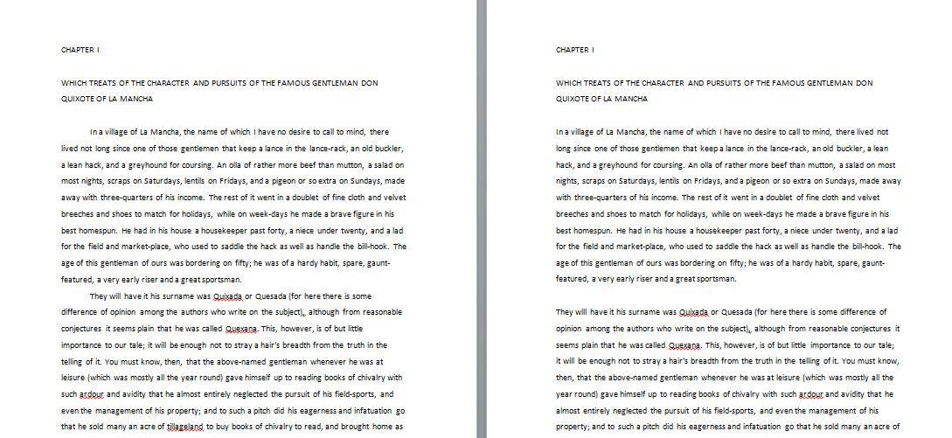
Figure 1-9. Comparison between paragraphs separated by indentation (left) and paragraphs separated by blank lines (right).
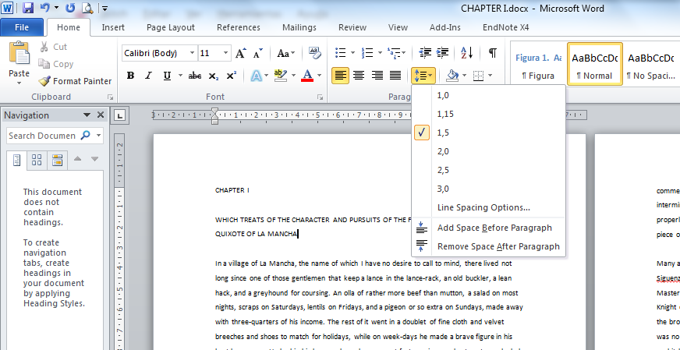
Figure 1-10. How to set line and paragraph spacing.

Section break or page break
It is necessary to use section breaks or page breaks provided by Word instead of using carriage return so that the text goes to the next page.
Instructions for creating section breaks:
- Option 1: using a mouse:
Select the “Page Layout” tab, the “Page Setup” section/group, and the “Breaks” menu (Figure 1-11).
- Option 2: using a keyboard:
Press “Alt + C” to select the “Page Layout” tab, and then press “B” to select the “Breaks” menu that shows the types of page breaks and section breaks. It is recommended to use the “Page” option (press the “P” key to select it) instead of using the “Enter” key.
When the document has several chapters, using the “Next Page” option is recommended (press the “N” key to select it).
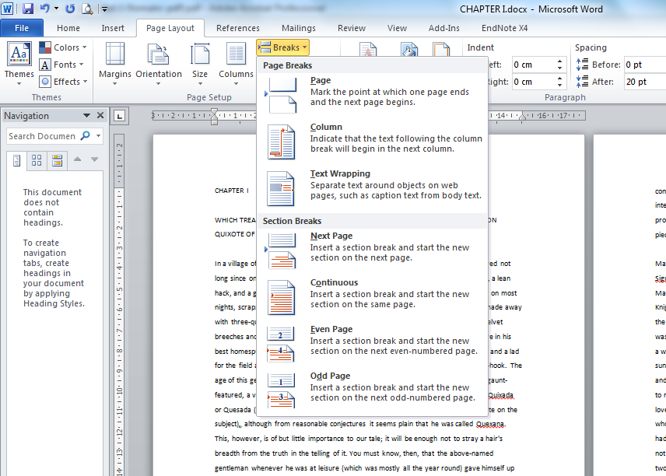
Figure 1-11. How to set section breaks and page breaks.

Lists, numbering and bullets
Regarding lists, using dashes, asterisks or symbols as a separating element should be avoided, because when done a list is simulated, but this is not the correct way to do so.
Instructions to create numbered lists or bullets.
- Option 1: using a mouse:
Select the “Home” tab, the “Paragraph” section/group, and the “Bullets” or “Numbering” option.
- Option 2: using a keyboard:
Write an asterisk to start a bulleted list or number “1” to start a numbered list and then press the spacebar or the tab key, and a list will be automatically generated.
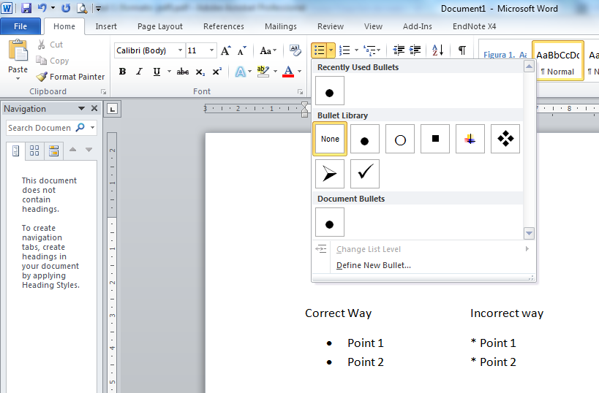
Figure 1-12. Correct way to create lists.

Columns and tables

Columns
If the requirement is to write a newspaper article or newsletter where placing the text in more than one column is necessary, it is recommended to use an adequate tool for this, avoiding the tab key to separate text or simulating it by means of tables.
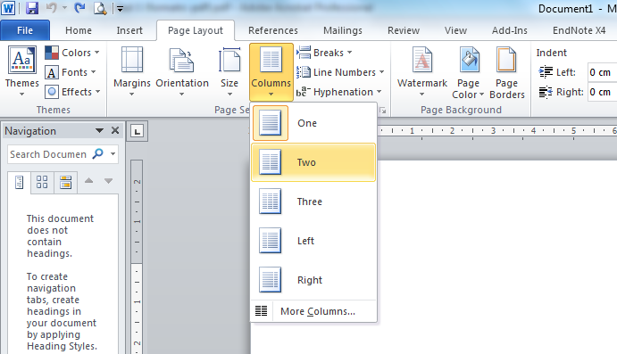
Figure 1-13. How to create text columns.
Furthermore, ample spaces between columns should be set when using text columns as shown in Figure 1-13 (Moreno López, Martínez & González, 2014). If this is not taken into account, readers will read the lines in a row instead of going down by the column. Following this recommendation will make the document easy to read by assistive devices, by people with low vision and by everyone in general.
Instructions to create text columns:
- Option 1: using a mouse:
Select the “Page Layout” tab, the “Page Setup” section/group, and the “Columns” option.
- Option 2: using a keyboard:
Press “Alt + C” to access the “Page Layout” tab and then press the “J” key to select the “Columns” menu.
Figure 1-14 shows that an ample space between columns provides a more accessible presentation.
Figure 1-14. Text columns should be separated by ample blank spaces.
The information showed in the columns may be difficult to access by a person with disabilities who needs assistive technology, so using columns is recommended only if really necessary.

Tables
As mentioned in the previous section, using the tool provided by Word is recommended to put the text in columns, avoiding using tables or tabulators. This is due to tables being elements that cause accessibility problems. For example, a user with total or partial blindness who uses assistive devices such as readers and/or braille devices reads tables row by row across the columns (Office, n.d.-e), as shown in Figure 1-15.
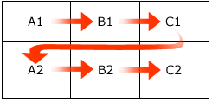
Figure 1-15. Direction in which an assistive device reads the content of a table.
Because of this, if tables are included for analysis in a document, it is important that the information contained can be read consistently line by line.
Example 1: Table seen by users with normal vision:
Destination | Month | Amount | Concept
Colombia | January | 500 | Product B
El Salvador | March | 200 | Product A
Spain | February | 600 | Product B
Table 1-1. Table structure for users with normal vision.
Example 2: Table read by an assistive device:
Destination, Month, Amount, Concept, Colombia, January, 500, Product B, El Salvador, March, 200, Product A, Spain, February, 600, Product B.
Users with normal vision can analyze the table shown in example 1 without difficulties, due to the eyes recognizing the heading for each piece of data and associating the information contained in the cells. However, users with visual disabilities lose the information that the table provides, and should be aided by a device to read the rows, which may be relevant or not depending on the design and layout of information.
Therefore, it is appropriate to describe how a table fits in the context of the document. Even if a title is not provided, it is very important to provide a summary as shown in Example 3.
Example 3: Summary of the content of the table.
“Details about importation of products A and B. The table is divided into four columns. From left to right, the first column “Destination” includes the three main destinations of importation: Colombia, El Salvador and Spain. The second column shows the month in which the importation was done (in this case, January, March and February, respectively). The third column shows an amount the values of which are 500, 200 and 600 respectively. The fourth column specifies the type of product imported. In conclusion based on the data shown in the table, 500 importations of product B were done in Colombia in January; 200 importations of product A were done in El Salvador in March; and 600 importations of product B were done in Spain in February”.
Furthermore, Moreno, López et al. (2014) recommends:
- Tables should not be too large and if possible they should be kept on one page.
- Tables divided into several pages tend to cause accessibility issues.
- When tables are inevitably large and take up more than one page, the headers of the table should be repeated on each page and rows should not be divided when moving to the next page.
If a table is inevitably large and it is divided into several pages, the headers of the table should be repeated in each page and rows should not be divided.
- Select the table and click the right button.
- In the menu select “Table Properties".
- In the “Row” tab, select the option “Repeat as header row at the top of each page”.
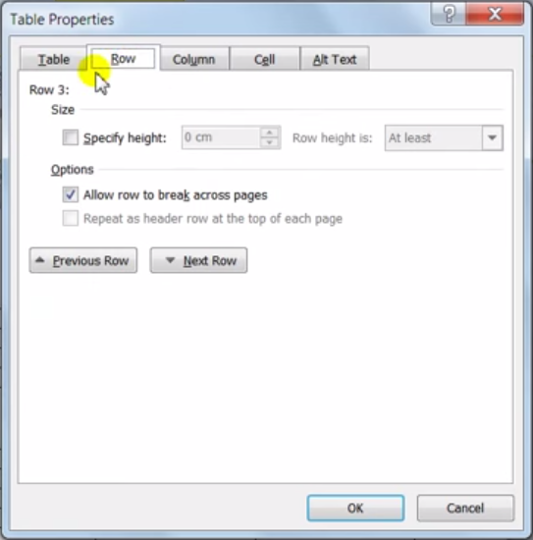
Figure 1-16. Repeat the header row in each page.
In conclusion, it is important to design simple tables, avoiding combining complex cells and tables.

Figure captions
When inserting figures it is recommendable to include a title or a figure caption. This will help users to identify the content and help the document authors to reference the figure and to better structure the document.
Instructions for creating figure captions.
- Option 1: using a mouse (Figure 1-17):
Select the figure and then the “References” tab. Then select the “Insert Caption” option in the “Captions” section/group. A window will be opened, giving the option to write the title (caption) of the figure. The steps should be repeated for each figure, and Word will automatically add similar titles and numbering.
- Option 2: using a keyboard:
Press “Alt + S” to activate the “References” tab and then press the “P” key to select the “Insert caption” option.
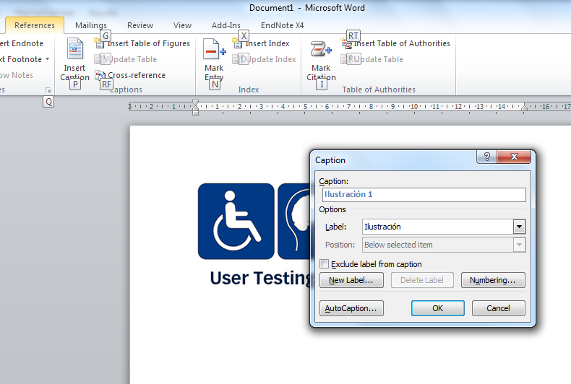
Figure 1-17. How to set figure captions.

Table captions
If the document has data tables, a title should be included for each of them. These titles will help the users who access the document using a reader to get familiar with the information contained in the tables. The same procedure is carried out for adding figure captions. In this case, the “Table” option is selected in the “Label” field, as shown in Figure 1-18.

Tables of contents
A table of contents provides a general visualization about the content of a document, schematizing the structure of the topics and subtopics of which is composed, establishing a direct link or a reference to a specific point in the document.
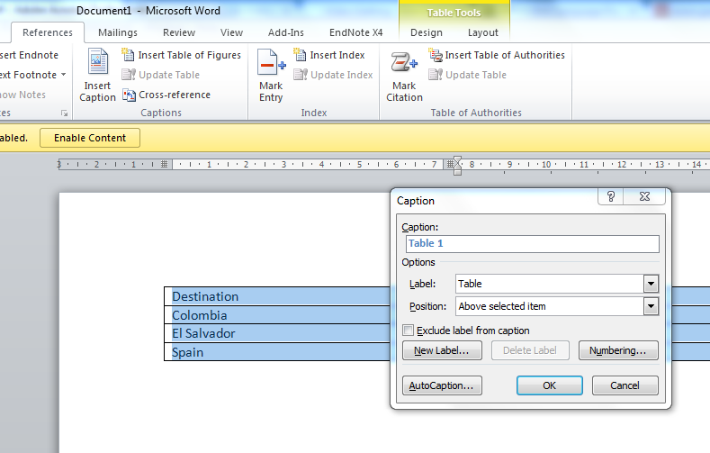
Figure 1-18. How to set table captions.
Instructions for creating tables of contents:
- Option 1: using a mouse:
Select the “References” tab, the “Table of contents” section, and the “Table of Contents” option.
- Option 2: using a keyboard:
Press “Alt + S” to activate the “References” tab, press the “T” key to activate the “Table of Contents” menu (Figure 1-19), and then use up and down keys to select any of the options of presentation contents.
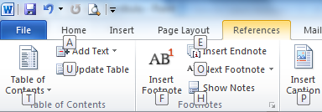
Figure 1-19. How to create a table of contents.
As new topics and/or subtopics are included, the table of contents can be updated by using the “Update table” option.
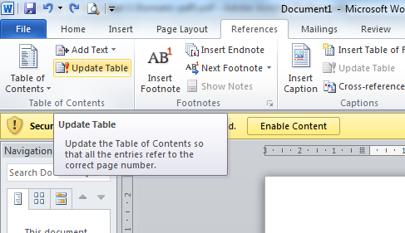
Figure 1-20. How to update the fields of tables of contents.

Tables of figures
The procedure for creating tables of figures is similar to creating tables of contents.
Instructions for creating tables of figures.
- Option 1: using a mouse:
Select the “References” tab, and then select the “Insert Table of Figures” option in the “Captions” section (Figure 1-21).
- Option 2: using a keyboard:
Press “Alt + S” to activate the “References” tab, and then press the “G” key for selecting the “Insert Table of Figures” option. A setup window will appear, as shown in Figure 1-22.
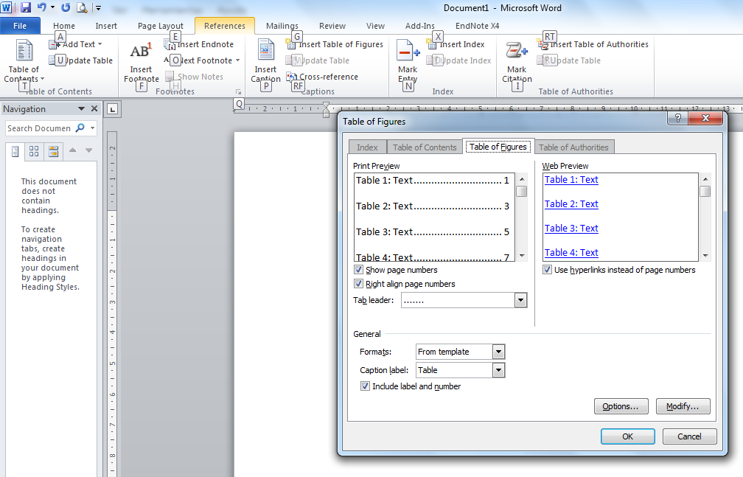
Figure 1-21. Creating a table of figures using a keyboard.
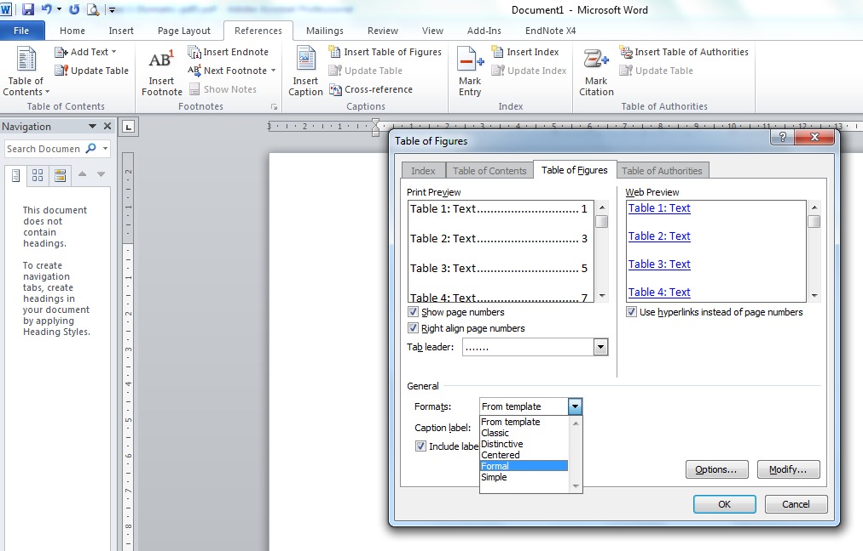
Figure 1-22. Creating a table of figures using a mouse.

Page numbers
With the aim of facilitating the access to the contents of the document, it is necessary to insert page numbers. This will help the user to find the page in which he/she is interested through the table of contents, and then to access it.
Instructions for creating page numbers.
- Option 1: using a mouse:
In the “Insert” tab, in the “Header and footer” section, select the “Page number” menu, which will show the options to insert the page numbers in the document (Figure 1-23).
- Option 2: using a keyboard:
Press “Alt + B” to activate the “Insert” tab. Then press the “J” key to select the “Page number” menu.
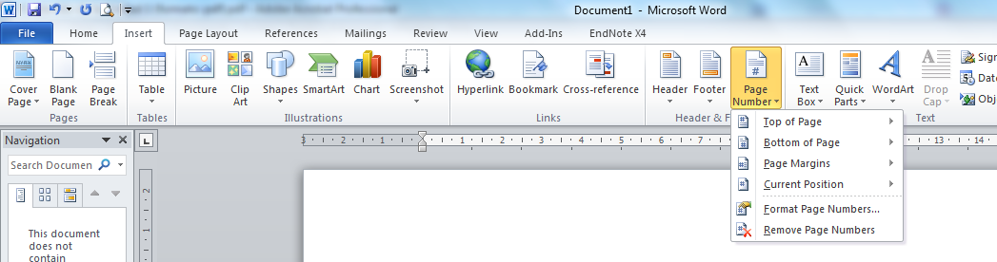
Figure 1-23. How to set page numbers.

Alternative texts
Non-text elements such as figures, graphs or schemes should have an alternative text to describe the information we want to communicate. The description contained in these elements should be able to replace the visual or auditory information in order to make sure users with sensory disabilities, who access the document using an assistive device such as Braille lines or readers, can get all the information.
Non-text elements that require alternative texts are figures, mathematical formulas, diagrams or schemes, videos, audios and text boxes.
Instructions for assigning an alternative text to a figure.
- Step 1: Click on the figure with the right mouse button and select “Format picture...” (Figure 1-24).
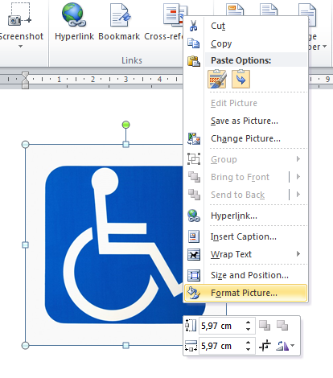
Figure 1-24. How to set the format to a picture.
- Step 2: Select the “Alt Text” option in the “Format Picture” window, and write a description for the information provided in the figure (Figure 1-25).
Alternative text of the example figure:
“The image shows the International Symbol of Access in white color with blue background”.
For creating an alternative text, imagine that you are talking to someone on the phone and that you have to describe a particular image. The description should be as objective and graphical as possible for the listener to know exactly what the image looks like without having to see it. The resulting description will be the alternative text (Fundación Universidad, 2013).
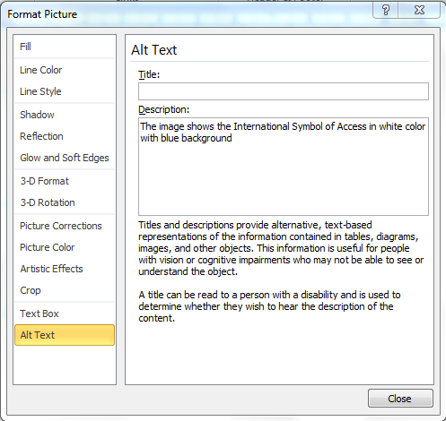
Figure 1-25. How to set an alternative text to the figure.

Accessible graphs
As in the case of figures, graphs should be accessible to all users, regardless of their limitations. To do this, it is necessary to consider the use of color, alternative texts and titles, which facilitate to access the information to be conveyed.

Using flashing elements
Checkpoint 7.1 of WCAG 2.0 suggests: “Until user agents allow users to control flickering, avoid causing the screen to flicker. [Priority 1]”.
When using flickering elements, such as animations, screen flashes or flickering content, users who have photosensitive epilepsy may suffer an attack.

Multimedia elements
If the document contains audio or video, the information to be conveyed should be accessible, ensuring that users with visual or hearing disabilities can receive the message.
According to access to information commission of the European Blind Union (EBU) (n.d.), multimedia material should be described in a manner that the reader knows what he/she can expect. If a user with visual disabilities is informed that the content of a video does not contain any audiodescription, then he/she will know that it can be ignored. Second, to make the information accessible to all users, some alternatives should be provided, such as the following:
- Audiodescription: Particularly aimed at users with visual (or limited visual) disabilities, where the videos or the image content are narrated on screen.
- Subtitles: Subtitles about what characters are talking about are shown on the screen. They are for hearing impaired people.
- Braille: It is a point system, which is used by people with visual disabilities to read and write.
- Sign language: It is the language used by deaf people to communicate.
- Easy reading: Easy reading texts are written in a short and simple language that can be understood by people with cognitive or intellectual disabilities.
Chapter 1 of this course goes deeper into guidelines for creating accessible audiovisual content.

Using color
When writing documents, it should be taken into account that among all users that may access the information, a small number could have, to some extent, color blindness. In many cases the problem may be not distinguishing colors or just a specific color, or being able to see only black and white.
Since we cannot know what the users’ limitations are who access the information, we should be careful with semantic use of color and contrasting colors and always provide an accessible design for all.

Semantic use of color
Using color as an indicator element should be avoided. Ultimately, if the use is necessary, verify that all information conveyed with color is also available without color.
Wrong way:
Relating to enrolment on the Web Accessibility course, available groups are marked in blue, and those marked in red are not available.
Group 01: Monday and Tuesday
Group 02: Wednesday and Thursday
Group 03: Friday and Saturday
Group 04: Sunday
Right way:
Relating to enrolment on the “Web Accessibility” course, available groups are marked as “Available”, and closed groups (i.e. not available) are marked as “Not available”.
Group 01: Monday and Tuesday (Available)
Group 02: Wednesday and Thursday (Not available)
Group 03: Friday and Saturday (Not available)
Group 04: Sunday (Available)

Contrasting colors
Foreground and background color combinations should have enough contrast to be perceived by people with color blindness or deficient color perception.
Web Content Accessibility Guidelines 1.0 (World Wide Web Consortium, n.d.), which are also useful for document accessibility, suggest in Guideline 2: “Don't rely on color alone”.
Checkpoint 2.2: “Ensure that foreground and background color combinations provide sufficient contrast when viewed by someone having color deficits or when viewed on a black and white screen. [Priority 2 for images, Priority 3 for text]”.
In “Pautas para el diseño de entornos educativos accesibles para personas con discapacidad visual” (in Spanish, title translated: “Guidelines for designing accessible educative environments for people with visual disabilities”) (Centro de Investigación, Desarrollo y Aplicación Tiflotécnica, 2005), some examples are shown of foreground and background color combinations which have a high contrast facilitating the reading of users with visual disabilities.
It is worth remembering that letters and their size affect reading and text comprehension. In order to make text readable enough, a minimum size of 12 points should be used, and sans serif typography.
Example:
BLACK ON WHITE | WHITE ON BLACK
YELLOW ON BLACK | WHITE ON BLUE
WHITE ON RED | BLUE ON WHITE
RED ON WHITE | YELLOW ON GREEN
Figure 1-26. Foreground and background color combinations.

Navigation links
If using links within the document is necessary, the target of each link should be clearly identified.
According to “Manual de accesibilidad y buenas prácticas” (in Spanish, title translated: “Manual of accessibility and good practice”) by Universidad del País Vasco, Spain (n.d.), links such as “click here”, “more info” or “read more” are not recommended because they do not sufficiently describe the link. When an internal or external link takes the user to a different page, the target should be correctly indicated before the user clicks on the link.
Examples for writing navigation links are detailed below.
Wrong way:
Once the pre-enrolment period is over, the University will publish a list for setting a date and time for each student to enroll.
+ info
More...
Information
Enrolment
Right way:
Once the pre-enrolment period is over, the University will publish a list for setting a date and time for each student to enroll.
More information about the enrolment process.
Performing online enrolment.
For inserting a navigation link or hyperlink in a document, as shown in Figure 1-27.
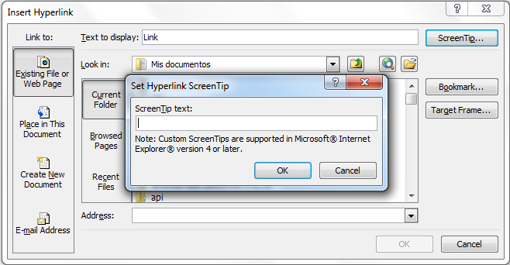
Figure 1-27. How to insert navigation links.
Instructions for creating accessible navigation links:
- Step 1: Select the “Hyperlink” option on the “Insert” tab.
- Step 2: Insert the text of the link and the address and select the “ScreenTip...” option to include the description about where the link takes the user.

Converting to a PDF document
For converting a document to PDF format, in addition to meeting the above criteria, the accessibility options for converting to PDF should be set as follows:
- Step 1: Select the “File” tab.
- Step 2: Select the “Save & Send” option and then “Create PDF/XPS Document”.
- Step 3: In the dialog box, press the “Options...” button to save the document and check the “Document structure tags for accessibility” box.
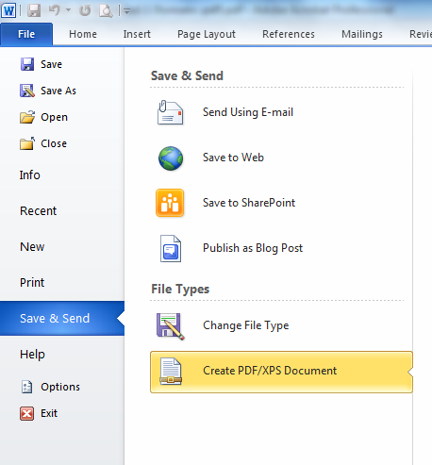
Figure 1-28. How to convert a document to PDF.
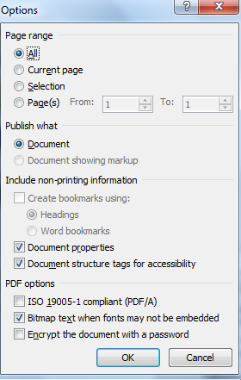
Figure 1-29. Accessibility options for conversion to PDF.

Accessibility evaluation tools
Several tools and techniques are available for evaluating the accessibility of documents. This evaluation warns about the problems with accessing content that people with disabilities may have due to their functional variety and/or using assistive products, and it also allows evaluating the compliance with accessibility guidelines defined by Web Accessibility Initiative (WAI).

Checking accessibility in Office 2010
Microsoft Office (Word, PowerPoint, Excel…), version 2010, offers an automatic tool for checking whether or not a document is accessible.
To perform this review, select the “File” tab, then the “Info” option, and then “Check for Issues”. Select the “Check Accessibility” option, as shown in Figure 1-30. All the non-accessible elements such as the alternative text of a figure will appear, which will need to be rectified in the document.
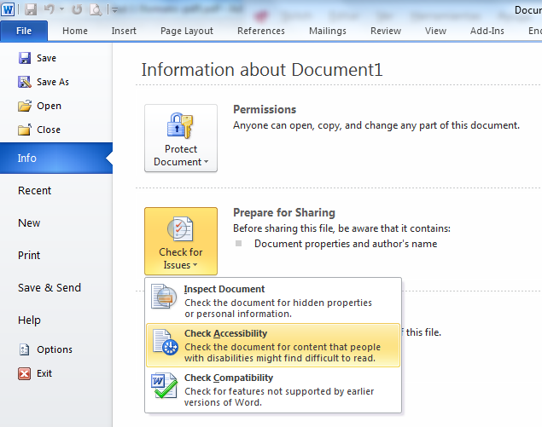
Figure 1-30. Location of tool “Check Accessibility”.
The tool for checking accessibility presents a task panel that shows the results of evaluation divided into three categories, “Errors”, “Warnings” and “Tips”, supplemented with an additional information section that guides the author with the motive and method of correction.
The categorization of validations specifically performed for the word processor (W) is presented below. These validations can also be presented in spread sheet documents (E) and slideshows (P).
- Errors: An error is for content that makes a file very difficult or impossible for people with disabilities to understand:
- All objects have alternate text (E, P, W).
- Tables specify column header information (E, P, W).
- Long documents use styles to provide structure (W).
- Warnings: A warning is for content that in most, but not all, cases makes a file difficult for people with disabilities to understand:
- Hyperlink text is meaningful (E, P, W).
- Table has simple structure (E, P, W).
- Tables do not use blank cells for formatting (E, P, W).
- Avoid the use of repeated blank characters (W).
- Headings do not contain too much information (W).
- The use of floating objects is avoided (W).
- Tips: A tip is for content that people with disabilities can understand, but that might be better organized or presented in a way that would improve their experience:
- Closed captions are included for inserted audio and video (E, P, W).
- Layout tables are structured for easy navigation (W).
- No image watermarks are used (W).
- All headings are in the correct order (W).

AccessODF
AccessODF is an extension for the word processor LibreOffice Writer which supports the author to evaluate and repair incidences of accessibility that may hinder or prevent people with disabilities to read documents in Open Document Text (ODT) format. Among the validations that the extension performs are the following:
- Validation of color contrast between text and background.
- Validation of text alternatives for images and other objects.
- Validation of, for example, language identification for the document and for language changes inside the document.
- Validation of the use of proper heading styles.
- Validation of the use of proper tables.
- Validation of the compatibility of images with Digital Accessible Information System (DAISY).

Usability testing
The validation of usability and accessibility of the document by the final user is the most important in order to check whether or not he/she can perform all tasks, find the information and access the whole content and find out how long the process is. Validation can be done through tests with people with different disabilities, with different levels of expertise and different familiarity with the content; and using assistive tools such as screen readers, among which we can mention:
- JAWS (payment software).
- NVDA (free software).

Document conversion to other formats for validation
If the Office version does not have any functionality for checking accessibility, the document can be saved as a portable PDF document or as an HTML page in order to validate accessibility with other available tools.
For validating accessibility of documents exported as an HTML page the following tools are suggested. The options will be discussed in more detail in Chapter 5.
- Examinator (WCAG 2.0 validation).
- Achecker (WCAG 2.0, HTML and CSS validation).
- TAW (WCAG 2.0 beta validation).
- HERA (WCAG 1.0 validation).
- WAVE (Web Accessibility Evaluation Tool).
For validating accessibility of documents exported as a portable PDF the following tools are proposed. Furthermore, other options will be studied in Chapter 3.
- Online validation tools: Check a PDF (Tingtun Checkers, n.d.).
- Validation tool: PDF Accessibility Checker (PAC).

Creating accessible presentations with PowerPoint

Translators:
Eva García López
Antonio García Cabot
University of Alcalá, Spain
Authors:
Carmen Pagés Arévalo
Luis Fernández Sanz
University of Alcalá, Spain

PowerPoint is the Microsoft Office tool for creating presentations. Its use has become so widespread that in many cases presentations are created to directly convey the information, without the speaker being present.
A PowerPoint presentation is composed of multiple slides that are passed sequentially and that may contain text, shapes, figures, graphs and multimedia files. Therefore, when creating accessible presentations we should take into account the accessibility of the presentation itself (format in which it is distributed, transitions between slides, narration, slides design, etc.) as well as the accessibility of the elements of the slides (text, figures, audio, video, animations of the elements, etc.).
This chapter explains the guidelines to be followed for creating accessible presentations and tools that help creating accessible presentations, and verifying that they are.

Creating accessible PowerPoint presentations

Tips for creating an effective presentation
Before explaining the points to be taken into account for creating an accessible presentation, some tips will be presented for creating effective presentations, because an accessible presentation should be equally or more effective than any other presentation. Here are some points to be taken into account when creating an effective presentation, which can be considered as good practices:

Reduce the number of slides and structure them
In order to convey a clear message and to keep the attention and the interest of the public, reduce the number of slides of the presentation to a minimum. The slides should have a hierarchical structure that facilitates the comprehension of the overall presentation, by using titles, subtitles, lists, etc. It is more convenient to use slide preexisting designs instead of starting from a blank slide and then adding elements. For example, using a slide with a title element provides information about the structure of the presentation. This does not happen when using a blank slide and including a text which is then bold formatted and is set to a large size, simulating a title. It is also convenient to include a slide's index at the beginning of the presentation, which explains the structure of the presentation and, if it is long or has a complex structure, remember on each slide to the public which part of the structure of the presentation is he/she explaining, so that the receiver does not feel lost. Including the number of the slide will help the receiver and also to the own speaker, to be oriented during the presentation.

Select a size and type of font suitable for the public
Select the most suitable font size helps to convey the message. The public should be able to read the slides from a certain distance, so a font size below 24 points may be too difficult to read. It is also recommendable to use a clear font type and a sufficient line spacing to facilitate reading.

Simplify the slide text
Use vignettes or short sentences, trying to include each of them in one line, because some projectors cut the edges of the screen. Complete the sentences with dots or semicolons and use bulleted or numbered lists. If acronyms are used, it is recommended to explain the full meaning of the acronym in its first appearance.

Use visual controls to help expressing the message
Add meaningful figures to complement the text, because figures and graphs help the public to remember, always limiting the number of figures to not overload the presentation. Avoid the use of text as figures, which may lose clearness. Do not use color as the only expressive medium, for example, using the colors of a traffic light to indicate something allowed, dangerous or prohibited, because some users will not be able to distinguish it. If it is used, then add a meaningful text to the color.

Create tags for graphs and diagrams so that they are understandable
Use simple and concrete tags for graphs and diagrams in order to make them understandable. Do not include too much information, as it would force to use a small font size or little separation between lines, which may difficult the reading.

Apply subtle and consistent backgrounds to the slides
The theme used for the presentation should not be too colorful to not distract the attention of the listeners. It is also important that there is enough contrast between the foreground and the background, in order to achieve an easy reading. It is best to use black text on white background.

Use templates and patterns
Using templates and patterns simplifies creating presentations because the structure, design and theme used in the presentation are already defined. Templates can be customized and created for different types of presentations. If a template is accessible, using it in future presentations will avoid many accessibility problems. Patterns can be created for all those elements that are considered to be included in every slide. Do not include indispensable information in a pattern, as it is not verbalized by screen readers.

Check spelling and grammar
Before showing a presentation to a public it is very important to check its spelling and grammar, because one error of this type would give a bad impression to the audience. Therefore, it is necessary to define the language of the document as the language used during the presentation. If some sentences or paragraphs are used in other languages, the correct language for each of them should be defined (it is also useful for correct intonation of screen readers). Short sentences and grammatically simple should be used, so that all people that are listening can understand the message.

Good practices for designing and creating accessible presentations
Below are the points to be followed in order to create accessible presentations for users with disabilities.

Adding alternative text to figures and objects
Alternative text (Alt text) appears when you hover the mouse over a figure or object, and helps people who use screen readers to understand their meaning. It should be included for the following objects:
- Figures.
- Clip arts.
- Graphs (not available in version 2007).
- Tables (not available in version 2007).
- Pivot tables (not available in version 2007).
- Shapes not containing text.
- SmartArt graphs.
- Embedded objects.
- Groups (all objects in a list, except shapes, should also have alternative text when they are in groups).
- Pen inputs.
- Audio and video files.
To add alternative text, press with the right mouse button over the figure or object and select “Format picture...”. In the left column, select option “Alt text” and add a title and a description (Figure 2-1). For adding alternative text to an entire graph or a SmartArt graphic, press over the edge of the graph or SmartArt graphic and not over a specific shape or part.
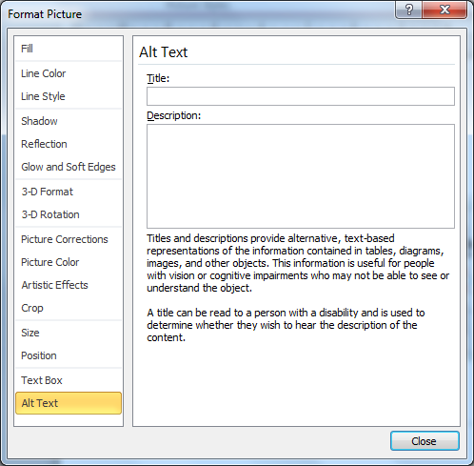
Figure 2-1. How to set alternative text for an object.
In the “Description” field, type an explanation about the shape, figure, graph, table, SmartArt graph or other object. This field should always be filled. Optionally, in the “Title” field, type a brief summary. This field should only be filled if a long and detailed explanation is written in the “Description” field. Only the description is usually typed, unless the graph or the table are complex. If so, it would be also useful to fill the title, so it is not necessary to read the whole description unless the user wants to read it.
People with disabilities can listen the title and determine whether or not they want to listen the description. If an element is purely decorative and it is not necessary to add information about it, a blank space should be included instead of a description.
For best results, add alternative text in field “Description”, not in field “Title”. The information contained in the field “Title” will not be saved as alternative text when the file is saved as HTML.
Alt Text command can be added to the toolbar shortcut to create a shortcut. This is usually useful when adding alternative text to shapes, figures, tables, SmartArt graphs or other objects. To do this, select “Customize quick access toolbar” in the upper left corner over the ribbon tabs. After selecting “More commands...”, select “Commands not in the ribbon” (below “Choose commands from:”), then select “Alt text...” and press button “Add >>“.
For using command Alt Text in the toolbar shortcut, firstly select the shape, figure, graph, table, SmartArt graph or other object before pressing the button in the toolbar, and then add the alternative text.

Enter information in the table column header
Having clear information about the column headers may put into context the listener and help navigating the table. This guideline means that data tables (except pivot tables) should have one or more header rows. For creating accessible row headers it is necessary to select the table, click over “Design” and then “Header row”.

Check that each slide has a title and it is unique
Titles of the slides are used for that people with visual disabilities are able to navigate and select the correct slide, so it is essential that each of them has a title and that it is unique, i.e., that uniquely identifies each slide. It is convenient that the titles of slides are meaningful and a useful way to convey the structure of the presentation to the reader.
For showing the titles of all slides, select tab “Outline”. This will show all the slides and their elements (Figure 2-2). Each slide is represented with a rectangle and its title, and below it, the elements of the slide appear in a bulleted list.
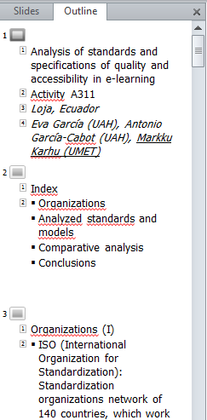
Figure 2-2. Outline view, showing some slides and their elements.
Titles may be assigned to slides in order to make the presentation more accessible, even when we do not want that they are visible. This may be useful in presentations completely visual, without text. There are two ways to include titles:
- Visible titles. In “Home” tab, press “Reset” to reset the placeholders on the selected slide. Placeholders are boxes with dotted borders that are part of all slide layouts. These boxes contain text of a title and main text; or objects such as SmartArt graphs, graphs, tables and figures. Once the placeholders have been reset, write a unique name in the title field.
- Not visible titles. Select “Home”, then “Arrange” and then “Selection Pane...”. Finally, press over the eye icon that is located next to the title text field of the slide to change visibility.

Use meaningful text for hyperlinks
The text of the hyperlinks should provide a clear description about the target of the link and should be presented in a legible format. The text of the hyperlink should not provide only the URL or only the name of the target file. Therefore, the following are not correct:
- The text of the hyperlink is the same as the target. For example, the text of the link is http://office.com/en-us/help/HA103691921033.xml.
- The text of the hyperlink has five or less characters, starts with “.” and does not show information on the screen. For example, using a file extension (e.g., .pdf) as the text of the hyperlink.
For making a hyperlink more accessible, firstly select the link, then select tab “Insert” and then “Hyperlink”. In field “Text to display”, type a sentence that describes briefly the target of the link. It is also possible to add additional information to a hyperlink. To show some text in a floating box when the mouse is over the hyperlink, press button “ScreenTip” and type the message. This message, for example, may give some indication about the type of information that will be accessed, and the degree of accessibility.

Use simple table structures
Navigation will be much simpler when not using nested tables, or combining and dividing cells. A table should have a simple two-dimensional structure so that people with disabilities are able to navigate through it and understand it easily.
To test and simplify a table structure, select the first cell and then press the tab key more than once just to make sure that the focus is firstly moved by the row and then down to the next row. The focus should always move from one cell to the next column, if it is not the last one in the row; and if it is the last one, the focus should move to the first cell of the next row. If combining or dividing cells is necessary to simplify the table, click on “Layout” (in “Table tools”) and then “Merge cells” or “Split cells”, as appropriate.
Figure 2-3 shows two tables. In the first one, the tabulator moves from the cell containing number 7 to the cell containing number 11, which is not the next column (it is column B and it should move to column C). In the second one, the tabulator moves from the cell containing number 10 to that containing number 11, which is not the next row (it is the second one and should move to the third). In both tables, the cell containing number 11 should not exist, and it should be combined with the cell containing number 7 to get just one cell.
Figure 2-3. Examples of incorrect tables’ structures.

Avoid using blank cells for formatting
Using blank cells (blank single cells or blank rows and columns) may confuse the user when using screen readers, because they may think that there is no more content to read in the table. To avoid this, the blank row or column should be removed, by locating the tabulator in a cell of the row or column, then clicking with the right mouse button and select “Delete rows” or “Delete columns”. When single blank cells are used, if they cannot be removed, it is better to type on them the word “empty” or any other value representing the absence of content.
Avoid using tables when for only formatting content. For example, if a text in two columns is desired, do not use a table with three columns and one row, and type the text in the first and the third columns. In such a case, a two content design should be selected for the slide and then type the text in each of the placeholders.

Include captions for audio and video
The multimedia audio, voice and video may convey important information that probably is not available for people with disabilities. When inserting multimedia content in a presentation, it is necessary to check that the content is available in alternative formats such as captions in videos, alternative text or transcripts of a narrative in the notes, which users with disabilities can use.
Recording a narration for the presentation allows people with visual disabilities to hear the presentation content. Typing the narration as notes in the slides may benefit people with hearing impairments or whose computers do not have sound card. When saving the presentation as a webpage file (.htm), the notes will appear below each slide. If the presentation is saved as a presentation file (.pptx), the notes can be printed.
If the presentation will be subtitled during its oral presentation, the bottom of the slide should not be used, since normally the captions occupy that space.
There is an add-in for inserting captions in Microsoft PowerPoint, called Subtitling Text Add-in for Microsoft PowerPoint (STAMP) (Office, n.d.-d). It allows creating closed captions for the video and audio of the presentations (only available in version 2010). This add-in allows to:
- Import captions from a Timed Text Markup Language (TTML) file, for creating captions from a video or audio file in the presentation.
- Create and edit captions in PowerPoint 2010.
- Remove the captions.
- Export captions to a TTML file.
- Enable and disable the captions in the presentation mode.
- Align captions.
- Importing text with information about the format of the TTML file, for example, style, color and alignment.
To install STAMP in a computer, the correct version (32 or 64 bits) should be downloaded from the repository. The downloaded file is a .zip file that has to be saved in the computer and subsequently decompressed. A .msi file will be extracted, and then it should be executed and follow the installation steps. To check whether it has successfully been installed, open PowerPoint and select “File” and then “Options”. In the dialog box, select “Add-Ins”. If STAMP is installed, “Subtitling Add-In for Microsoft PowerPoint” should appear in “Active Application Add-Ins”, as shown in Figure 2-4.
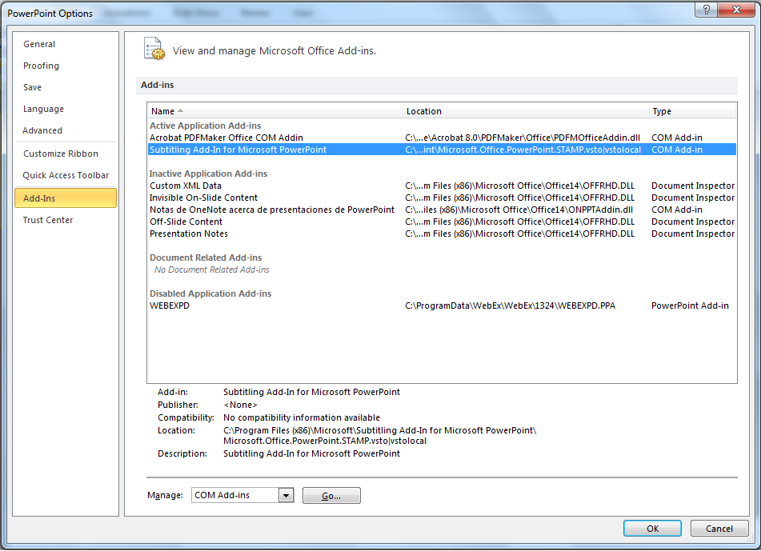
Figure 2-4. STAMP add-in installed.
When a presentation has an audio or video file included and the add-in STAMP is installed, the options of group “Add captions” (in tab “Playback”) will be available. Figure 2-5 shows the option for creating captions for a video in a PowerPoint presentation.
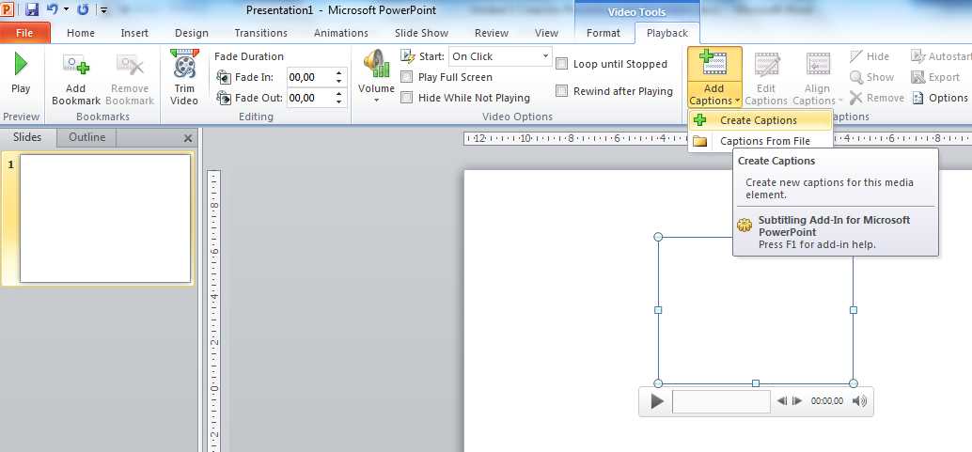
Figure 2-5. How to create captions for a video in a PowerPoint presentation.
The options of group “Add captions” allow to:
- Create captions (option “Create Captions”). The steps for creating captions are shown in Figure 2-6, which represents dialog box “Caption Editor”. These steps are explained below.
Press button “Play” (1) to start playing the audio or video. Press button “Add a new caption” (2) to add a new row of captions. The title will be created to start at the moment the video or audio is playing (i.e. at “Start Time”). You can also locate the moment of the video you want, stop it and press over (3) to fix that time as start time or end time of the caption shown in the row. If the end time is not entered, the end time will be the start time of the following row. Press over text field “Caption text” (4) and type the text that will appear as a caption.
By repeating the previous steps, new rows for captions can be created. When finished, press button “Update” (5). It is not mandatory to create captions in order. To add a new caption between two existing rows, create the new row at the end and press over “Sort the captions” to put them in order of time sequence.
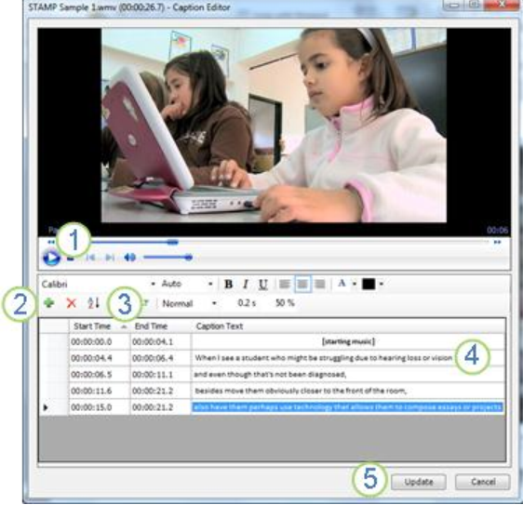
Figure 2-6. How to edit captions for a video in a PowerPoint presentation.
- Insert captions by importing them from a TTML file (option “Captions from File”).
- Edit captions (option “Edit Captions”). It allows modifying the captions' text, the time they start and end, their size, color and font type, their transparency, adding and removing captions rows, etc.
- Hide or show captions (options “Hide” and “Show”).
- Remove existing captions (option “Remove”).
- Align the captions when a video has been moved or has changed its size (option “Align Captions”). They may be located at the bottom of the video or at the bottom of the slide.
- Set default values for formatting the captions (option “Options”). These values are:
- The transparency of the captions can be modified by changing the percentage. By default, transparency is set to 50% but it may be changed for ensuring that the captions can be clearly read.
- The fade duration can be modified by changing the fade duration. By default, it is set to 0.2 seconds.
- Timing accuracy for start time and end time of captions. They are always defined as hours, minutes and seconds, but it is possible to add tenths, hundredths or thousandths of a second.
- Selection of automatic action about inserting a video or audio file (when adding new media). It determines what PowerPoint will do when a file of this type is inserted. The options are: “Do nothing”, “Create captions” (selected by default, it automatically opens the captions editor) and “Import captions” (it automatically opens the dialog box to import a TTML file with captions).
- The font type, size, style, etc. of the captions can be modified by using the font options that are displayed in the window.

Check the reading order
Someone who cannot see a slide, listens its content, its shapes or the text of the slide in a certain order. It is important to check the reading order that screen readers will use in each slide, in order to follow a logical order and making sense. To do this, in tab “Home”, group “Drawing”, select “Arrange” and then “Selection pane...”. The reading order of the elements of each slide will be showed, in reverse order to be read (they will be read from bottom to top).
If content is only placed in the placeholders of the slide, it is ensured that the reading order will be correct. Therefore it is important to use one of the slides designs when adding a new slide, and do not include any new element to the original design. When new elements are necessary to be included, then the reading order should be verified and corrected by means of the selection pane.
The selection pane shows all the objects of the slide. These objects are read starting with the element of the list that is located at the bottom and finishing with the element of the list that is at the top. Correct all elements that do not follow the order by using the “Re-order” arrows located at the bottom of the pane. Figure 2-7 shows that when an element is highlighted in the selection pane it is also selected in the slide. In the example showed, the latter element of the list will be the first read, it is highlighted in the selection pane and selected in the slide (the number of slide).
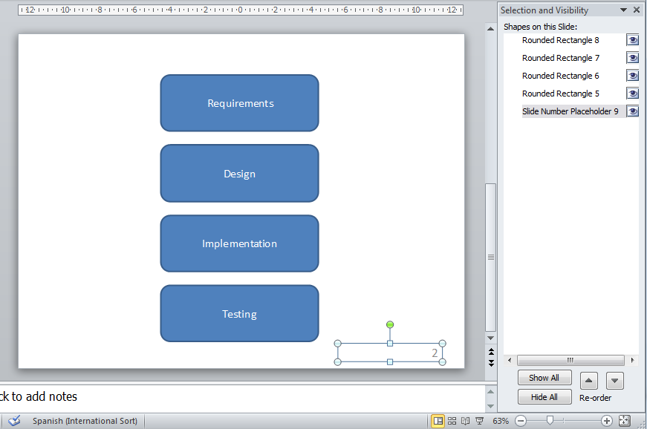
Figure 2-7. Selection pane showing the reading order.

Increase visibility for people with color perception disabilities
When creating a presentation, it is important to choose elements that increase the visual contrast for people who do not distinguish colors. Some good rules to follow are:
- Avoid using orange, red and green colors, both in the template and in the text.
- Use animations or circles marks to highlight information instead of using laser pointers or colors.
- Use a high overall contrast in the presentation. According to the WCAG (World Wide Web Consortium, 2008), a minimum contrast of 4.5:1 is needed, not only for images, but for text; except large-scale text, which allows a contrast ratio of at least 3:1. The contrast ratio is calculated by the formula (L1 + 0.05) / (L2 + 0.05), where L1 is the relative luminance of the lighter of the text or background colors, and L2 is the relative luminance of the darker of the text or background colors (0 luminance is for the darkest black and 1 for the lightest white). Luminance is calculated with RGB color values, which can be obtained in PowerPoint by opening the font color menu and selecting option “More colors...”. A dialog box will be open (Figure 2-8), which provides the three RGB color values. For detailed calculation of the luminance with those three values please visit the WCAG 2.0 website, and for a better knowledge of colors luminance visit the RGB color model page (Wikipedia).
- Do not use background with gradient color or patterns, especially if some information (text, figures, graphs, etc.) will be inserted over.
- Use textures instead of colors in graphs to highlight remarkable points. Do not use different colors to mark information in graphs. For example, on a linear graph, two different type lines may be used (e.g., continuous and dashed) in addition to a different color for showing two series of different values. In pie graphs and bar graphs, a grayscale or filling with different patterns may be used.
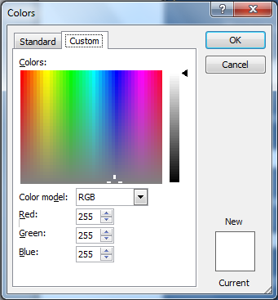
Figure 2-8. Showing the three values of a RBG color.

Avoid animations and automatic transitions
Animations should be not used because they may disorient some users. Automatic transitions between slides should also be avoided because when using them, the user may not have enough time for seeing, listening or reading the whole content of the slide. It is better to allow the user to decide when he/she wants to go to the next slide, so that way we are sure that he/she will always be able to see, listen or read it completely.
Action buttons allow changing from one slide to another. They can be used when their aim is clear (if the icon is not explicit enough, a text can be added over the button), an alternative text is used to describe them and they are big enough that people with disabilities are able to press over them.
The use of animated images or flickering elements can produce photosensitive epilepsy attacks to some users. The Accessibility Observatory from the Spanish Government (2011) recommends the following:
- Do not use more than three general flashes (six transitions from light to dark, or from dark to light) per second.
- Flickering may take up to five seconds. Otherwise, mechanisms to pause, stop or hide it should be provided.

Do not include relevant information in the pattern of the slide or in the footer
The pattern of the slide is not read by screen readers so any element conveying information should not be included in it. The pattern is the perfect place to include the companies' logos. Similarly, information in the footer is not read by screen readers so it should not contain relevant information.

Convert to other formats
In many cases it would be useful to convert a PowerPoint presentation to other types of files, such as HTML, PDF or video (WMV). The accessibility of the new document remains unchanged from the original one. To be sure about it, the following should be checked:
- PDF documents. When selecting PDF as document type in option “Save as” from tab “Home”, button “Options...” is showed. When this button is pressed, a new dialog box will appear (Figure 2-9), and we should be sure that option “Document structure tags for accessibility” is selected.
- Videos. To record a video of a presentation, select “File”, then “Save & send” and finally “Create a video”. For getting an accessible video it is convenient to have previously recorded timings between slides (with a sufficiently long time) and narrations of slides. When creating the video, option “Use recorded timings and narrations” should be selected.
- Word. To create or add all or some slides of the presentation to a Word document, select “File”, “Save & send” and finally “Create handouts”. In the Word document, the slides will appear as images, so screen readers will not be able to read their information. This problem can be solved by typing the content of the slide or explaining it in the notes area of each slide. When the notes of a slide are converted to Word, they are showed below the corresponding image.
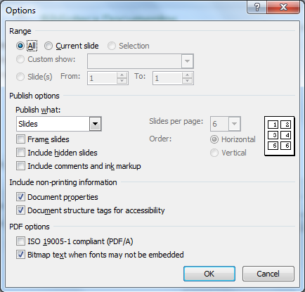
Figure 2-9. Options for saving a document as a PDF.

Tips for presenting in an accessible way
PowerPoint is often used by a speaker as a support for a presentation to a group of people. Some tips and techniques should be used to guarantee that the speaker is able to address to any member of the audience in the most effective way:
- Look straight ahead at all times when talking. If you are writing on a blackboard, you have to turn around every time you talk. Always speak in front of the audience. This is important because deaf people may be in the public and they need to see how the speaker's lips are moving in order to understand him/her.
- All content in a slide should be read and explained to the audience, both text and images or graphs. In a big room, the information of a slide may not be read from the back of the class or a person with visual disabilities may not do it.
- Use a microphone or an audio system, if possible.
- If an animation has been included into a presentation, be sure that it has finished moving before you start talking. If an animation is moving, participants will lose concentration on the speaker to dedicate it to the animation.
- The readability of text on the screen will be affected by the light levels in the room. As a general rule, if the presentation takes place in a room well lit, the text will be more legible when it is dark and the background is light. On the contrary, in a dark room, the presentation will be easier to read with a dark background and a light text. Take into account that a text may look thinner when the background is dark. In that case, the readability can be increased by setting the text to bold.
- Leave enough time for moving from one slide to another and make small pauses when moving from one topic to another.
- Do not create a very long presentation: some people need to take a break every so often. If a presentation is planned to take up all morning or all afternoon, divide the presentation into at least two or three parts.
- Plan with the event organizers whether the screen will include captions or the image of a sign language interpreter. In those cases, design the presentation by considering the available space.

Checking the accessibility of a PowerPoint presentation

Executing the accessibility checker
For checking whether all guidelines have been taken into account, Microsoft PowerPoint has the Accessibility Checker, which will check the whole presentation and will mark all possible problems for people with disabilities. To run it, go to tab “File” and select “Info”. Click on “Check for issues” and then select “Check accessibility” (Figure 2-10) (Office, n.d.-a).
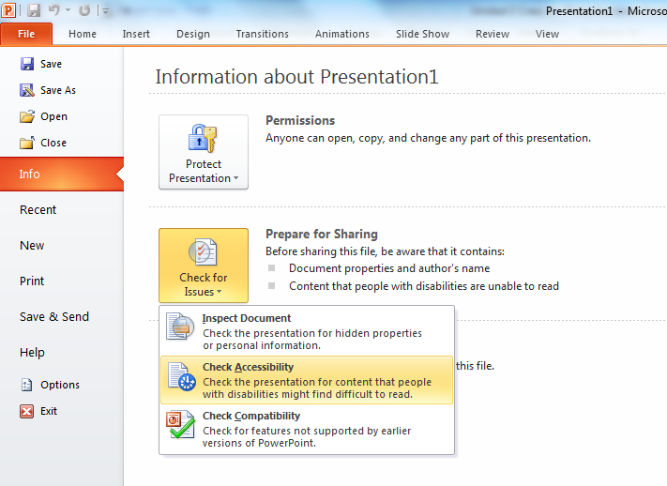
Figure 2-10. How to run the Accessibility Checker.
The accessibility checker will examine the whole presentation, will show the file and will open a dialog box indicating all problems found as a result of the inspection (Figure 2-11).

Additional information about the problems found
Microsoft provides more information about the problems found by the accessibility checker. When the dialog box is open, if you click over one of the problems found, the slide containing the problem will be showed, and more information is showed in field “Additional Information” at the bottom of the box. It shows the following:
- Reason for correction that explains why the problem found is a problem for accessibility.
- Correction procedure, including the steps that can be followed for modifying the content and make it accessible.
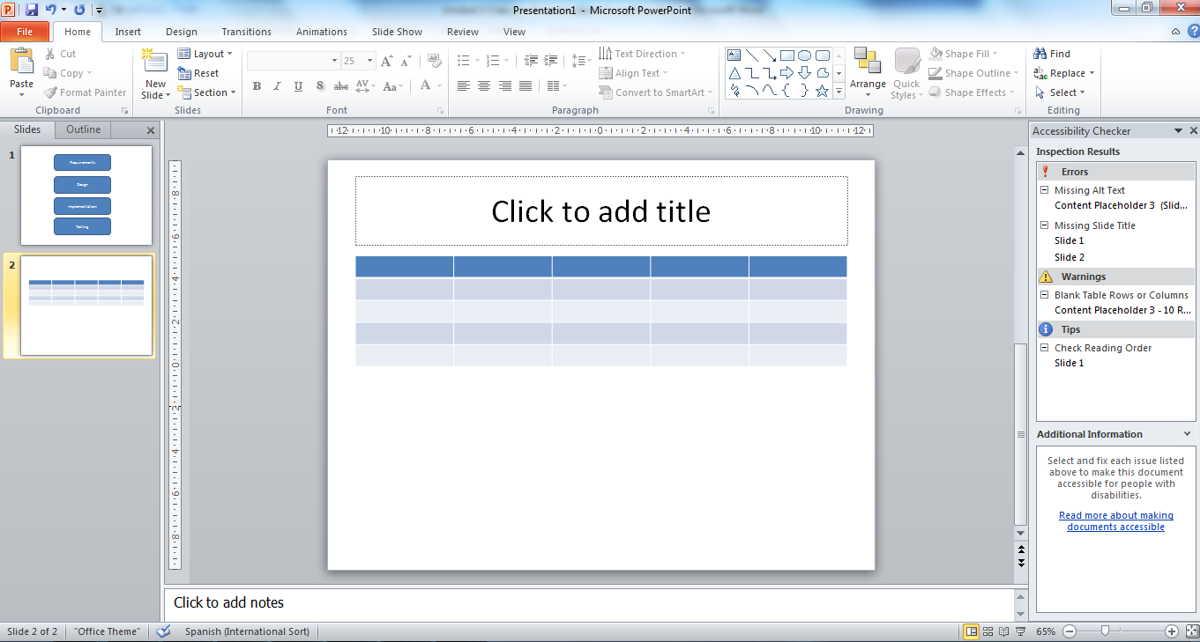
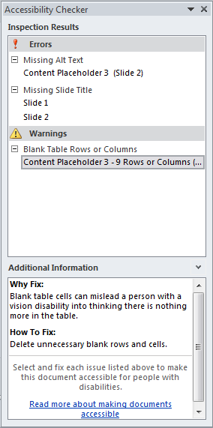
Figure 2-11. Results of an examination by the Accessibility Checker.
The Accessibility Checker flags three different issues, from most to least important: errors, warnings, and tips.
- Error: content that makes a file very difficult or impossible for people with disabilities to understand.
Rule name | Accessibility Checker checks that
All objects have alternate text | All objects use alternate text.  Alternate text doesn’t contain an image or file extension.
Tables specify column header information | The header box is selected for each table in a deck.
All slides have titles | Each slide in a deck has a title.
Table 2-1. Accessibility Checker, errors detection.
- Warning: content that in most, but not all, cases makes a file difficult for people with disabilities to understand.
Rule name | Accessibility Checker checks that
Hyperlink text is meaningful | Link text has a Screen Tip and matches the link target.
Table has simple structure | There are no issues that cause tables to be non-rectangular, such a split cells, merged cells or nested tables.
Tables don’t use blank cells for formatting | There are no entirely blank rows or columns in a table.
Table 2-2. Accessibility Checker, warnings detection.
- Tip: content that people with disabilities can understand, but that might be better organized or presented in a way that can improve their experience.
Rule name | Accessibility Checker checks that
Closed captions are included for inserted audio and video | All audio and video objects in the document have closed captioning.
The reading order of a slide should be logical | Slides appear to be in a logical order.
The slide titles in a deck should be unique | Each non-blank slide in a deck has a unique title.
Table 2-3. Accessibility Checker, tips.
In all cases, the accessibility checker explains how to solve the problem found (“How to fix”, within “Additional information” field). There are only two cases in which a problem is found but it does not exist or it has already been corrected:
- The case of subtitling an audio or video (type tip). The checker simply marks all audio and video objects for the user to verify that it meets accessibility, i.e., it has an alternative text, captions, descriptions, transcripts, etc.
- The case of reading order of elements in a slide (type tip). The user should be sure that, when used objects that are not part of the template of the slide, the reading order of the content of the slide makes sense. The check is very basic because the checker simply marks all slides containing objects of that type, without discerning whether the reading order is correct or not, since it only alerts the user to check it.

Checklist
This section summarizes the key concepts of the chapter. It tries to check the degree of accessibility of a PowerPoint presentation by means if a checklist.
- Structure the presentation: templates, slide's index, page numbers, using existing slides design.
- Do not include indispensable information in a pattern or in the footer.
- All slides have a title and it is unique (it may be invisible).
- Check the reading order of the elements in a slide, especially those included in the existing slides designs.
- Text size is at least 24 points and the font is legible, sufficient spacing, and high contrast between background and text.
- Apply the correct language to the document and its exceptions (paragraphs, sentences).
- Short sentences that do not occupy the whole screen and that are grammatically simple, ending in a point or a semicolon, or organized in numbered or bulleted lists.
- Graphs and diagrams have simple tags.
- Text in hyperlinks is meaningful.
- Figures and objects have alternative text: field “Description” is mandatory, field “Title” is optional. If a figure or an object is not meaningful, insert a blank space in “Description”.
- Tables do not have blank cells, blank columns or blank rows. If they are necessary then type “Empty” within.
- Tables have a simple structure, not nested or with combined or divided cells.
- Tables have meaningful headers and repeat the header row when moving to the next page.
- Audio and video files have captions.
- The recorded narration of the presentation is transcribed as notes or captions of the presentation.
- Do not use colors as the only mean to convey information (very important in graphs).
- Do not use color gradients or frames when any information is going to be inserted over them.
- Avoid using orange, red and green colors.
- Avoid using animations, blinking elements, animated images and automatic transitions.
- The action buttons are big and expressive enough (both figures and text).
- Make sure to preserve accessibility when changing between formats.

Keyboard shortcuts

Navigating the ribbon
To do this: | Press:
Select the active tab of the ribbon and activate the access keys. | “Alt” or “F10”. Press either of these keys again to move back to the document and cancel the access keys.
Move left or right to another tab of the ribbon, respectively. | “Alt” or “F10” to select the active tab, and then ““ or ““.
Hide or show the ribbon. | “Ctrl + F1”.
Display the shortcut menu for the selected command. | “Shift + F10”.
Move the focus to select each of the following areas of the window:  - Active tab of the ribbon.  - Any open task panes.  - Your document.  - Show the status bar at the bottom of the window. | “F6”.
Move the focus to each command on the ribbon, forward or backward respectively. | “Alt” or “F10” and then “Tab” or “Shift + Tab”
Move down, up, left, or right among the items on the ribbon, respectively. | “⬆”, “⬇”, “⬅” o “➔”.
Activate the selected command or control on the ribbon. | “Space bar” or “Enter”.
Open the selected menu or gallery on the ribbon. | “Space bar” or “Enter”.
Activate a command or control on the ribbon so you can modify a value. | “Enter”.
Finish modifying a value in a control on the ribbon, and move the focus back to the document. | “Enter”.
Get help on the selected command or control on the ribbon. (If no help topic is associated with the selected command, a general help topic about the program is shown instead.) | “F1”
Table 2-4. Keyboard shortcuts for navigating the ribbon.

Common tasks while running a presentation
To do this | Press*
Start a presentation from the beginning. | “F5”
Perform the next animation or advance to the next slide. | “N”, “Enter”, “Page down”, “➔”, “⬇”, or “Space bar”
Perform the previous animation or return to the previous slide. | “P”, “Page up”, “⬆”,”⬅”, or “Back space”.
Go to slide number. | “Number + Enter”.
Display a blank black slide, or return to the presentation from a blank black slide. | “B” or “.”.
Display a blank white slide, or return to the presentation from a blank white slide. | “W” or “,”.
Stop or restart an automatic presentation. | “S”.
End a presentation. | “Esc” or “-”.
Erase on-screen annotations. | “E”.
Go to the next slide, if the next slide is hidden. | “H”.
Set new timings while rehearsing. | “T”.
Use original timings while rehearsing. | “O”.
Use mouse-click to advance while rehearsing. | “M”.
Re-record slide narration and timing. | “R”.
Return to the first slide. | Press and hold right and left mouse buttons for 2 seconds
Change the pointer to a pen. | “Ctrl + P”.
Change the pointer to an arrow. | “Ctrl + A”.
Change the pointer to an eraser. | “Ctrl + E”.
Show or hide ink markup. | “Ctrl + M”.
Hide the pointer and navigation button immediately. | “Ctrl + H”.
View the All Slides dialog box. | “Ctrl + S”.
View the computer task bar. | “Ctrl + T”.
Display the shortcut menu. | “Shift + F10”.
Go to the first or next hyperlink on a slide. | “Tab”.
Go to the last or previous hyperlink on a slide. | “Shift + Tab”.
Perform the “mouse click” behavior of the selected hyperlink. | “Enter” while a hyperlink is selected.
Table 2-5. Keyboard shortcuts for common task while running a presentation.

Media during presentation
To do this | Press*
Stop media playback. | “Alt + Q”.
Toggle between play and pause. | “Alt + P”.
Go to the next bookmark. | “Alt + End”.
Go to the previous bookmark. | “Alt + Home”.
Increase the sound volume. | “Alt + ⬆”.
Decrease the sound volume. | “Alt + ⬇”.
Seek forward. | “Alt + Shift + Page down”.
Seek backward. | “Alt + Shift + Page up”.
Mute the sound. | “Alt + U”.
Table 2-6. Keyboard shortcuts for media during presentation.

Working with shapes, text boxes, and WordArt
To do this | Press*
Select an object (with text selected inside the object). | “Esc”.
Select an object (with an object selected). | “Tab” or “Shift + Tab” until the object you want is selected.
Select text within an object (with an object selected). | “Enter”.
Select all objects. | “Ctrl + A” (on the “Slides” tab).
Select an object that is under other objects and cycle forward through the stack of objects. | “Tab” after you select the top object.
Select an object that is under other objects and cycle backward through the stack of objects. | “Shift + Tab” after you select the top object.
Open the Selection pane. | “Alt”, “H”, “SL”, and then “P”.
Cut selected object. | “Ctrl + X”.
Copy selected object. | “Ctrl + C”.
Paste cut or copied object. | “Ctrl + V”.
Copy formatting only. | “Ctrl + Shift + C”.
Paste formatting only. | “Ctrl + Shift + V”.
Paste special. | “Ctrl + Alt + V”.
Group shapes, pictures, or WordArt. | “Ctrl + G” after you select the items that you want to group.
Ungroup shapes, pictures, or WordArt. | “Ctrl + Shift + G” after you select the group that you want to ungroup.
Show or hide the grid. | “Shift + F9”.
Show or hide guides. | “Alt + F9”.
Undo the last action. | “Ctrl + Z”.
Redo the last action. | “Ctrl + Y”.
Table 2-7. Keyboard shortcuts for working with shapes, text boxes, and WordArt.

Working with SmartArt graphics
To do this | Press*
Select the next element in a SmartArt graphic. | “Tab”.
Select the previous element in a SmartArt graphic. | “Shift + Tab”.
Select all shapes. | “Ctrl + A”.
Remove focus from the selected shape. | “Esc”.
Nudge the selected shape up. | “⬆”.
Nudge the selected shape down. | “⬇”.
Nudge the selected shape left. | “⬅”.
Nudge the selected shape right. | “➔”.
Edit text in the selected shape. | “Enter” or “F2”.
Delete the selected shape. | “Delete” or “Backspace”.
Cut the selected shape. | “Ctrl + X” or “Shift + Delete”.
Copy the selected shape. | “Ctrl + C”.
Paste the contents of the Clipboard. | “Ctrl + V”.
Undo the last action. | “Ctrl + Z”.
Enlarge the selected shape horizontally. | “Shift + ➔”.
Reduce the selected shape horizontally. | “Shift + ⬅”.
Enlarge the selected shape vertically. | “Shift + ⬆”.
Reduce the selected shape vertically. | “Shift + ⬇”.
Rotate the selected shape to the right. | “Alt + ➔”.
Rotate the selected shape to the left. | “Alt + ⬅”.
Move one character to the left. | “⬅” .
Move one character to the right. | “➔”.
Move up one line. | “⬆”.
Move down one line. | “⬇”.
Move one word to the left. | “Ctrl + ⬅”.
Move one word to the right. | “Ctrl + ➔”.
Move one paragraph up. | “Ctrl + ⬆”.
Move one paragraph down. | “Ctrl + ⬇”.
Move to the end of a line. | “End”.
Move to the beginning of a line. | “Home”.
Move to the end of a text box. | “Ctrl + End”.
Move to the beginning of a text box. | “Ctrl + Home”.
Cut selected text. | “Ctrl + X”.
Copy selected text. | “Ctrl + C”.
Paste selected text. | “Ctrl + V”.
Undo the last action. | “Ctrl + Z”.
Delete one character to the left. | “Backspace”.
Delete one word to the left. | “Ctrl + Backspace”.
Delete one character to the right. | “Delete”.
Delete one word to the right. | “Ctrl + Delete”.
Promote the selected text. | “Alt + Shift + ⬅”.
Demote the selected text. | “Alt + Shift + ➔”.
Check the spelling. | “F7”.
Table 2-8. Keyboard shortcuts for working with SmartArt graphics.

Working with the caption editor of add-in STAMP
To do this | Press*
Move back 2 seconds of playback. | “F2”.
Set start time of the current caption. | “F3”.
Set end time of the current caption. | “F4”.
Set focus to caption text for editing. | “F5”.
Insert new caption at the bottom of grid, and set start time. | “F6” o “Insert”.
Delete current caption. | “Delete”.
Start or pause the playback. | “Ctrl + P”.
Slows the playback speed. | “Ctrl + Shift + S”.
Resumes normal playback speed. | “Ctrl + Shift + N”.
Increases the playback speed. | “Ctrl + Shift +G”.
Table 2-9. Keyboard shortcuts for working with the caption editor of add-in STAMP.

Creating accessible PDF documents

Translators:
Eva García López
Antonio García Cabot
University of Alcalá, Spain
Authors:
María Patricia Valencia Chaverra
Universidad Católica del Norte, Colombia
Janneth Chicaiza Espinosa
Universidad Técnica Particular de Loja, Ecuador

This chapter is aimed to readers who have prior knowledge on computer science and technology. Knowledge acquired will contribute to the professional education of the learner through the use of technological tools that will provide accessibility in online contents.
More specifically, it will be learn how to create accessible PDF files from documents or presentations, and to evaluate and improve accessibility of the generated documents. An accessible PDF ensures accessibility from different devices and offers support to people with disabilities, especially with visual disabilities.
Finally, the chapter explains how to create an accessible PDF from Word documents and PowerPoint presentations.

Accessibility in PDF documents. Basics
Many digital resources are available on the web in Portable Document Format (PDF). Several institutions and educational content providers have published on the web many educational resources, so it is important that they are accessible in order to users are able to use them from any device and with any type of disabilities they may have.
A PDF document should meet different conditions for ensuring that it can be read by users with disabilities. However, because it is mainly a textual resource, the main aspects of accessibility attended in PDF documents target people with no vision. Nevertheless, there are more types of disabilities, such as auditory, motor, cognitive and different kind of visual disabilities, which should also be taken into account when creating an accessible PDF document (Centro de Referencia en Accesibilidad y Estándares Web, 2009).
In this section, the basics necessary to create an accessible PDF document are presented.

What is an accessible PDF and how do people with disabilities access to the content of a PDF?
Company Adobe created Acrobat, which works with documents in PDF format. These documents may include mostly text, but also tables and figures.
PDF is one of the most widely used formats on the Internet for document exchange. The software necessary to access to a PDF is called PDF file viewer, and one of the most used is Adobe Acrobat. A free trial of version Adobe Acrobat Reader XI Pro can be downloaded from the official website.
Other applications that allow to open PDF files and that do not require to be paid for being used are:
- Foxit Reader.
- Sumatra PDF.
According to their source, PDF documents can be of two types (Centro de Referencia en Accesibilidad y Estándares Web, 2009):
- PDF image. It is generally a scanned document, and an Optical Character Recognition (OCR) is needed to convert images into text.
- A document generated from a file text. This type of PDF can be processed to support various accessibility characteristics.
This chapter teaches how to generate PDFs of the second type, i.e., text generated by a computer.
In August 2012, standard ISO 14289-1 (International Organization for Standardization, 2012) was published, which defines a new PDF/Universal Accessibility (PDF/UA) file format, which is accessible for people with disabilities. This is a milestone in the evolution of PDF format (Carreras, 2011), and means that Acrobat will soon offer support for creating PDF files in PDF/UA format.
About this new format, Carreras (2011) says that PDF/UA is not a specification to evaluate accessibility of a PDF content or a guide to create accessible PDF, but it is aimed at developers of PDF viewers and developers of tools for creating PDF, as well as at providers of support products.

Characteristics of an accessible PDF
The characteristics that an accessible PDF should meet are (Centro de Referencia en Accesibilidad y Estándares Web, 2009):
- The document is correctly structured. The four elements that define a document with a correct structure are shown in Figure 3-1 (Sama Rojo & Sevillano Asensio, 2012-a).
Figure 3-2 shows the structure of a PDF document, which includes bookmarks. This way, having marked or tagged the sections, tables and figures of the document, a screen reader will be able to navigate and locate in an easier way the information of the document, if and when explicit indications have been given about the reading order of the text.
Figure 3-1. Elements that define a PDF document properly structured.
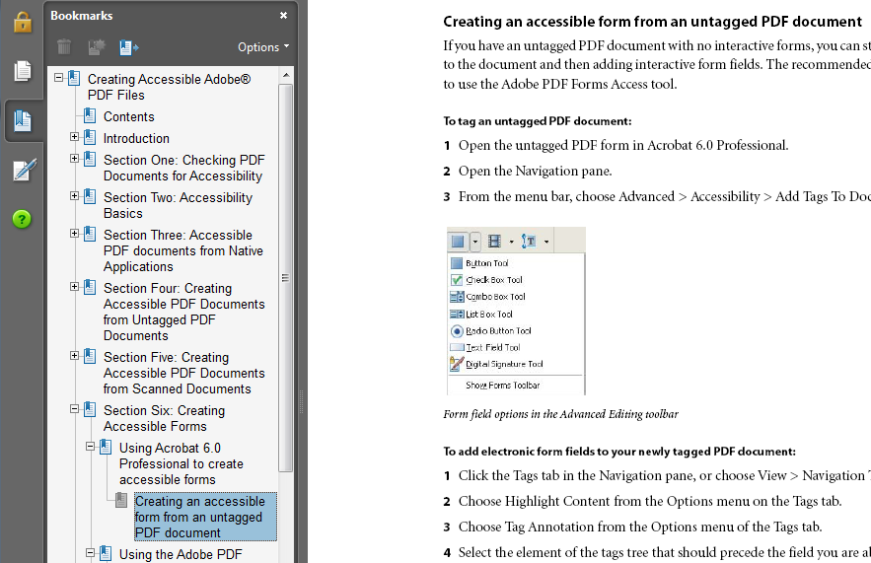
Figure 3-2. Structure of a PDF with bookmarks.
- Alternative text in figures. An accessible PDF document has a descriptive text in each figure so that screen readers are able to read the text that describes the figure.
- Language of document. An accessible PDF specifies the language of document explicitly so that the reader is able to detect it and perform reading better.
- Accessible security. An accessible PDF document should have proper security settings so that it does not interfere on screen readers' work.
- Links. Internal and external links of a PDF document should be well defined, i.e., inserted as hyperlinks in the source document.
- Navigation. An accessible PDF document should support navigation and organization such as a table of contents, bookmarkers or headers so that the user is able to navigate the document easily without having to read the content until he/she finds what is looking for (Centro de Referencia en Accesibilidad y Estándares Web, 2009).
Moreover, if a document is designed for collecting data from people, forms are created using aggregation fields such as text fields, option groups and checkboxes, among others. Figure 3-3 shows an example form designed to collect data of projects from a group of students.
If a document has a data form, the PDF file should meet at least two characteristics to have a proper structure:
- Tabulation order. It is the order in which the fields in the form will be navigated while being filled or examined using the keyboard.
- Field identification. Each data field should be clearly identified and include the corresponding accessibility properties for each of the objects.
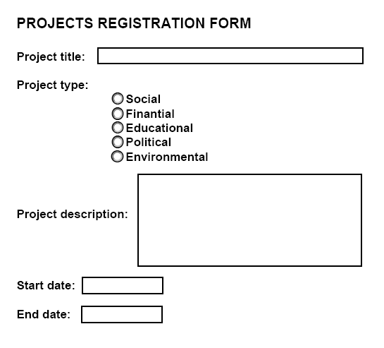
Figure 3-3. Form example.

Accessibility standard WCAG 2.0. Principles applicable to PDF documents
WCAG 2.0 (World Wide Web Consortium, 2008) proposes a set of recommendations to create more accessible web content. When they are followed, a more accessible content is guaranteed for a greater number of people with disabilities, including blindness and low vision, deafness and hearing impaired, mobility limitations and combinations of the above.
Four principles are proposed by WCAG 2.0:
- Perceivable: Information and user interface components must be presentable to users in ways they can perceive. That is, the content should be perceived by one or more senses of anyone, even though he/she is blind or has a low vision.
- Operable: User interface components and navigation must be operable, i.e., a user should be able to perform the action required to interact with it. This interaction can be achieved in PDF files by means of forms.
- Understandable: Information and the operation of user interface must be understandable, both information and interaction.
- Robust: Content must be robust enough that it can be interpreted reliably by a wide variety of user agents, including assistive technologies.

Statement of WCAG 2.0 guidelines
For each of the above principles, WCAG 2.0 establishes a set of guidelines, which should be met by an accessible PDF and are the following:
- Guideline 1.1. Text alternatives: Provide text alternatives for any non-text content so that it can be changed into other forms people need, such as large print, braille, speech, symbols or simpler language.
- Guideline 1.2. Time-based media: Provide alternatives for time-based media, which includes audio, video, audio and video, and audio and/or video combined with interaction resources.
- Guideline 1.3. Adaptable: Create content that can be presented in different ways (for example simpler layout) without losing information or structure.
- Guideline 1.4. Distinguishable: Make it easier for users to see and hear content including separating foreground from background.
- Guideline 2.1. Keyboard accessible: Make all functionality available from a keyboard.
- Guideline 2.2. Enough time: Provide users enough time to read and use content.
- Guideline 2.3. Seizures: Do not design content in a way that is known to cause seizures.
- Guideline 2.4. Navigable: Provide ways to help users navigate, find content, and determine where they are.
- Guideline 3.1. Readable: Make text content readable and understandable.
- Guideline 3.2. Predictable: Make Web pages appear and operate in predictable ways.
- Guideline 3.3. Input assistance: Help users avoid and correct mistakes.
- Guideline 4.1. Compatible: Maximize compatibility with current and future user agents, including assistive technologies.
Each guideline is directly related to one or more types of disability (Table 3-1). If these guidelines are not met when creating a PDF, some special groups will not be able to access to it.
Guideline | Description | Blindness | Low vision | Hearing | Motor
1.3. | Automatic speech synthesizer. | Yes | Yes | Empty | Empty
1.3. | Alternative presentation of images, tables and graphs. | Empty | Empty | Yes | Yes
1.4. | Contrast. | Empty | Yes | Empty | Empty
1.4. | Larger texts. | Empty | Yes | Empty | Empty
1.4. | Alternative text. | Yes | Empty | Empty | Empty
2.1. | Move from the bookmarkers window to the document window using the keyboard. | Yes | Yes | Empty | Empty
2.1. | Mechanisms to jump, go forward, go backward and navigate. | Empty | Empty | Yes | Yes
2.4. | Create two versions of a document | Yes | Yes | Yes | Yes
3.1. | Set the language of each document | Yes | Yes | Yes | Yes
4.1. | Compatibility between content and current technologies | Yes | Yes | Yes | Yes
Table 3-1. Accessibility guidelines and types of disability.

Summary tables of accessibility requirements by type and level of adaptation
WCAG 2.0 proposes three levels of adaptation to accessibility (conformance levels):
- Level A: For level A conformance (the minimum level of conformance), the PDF document satisfies all the level A success criteria, or a conforming alternate version is provided.
- Level AA: For Level AA conformance, the document satisfies all the level A and level AA success criteria, or a level AA conforming alternate version is provided.
- Level AAA: For level AAA conformance, the web page satisfies all the level A, level AA and level AAA success criteria, or a level AAA conforming alternate version is provided.
Table 3-2 shows the principles, guidelines and success criteria that a PDF document should meet to be technically accessible. In Carreras (2011), a table can be observed, which also includes a reference to the PDF technique that allows achieving all the success criteria.
Principle | Guideline | success criteria | Level
1. Perceivable | 1.1 Text alternatives | 1.1.1 Non-text content | A
1. Perceivable | 1.2 Time-based media | 1.2.1 Audio-only and video-only (prerecorded) | A
1. Perceivable | 1.2 Time-based media | 1.2.2 Captions (prerecorded) | A
1. Perceivable | 1.2 Time-based media | 1.2.3 Audio description or media alternative (prerecorded) | A
1. Perceivable | 1.3 Adaptable | 1.3.1 Info and relationships | A
1. Perceivable | 1.3 Adaptable | 1.3.2 Meaningful sequence | A
1. Perceivable | 1.3 Adaptable | 1.3.3 Sensory characteristics | A
1. Perceivable | 1.4 Distinguishable | 1.4.1 Use of color | A
1. Perceivable | 1.4 Distinguishable | 1.4.2 Audio control | A
2. Operable | 2.1 Keyboard accessible | 2.1.1 Keyboard | A
2. Operable | 2.1 Keyboard accessible | 2.1.2 No keyboard trap | A
2. Operable | 2.2 Enough time | 2.2.1 Timing adjustable | A
2. Operable | 2.2 Enough time | 2.2.2 Pause, stop, hide | A
2. Operable | 2.3 Seizures | 2.3.1 Three flashes or below threshold | A
2. Operable | 2.4 Navigable | 2.4.1 Bypass blocks | A
2. Operable | 2.4 Navigable | 2.4.2 Page titled | A
2. Operable | 2.4 Navigable | 2.4.3 Focus order | A
2. Operable | 2.4 Navigable | 2.4.4 Link purpose (in context) | A
3. Understandable | 3.1 Legible | 3.1.1 Language of page | A
3. Understandable | 3.2 Predictable | 3.2.1 On focus | A
3. Understandable | 3.2 Predictable | 3.2.2 On input | A
3. Understandable | 3.3 Input assistance | 3.3.1 Error identification | A
3. Understandable | 3.3 Input assistance | 3.3.2 Labels or instructions | A
4. Robust | 4.1 Compatible | 4.1.1 Parsing | A
4. Robust | 4.1 Compatible | 4.1.2 Name, role, value | A
1. Perceivable | 1.2 Time-based media | 1.2.4 Captions (live) | AA
1. Perceivable | 1.2 Time-based media | 1.2.5 Audio description (prerecorded) | AA
1. Perceivable | 1.4 Distinguishable | 1.4.3 Contrast (minimum) | AA
1. Perceivable | 1.4 Distinguishable | 1.4.4 Resize text | AA
1. Perceivable | 1.4 Distinguishable | 1.4.5 Images of text | AA
2. Operable | 2.4 Navigable | 2.4.5 Multiple ways | AA
2. Operable | 2.4 Navigable | 2.4.6 Headings and labels | AA
2. Operable | 2.4 Navigable | 2.4.7 Focus visible | AA
3. Understandable | 3.1 Legible | 3.1.2 Language of parts | AA
3. Understandable | 3.2 Predictable | 3.2.3 Consistent navigation | AA
3. Understandable | 3.2 Predictable | 3.2.4 Consistent identification | AA
3. Understandable | 3.3 Input assistance | 3.3.3 Error suggestion | AA
3. Understandable | 3.3 Input assistance | 3.3.4 Error prevention (legal, financial, data) | AA
1. Perceivable | 1.4 Distinguishable | 1.4.9 Images of text (no exception) | AAA
2. Operable | 2.1 Keyboard accessible | 2.1.3 Keyboard (no exception) | AAA
2. Operable | 2.4 Navigable | 2.4.8 Location | AAA
2. Operable | 2.4 Navigable | 2.4.9 Link purpose (link only) | AAA
3. Understandable | 3.1 Legible | 3.1.4 Abbreviations | AAA
Table 3-2. Success criteria by conformance level.

Tools for analysis and correction
Once the PDF document has been created, the user should analyze it using checking accessibility tools and then optimize its accessibility characteristics. In this section, some of those tools are mentioned.
Tool | Description
Check a PDF. | Online tool for checking accessibility created by the Norwegian Government. It allows checking accessibility of PDF documents (as well as web pages). Users can choose between using the web address (URI) of the PDF file or uploading a document.
PDF Reader. | Free checking tool, which can be free downloaded and installed in Microsoft Windows 2000, XP or Vista.
PDF Accessibility Checker (PAC).  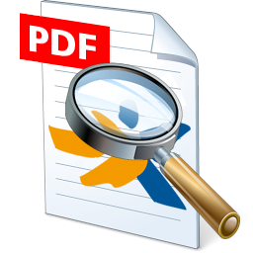 | Free checking tool, which can be free downloaded and installed in Microsoft Windows XP, Vista or Windows 7. It is also possible to run it in Mac after some adjustments.
Adobe Acrobat.   | Commercial package that allows users to view, create and modify PDF files. The Pro version can be free downloaded from web.
Table 3-3. Tools for accessibility checking.
Table 3-3 shows four tools that can be used to check the accessibility of a PDF document. The automatic check performed with tools such as those mentioned in Table 3-3 includes checking the technical characteristics of the document, but not all accessibility criteria. Below are described two of the most popular checking tools.

Checking using Adobe Acrobat
Adobe Acrobat Professional provides a set of tools and functionalities to help creating accessible PDF documents. The functionalities provided are (types (Centro de Referencia en Accesibilidad y Estándares Web, 2009):
- Checking accessibility issues using tool Accessibility checker.
- Correct issues in PDF documents tagged using tab Tags palette.
- Check the document by a screen reader included in some versions of Adobe Acrobat.
- Create accessible PDF forms using tab Tags palette. Tagged PDF forms allow screen readers to recognize the fields, read the textual descriptions associated to each field and identify the reading order of them.
- Function read out loud allows seeing how the document will be presented to readers when using this tool for converting text to speech.
Two types of accessibility checking are provided by Adobe Acrobat Professional, quick and full:
- Quick: checks for document structure tags, searchable text, and appropriate security settings for accessibility.
- Full: in addition to the standard option, it validates some of the accessibility guidelines in WCAG 2.0 and other standards.
Table 3-4 shows a summary of the characteristics analyzed during each type of check.
Characteristic examined | Quick check | Full check
Logical structure of the tagged PDF document | X
Reading order |  | X
Alternate text for images and other visuals |  | X
Specification of the document language |  | X
Reliable character encoding |  | X
Descriptions for all form fields |  | X
Structure of tables and lists |  | X
Security settings appropriate for accessibility | X | X
Table 3-4. Accessibility checking provided by Acrobat.
More checking options of this tool can be found in Acrobat help website, as well as the results and effects that may be obtained after correcting errors.

Checking using PDF Accessibility Checker
Tool PDF Accessibility Checker (PAC) conducts the following tests within PDF documents:
- Test 1: Document is marked as tagged.
- Test 2: Document title available.
- Test 3: Document language defined.
- Test 4: Accessible security settings.
- Test 5: Tab follows tag-structure, i.e., it checks whether all pages in the PDF document are configured such that when Tab key is used, the jumps performed follow the structure of tags.
- Test 6: Consistent heading structure.
- Test 7: Bookmarks available.
- Test 8: Accessible font encodings.
- Test 9: Content completely tagged.
- Test 10: Logical reading order.
- Test 11: Alternative text available for non-text content.
- Test 12: Correct syntax of tags.
- Test 13: Sufficient contrast for text.
- Test 14: Spaces existent.

Creating accessible PDF documents

Requirements previous to design, layout and content of the source document
Chapter 1 and Chapter 2 should be inspected in order to detect certain problems that can affect the accessibility of the PDF file you are trying to create.

Creating PDF files from existing documents
How to create an accessible PDF depends on the source of the document. If the document is written with a word processor, it can be converted into a PDF document using the Adobe Acrobat virtual printer.
The accessibility of the PDF document will depend directly on the accessibility of the source document, because the more correct is the source document, the more accessible will be the final PDF and fewer revisions or modifications should be made. It is always advisable to check the accessibility of the document. Therefore, before applying the following steps, it is important that the source document has been analyzed for checking the aforementioned accessibility characteristics.
The procedures detailed below to create and modify PDF documents have been designed for Adobe Acrobat Professional. Although they could also work for later versions, small changes might be required for previous versions of Adobe Acrobat.
Also, the processors in which the text documents are created can be many, such as Open Office Writer and Microsoft Office Word, each with its different versions. In this section, procedures to create PDF documents from these two tools are presented. There exists bibliography with procedures for other options (Carreras, 2009; Centro de Referencia en Accesibilidad y Estándares Web, 2009).

Creating PDF files from Open Office Writer documents
To create a PDF document from the word processor OpenOffice.org (Open Office Writer), the following steps are required:
- Step 1. In menu “File”, select the option to “Export as PDF” format.
- Step 2. In the dialog that opened, the export options are showed. Be sure that the following options are selected in tab “General Tagged PDF and Export bookmarks” (Figure 3-4).
- Step 3. In the window that appears, choose the location where the PDF file will be saved, put a name for the file and finally click “Save” button.
Exporting as PDF is similar in the rest of Open Office programs.

Creating PDF files from Microsoft Word 2003/2007/2010 documents
In Microsoft Office Word 2007 or Microsoft Office Word 2010 there are two ways to create a PDF file from a Word document previously created (Sama Rojo & Sevillano Asensio, 2012-a):
- Using the Word functionality.
- Using the PDFMaker functionality of Adobe Acrobat Professional.
In both cases it is necessary to configure some accessibility options. The configuration procedures and the creation of PDF files using the aforementioned techniques are showed below.
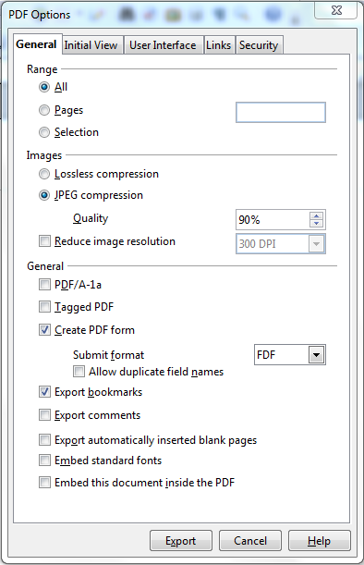
Figure 3-4. Options to export as PDF in Open Office.

Using the Word functionality
To generate a PDF document from Microsoft Office Word 2007 or 2010 without using PDFMaker, perform the following steps:
- Step 1. In Word 2007, from the main window of the tool, go to menu “File Save as PDF or XPS”.
In Word 2010, from the main window of the tool, go to menu “File Save & Send Create PDF/XPS Document Create PDF/XPS”.
- Step 2. A dialog will open (Figure 3-5) to save the document. Then click “Options” button and be sure that checkbox “Document structure tags for accessibility” is selected and click button “OK”.
- Step 3. Select the location of the file, put a name to the PDF document and click “Publish” button.
Now the PDF file can be opened by a PDF viewer.
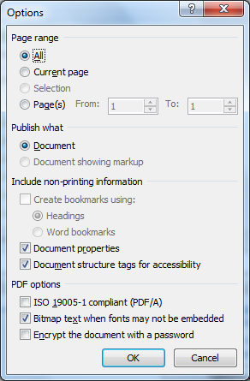
Figure 3-5. Accessibility options in Word for saving as PDF.

Using the PDFMaker functionality of Adobe Acrobat Professional
PDFMaker is installed in the Windows Office applications when Adobe Acrobat is installed. PDFMaker allows converting documents of these applications into tagged PDF documents in which links, styles, bookmarks and the logical structure of the source document are kept. Below are described three activities included in the PDFMaker configuration previous to the creation of PDF documents from Word.
The first three procedures explained should be performed the first time that a PDF file is going to be created from Office Word in the computer. The following times only the last procedure “Creating a PDF file from a Word document” is needed.

PDFMaker configuration from Adobe Acrobat
To configure this component from Adobe Acrobat, do the following:
- Step 1. From Adobe Acrobat Professional tool, select menu “Edit” and then option “Preferences…”.
- Step 2. A menu will open, in which you have to click “Convert to PDF”.
- Step 3. A list with source formats will be showed. Select “Microsoft Office Word” and click “Edit settings…”.
- Step 4. In the dialog “Adobe PDF settings for supported documents”, be sure that option “Enable accessibility and reflow” (Figure 3-6). Finally, click “OK”.

Activation of PDFMaker button bar
In Microsoft Office 2003 and earlier versions, the options to create PDF documents are in the Adobe PDF menu; and in later versions (such as 2007 or 2010), the Acrobat ribbon provides the respective functionalities. When Adobe Acrobat is installed in a computer, the options to generate PDFs are added (Figure 3-7).
However, if the buttons of the PDF toolbar do not appear in Microsoft Word after Adobe Acrobat is installed, the following steps should be followed to activate them. Otherwise, i.e., if these buttons are already available from Word, proceed to the next paragraph (Setting preferences for Adobe PDFMaker in Microsoft Word).
In Microsoft Office Word 2003 or earlier versions:
- Step 1. Go to menu “View” and click “Toolbar”.
- Step 2. Select option “Acrobat PDFMaker”.
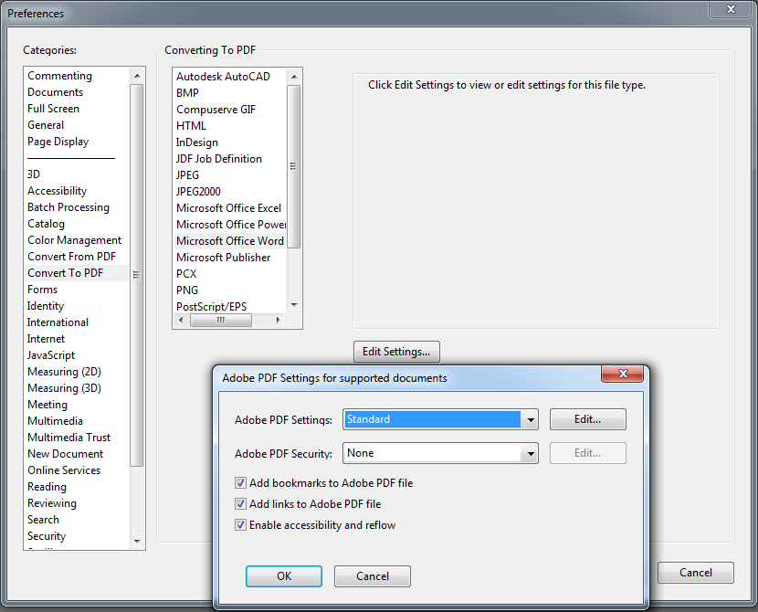
Figure 3-6. Options of converting Word documents in Adobe Acrobat Professional.
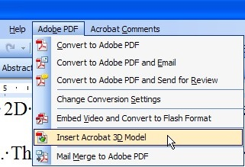
Figure 3-7. PDFMaker in Microsoft Word 2003.
In Microsoft Office Word 2007 or later:
- Step 1. In Word 2007, click “Office” and then “Word Options”. In Office 2010, click tab “File” and then click “Option”.
- Step 2. Click “Adds-In”, on the left side of the dialog box.
- Step 3. Do one of the following:
- If “Add-In Acrobat PDFMaker Office COM” does not appear, choose “COM Adds-In” in pop-up menu “Manage” and click “Find”.
- If “Office COM Add-In” of Acrobat PDFMaker appears in “Disable adds-in application”, choose “Disable elements” in pop-up menu “Manage” and click “Go”.
- Step 4: Select “Office COM Add-In” of Acrobat PDFMaker and click “Accept”.
- Step 5: Close the Word application and start it again.

Setting preferences for Adobe PDFMaker in Microsoft Word
The following steps are necessary to assign the adequate parameters to PDFMaker and create accessible PDFs.
- Step 1. Choose one of the following options, depending on the Word version:
- In Microsoft Word 2003 or earlier, go to menu “Adobe PDF” and select “Change conversion settings”.
- In Microsoft Word 2007 or 2010, go to ribbon “Acrobat” and click “Preferences”.
- Step 2. In window “Acrobat PDFMaker” that appears after the first step, check the following parameters (the names of the options may vary slightly between different Office versions):
- In tab “Settings”, the following boxes must be selected: “Add bookmarks to the Adobe PDF file”, “Add links to the Adobe PDF file” and “Enable accessibility and reflux with Adobe PDF file”.
- In tab “Security”, box “Enable text access to screen readers for users with visual disabilities” must be selected.
- In tab “Word”, select boxes “Convert cross references and tables of content in hyperlinks”, “Convert links of footnotes and endnotes” and “Enable advanced tagging”.
- In tab “Bookmarks”, select box “Convert Word titles in bookmarks” and choose the styles you want to convert into bookmarks in the PDF document.

Creating a PDF file from a Word document
Perform the following steps to create a PDF file from a Word document.
- Step 1. Open the file from Microsoft Word.
- Step 2. Do one of the following, depending on the Word version with which the document has been created:
- In Word 2003 or earlier, click “Convert to Adobe PDF” in menu “Adobe PDF”.
- In Microsoft Office 2007 or 2010, click “Create PDF” in “Acrobat” ribbon.
- Step 3. In the dialog box, select “Save Adobe PDF file as” and put a name for the new PDF file, choose the location where it will be saved and finally click “Save”.

Creating PDF files from existing accessible presentations
In this section, the process to be followed for creating a PDF file from an accessible PowerPoint presentation is explained. The easiest method is explained below, however, one of the two methods presented in the previous section can also be followed. The steps are very similar to those already described for Microsoft Word.
- Step 1. Choose one of the following options, depending on the Office PowerPoint version in which the presentation was created.
- In PowerPoint 2007, click “Microsoft Office” button and select “Save as”.
- In PowerPoint 2010, click menu “File” and select “Save as”. In PowerPoint 2013, before accessing menu “Save as”, firstly select the location of the file.
- Step 2. In the dialog box that appears, enter a name for the PDF file. In menu “Type” select “PDF” and select the location where the file will be saved. To finish, click “Save” button.

Evaluating accessibility of a PDF document
In this section, the steps necessary to evaluate the accessibility of a PDF document using Adobe Acrobat Pro and PDF Accessibility Checker tools are explained.
Sama Rojo & Sevillano Asensio (2012-a) recommend to work with the aforementioned tools, according to the flow showed in Figure 3-8. This process is necessary because the authors discovered that PDF Accessibility Checker detects accessibility issues in documents that Acrobat detected as valid.
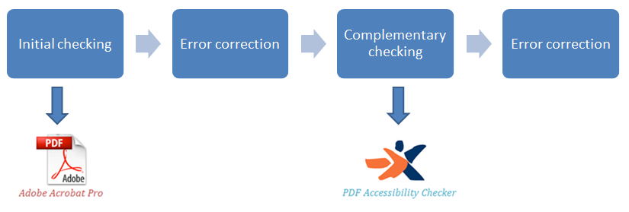
Figure 3-8. Accessibility evaluation process of a PDF document.
It is important to note that the checking process should be cyclical, i.e., after checking by using one of the tools, the issues reported have to be corrected and then analyze again the document until no issues are detected.
In the following sections, the steps for each type of checking indicated in Figure 3-8 are described. The “Correcting errors” component is explained in section 3.6.

Initial checking

Adobe Acrobat Professional X
As mentioned in section 3.1.4.1, Adobe provides two types of accessibility checking: quick and full. In this case, full checking is used. To access to it from this tool, go to “Tools Accessibility Quick Check or Full Check”.
If full check is selected, a pop-up window will appear (Figure 3-9), in which the user can choose between different options of reports and comments. In the case of Quick check, a simple and quick check is executed.
In the advanced check settings window (Figure 3-9), the following options can be selected:
- In section “Report and comment options”, choose the directory where the accessibility report will be saved. By default, it is saved in “My documents” folder.
- In “Page range”, a page range can be selected, which is convenient when the document is very large and different checkings for each section of the document may be performed.
- In section “Checking options” the following can be selected:
- The accessibility standard (Adobe PDF, Section 508 (U.S.) or World Wide Web Consortium (W3C)) in “Name”, by default, “Adobe PDF” will appear.
- The accessibility options that should be checked. For a full check, selecting all options is recommended.
To proceed with the analysis, click button “Start checking”.
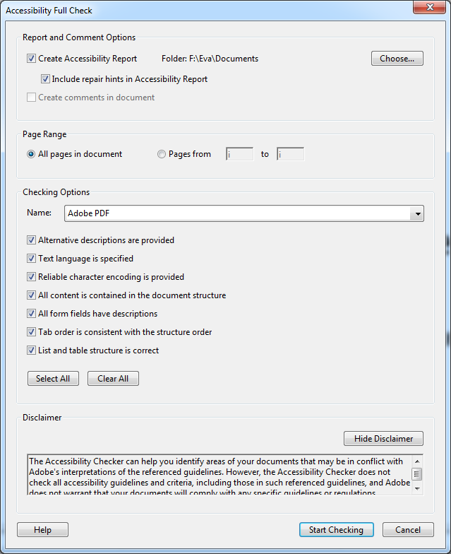
Figure 3-9. Advanced check settings window of Adobe Acrobat.
Once the analysis process has finished the results will appear, including links and useful tips for performing corrections. Furthermore, you can go to the directory selected for viewing the results of the accessibility report.
In Figure 3-10, “Accessibility checker” pane is showed, which is displayed after a full checking.
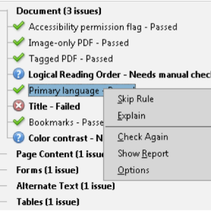
Figure 3-10. Accessibility checker pane.
An icon which indicated the state is located beside each analyzed characteristic. The elements that did not pass the checking appear as errors and they must be corrected by the user. Below are listed all the possible states:
-  Passed: The element is accessible.
- Skipped by the user: the rule was not checked because it was not selected in the dialog box “Accessibility checker settings”.
- Needs manual check: the full checking function could not check the element automatically. Check the element manually.
- Failed: the element did not pass the accessibility checking.
From this point, the accessibility issues detected can be corrected (see section 3.6). Once all errors are corrected, the second analysis can be performed with the other suggested tool (PDF Accessibility Checker).

Complementary checking
The tool used for the complementary checking is PDF Accessibility Checker (PAC).
PAC is a tool recommended by the consortium that regulates web technologies (W3C) and, as aforementioned in section 3.1.4.2, it allows checking fourteen criteria that an accessible PDF should meet.
In the PDF Accessibility Checker official website, information about its installation and use can be found. In this section only the essentials are explained, in order to it can be used when analyzing a PDF document.
PAC needs the following software previously installed in the computer:
- Operating system: Windows XP, Windows Vista or Windows 7.
- RDF Viewer: Adobe® Reader version 8 or later.
- Web browser: Mozilla Firefox 3 or later, Internet Explorer 8 or later, or Google Chrome.
- Microsoft .NET Framework 2.0 SP2 or later.
Using PAC is quite simple. To perform the technical analysis of a PDF file, run the tool and do the following (Figure 3-11):
- Step 1. Download the PDF document to be analyzed. By clicking button “Browse”, the location where the file is saved can be selected.
- Step 2. To start checking, click “Start”.
- Step 3. Review the summary of the results of the analysis. The elements marked with a red cross are those that could not be validated.
- Step 4. If the report has errors, you can click button “Report” to view the details and determine the elements that can be improved or corrected.
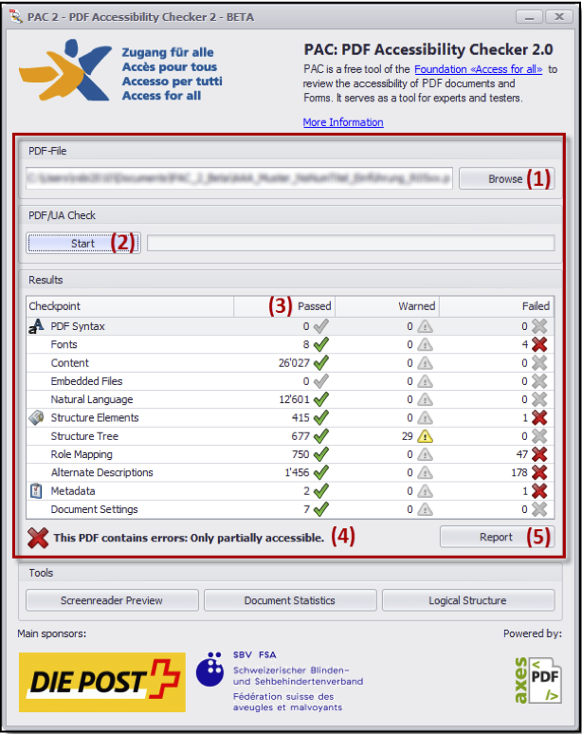
Figure 3-11. Results of a checking performed by PAC.

Initial technical checking for detecting issues that require modifying the original document
In addition to the checking recommended to be performed for the source document, creating a first version of the PDF document is suggested, with the aim of performing an initial technical checking using Adobe Acrobat tool.
Checking accessibility helps detecting errors in some elements of the document, which should be corrected in the application in which the source document was created (i.e., OpenOffice or Microsoft Office) because they cannot be corrected directly in the PDF document or correcting it manually from Adobe Acrobat will be very difficult for the user.
Therefore, based on the results of this first accessibility analysis, the necessary changes should be carried out in the source document or presentation. Then the PDF file will be created again and a new technical checking will be performed from Acrobat, with the aim of checking whether the errors previously reported have been solved. If so, other errors may be corrected directly from Adobe Acrobat by the processes indicated in section 3.6.
Next, a method is proposed to address the accessibility issues that are reported by Acrobat and that should be corrected in the source document.
- Step 1. Using one of the procedures previously described (sections 3.2.2 and 3.3), create the PDF file.
- Step 2. Using Acrobat tool, perform a full checking of the PDF file created.
- Step 3. In “Accessibility checker” pane, review whether errors have been reported in the elements indicated in Table 3-5. The aspects that should be reviewed and corrected in the source document are also indicated.
- Step 4. Once the issues mentioned in Table 3-5 have been corrected, a new version of the PDF file can be generated and continue checking. If any error was pending resolution, Adobe Acrobat can be used to solve it. Below are indicated the procedures to be applied for each type of error.
Rule reported with error | Element to be corrected in the source document
Document Tagged PDF.  Page content Tagged content. | For a PDF document is considered tagged, it should include information about which elements are text, which are titles, which are figures, which are lists, etc.  If any error is detected by this rule, it is because structural elements (titles, paragraph styles, lists, bullets, among others) were not used in the application in which the source file (text document or presentation) was created, i.e., Microsoft Office or OpenOffice.
Document Bookmarks. | Bookmarks facilitate navigation between sections of the document.  If the document is organized into different sections, it is important that a table of contents is inserted when creating the document (in OpenOffice or Microsoft Office) and when exporting it to PDF.
Headings Appropriate nesting. | This category analyzes whether nesting styles used for titles and subtitles of the sections of the document are correct or not, i.e., it checks whether styles have been used hierarchically (firstly Title 1, then Title 2, Title 3, etc.).
Document Color contrast. | Review the colors used in the different elements in the source document, considering guidelines provided in Chapter 1 for use of color.
Page content Character encoding. | Only fonts recognized by Acrobat may be used in the text of the source document, so reading the details of the issues generated is recommended to determine the cause of the error. Once the origin of the problem is detected, open the source document in the application in which it was created and change the font type.
Tables Rows.  Tables TH and TD.  Tables Headers. | If any error was reported in the tables of the document, the source document should be reviewed to detect what tables are not properly structured. Correcting a table from Adobe Acrobat requires the user a deep knowledge of its structure, which is very complicated.  For this reason it is important that guidelines explained in Chapter 1 for creating and managing tables are taken into account to create the source document from which the PDF file will be generated.
Lists List elements  Lists Lbl and LBody | Adobe Acrobat Professional, can detect to types of accessibility issues in this category:  - When numbered lists or bulleted lists are not used for creating lists.  - Nesting groups of elements is not correct or is not clear.  Therefore, if an error is generated in the elements referred to the left, the source document should be reviewed to determine the elements that are generating the error.
Table 3-5. Initial accessibility checking in a PDF document that involves manual correction in the source document.

Correcting accessibility issues in a PDF file
Although the processes to create PDF files from accessible documents or presentations have been explained before, some accessibility issues may still persist. In this section, some of the most common errors that the analysis tools can detect are presented, and also how to correct them directly on the PDF document.
Adobe Acrobat Professional presents the results of the full check, organized into several categories: Document, Page content, Alternative text, Tables, Lists and Titles.
Acrobat offers the following options to solve the accessibility issues detected after a full checking (Adobe, n.d.):
- Correct: Acrobat solves automatically the issue of the element or shows a dialog box asking whether you want to correct the issue manually.
- Skip rule: It deselects this option in the dialog box “Accessibility checking settings” for future checking in this document and changes the state of the issue of the element to “Skipped”.
- Explain: It opens the online help.
- Check again: It re-runs the checker for all elements. It is recommendable to use this option after modifying one or more elements.
- Show report: It displays a report with links to tips about how to repair the failed checking.
- Options: It opens the dialog box “Accessibility checker settings”, where the checking to be performed can be selected.
Although in some cases the automatic correction of Acrobat can be enough for correcting minor problems, in other cases it is advisable to perform a manual correction.
To correct automatically, do the following:
- Previous step: “Run the full check”.
- In “Accessibility checker” pane, click with the right mouse button on the element marked with error and select “Solve”.
- On the element that the solution was applied, click with the right mouse button again and select “Check again” to verify that the error has been solved.
Below are indicated the categories of errors and the suggested tips to correct them.

Document
Eight errors may occur in this category. In Table 3-6, the steps to be followed for each error are showed:
Element | Description | Correction
Indicator of accessibility permission. | The author of a document can specify that no part of the accessible PDF can be copied, printed, extracted, commented or edited.  This configuration could interfere with the ability of a screen reader to read the document, because these readers should be able to copy or extract the text of the document in order to convert it to speech. | To establish the appropriate security settings, the following steps are:  - Go to menu “File Properties”. In the window “Document properties “Security”.  - Select “No security” in menu “Security method”.
Image-only PDF file. | It indicates whether the document has non-text content that is not accessible. If the document seems to contain text but does not contain any font it could be an image-only PDF file. | To recognize text in digitalized images, automatic correction can be selected: “Accessibility checker pane Image-only PDF file Solve”.
Tagged PDF. | An untagged PDF hinders screen readers work because they will not be able to determine the correct reading order of the elements of the document. | The way of correction suggested is to apply the tags manually, i.e., open the source file (document or presentation) in the application, tag the content and generate again the PDF.  These problems can also be corrected from Adobe Acrobat. The steps necessary to do so are explained in the Acrobat help website.
Logical reading order. | If the content of the document is not tagged using the appropriate tags, the screen reader will read in wrong order. | This rule must be manually checked. Special attention should be paid on text distributed in tables or columns, or footer notes.  To check the reading order of the document, go to pane “Order” (“View Show/Hide Navigation panels Order”).  In “Order” pane, the information of the PDF document can be viewed, reordered or retagged.
Primary language. | If the language has not been established in the original file (document or presentation), it can be performed in the PDF document using Adobe Acrobat Professional. When the language is explicitly established, the screen reader will be able to know the language to be used. | To establish the language of a PDF document:  - Select “File” menu and then “Properties”.  - In the window “Document properties”, go to tab “Advanced”, locate the section “Reading options” and select the appropriate language of the document.
Primary language.  (Cont.) | The language for the whole document can be established, but also different languages for different parts of the document. | To establish the language in sections or specific words:  - If pane “Tags” is not visible, go to menu “View” Show/Hide Navigation pane” Tags”.  - In pane “Tags”, locate the text element to which a language will be assigned, click with right mouse button and select “Options Properties”.  - In dialog box “TouchUp Properties”, select tab “Tag”, select a language in “Language” and finally apply changes by clicking button “Close”.
Title. | The PDF document has no property title. | If the source file did not have the property title established, the value can be assigned from Adobe Acrobat. To do this, do the following:  - Go to “File” menu and select "Properties”.  - In window “Document properties”, go to tab “Description” and fill the missing fields. Completing at least title, description and keywords is advisable.  - Close the dialog box, click “Accept”.
Bookmarks. | If the document is short and it is not necessary to organize it into different sections, checking of this rule can be skipped. | Small adjustments can be performed in document bookmarks from Adobe Acrobat from “Bookmarks” pane.  If pane “Bookmarks” is not visible, go to “View Show/Hide Navigation pane Bookmarks”.  In “Bookmarks” pane.  If you need to create a bookmark for a section in the document, locate in the main window of Acrobat the page and the first line of the section that will be marked. To create a new bookmark, click button “New bookmark” and assign a title to the bookmark. Finally, to assign a location within the document, click with right mouse button over the bookmark title, select “Set Destination” (Figure 3-12) and a dialog box will appear, which asks “Are you sure you want to set the destination of the selected bookmark to the current location?”. Click “Yes”.  If you need to modify or remove a bookmark, click with right mouse button over the bookmark and select one of the available options.
Color contrast. | When errors are detected in this rule, it is possible that the document includes content non-accessible for colorblind people. | In section 1.1.16 of Chapter 1, some guidelines about managing color were explained for avoiding accessibility issues.  If any error is detected, it is preferable to correct it in the source document (the document from which the PDF file was generated) and generate again the PDF.  The other option is correcting it in Adobe Acrobat. To do so, do the following:  - Go to menu “Edit” (or “Acrobat” in Mac platforms) and then “Preferences”.  - In window “Preferences”, click “Accessibility”.  - Select checkbox “Replace document colors” and then select “Use high-contrast colors”.  - In combo box “High-contrast color combination”, select the most adequate combination of colors and click “OK”.
Table 3-6. Errors discovered in category document.
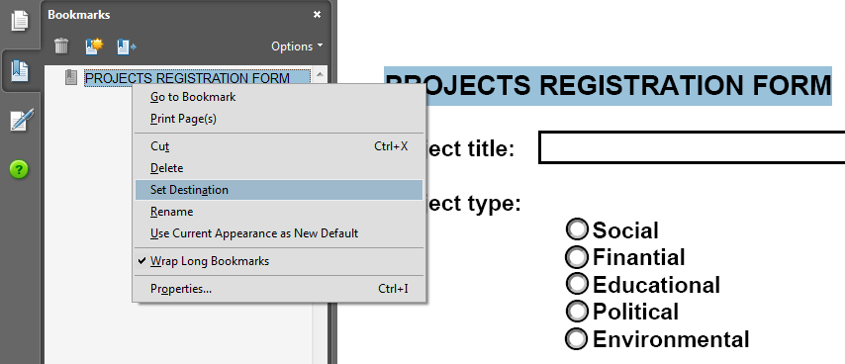
Figure 3-12. Assignation of a target to a bookmark.

Content page

Tagged content, annotations and multimedia elements
In this section, the process that allows correcting the accessibility issues detected in the following rules is explained:
- Tagged content: it checks whether the content of the PDF is tagged.
- Tagged annotations: it checks whether all annotations are tagged, i.e., it checks whether the annotations of the document (such as comments and editorial marks - insert and highlight) are included in tree "Tags" or are marked as artifacts.
- Tagged multimedia elements: it checks whether all multimedia objects are tagged.
Any error reported in these three checkings can be corrected through pane "Content”.
- Step 1. Open pane "Content". To do this, go to menu "View Show/Hide Navigation pane Content".
- Step 2. In pane "Content", click with right mouse button on the element (content, annotation or multimedia element) you want to tag and select “Options Create artifact".
As an example, the creation of an artifact for a text of the page is shown in Figure 3-13.
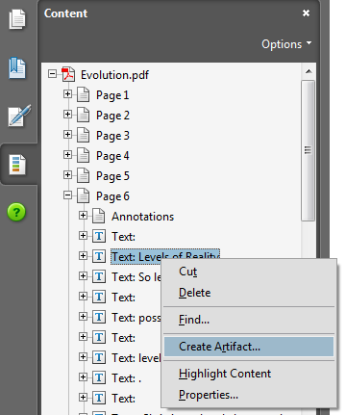
Figure 3-13. Content pane. Create artifact.
- Step 3. To assign a tag to the content, go to "Tools Accessibility TouchUp reading order" and click on the element to be tagged (Figure 3-14, step a). Then, in window "TouchUp reading order", select the type of tag to be assigned (Figure 3-14, b).
- Step 4. To confirm the change, click "Close" button in window "TouchUp reading order".
Repeat steps 2 to 4 for each page element you want to tag.
An alternative, instead of manually tagging element by element, is to let Acrobat to assign automatically tags to the annotations. To do this, select "Tag annotations" in menu "Options" of pane "Tags".
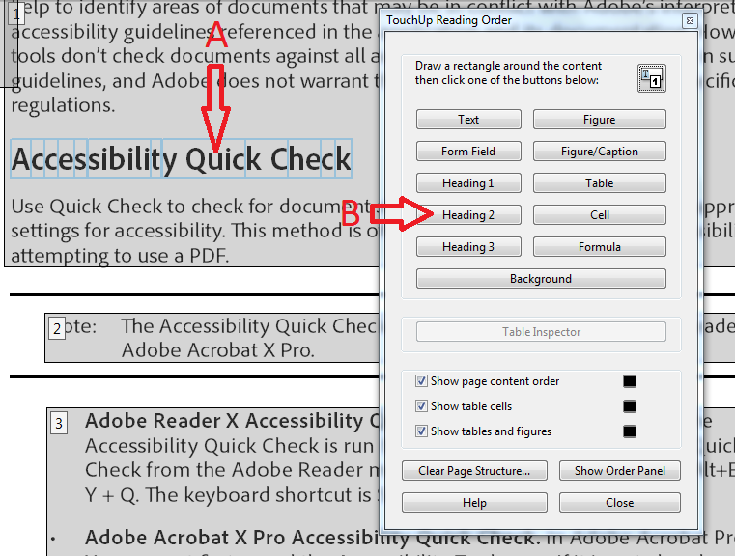
Figure 3-14. Retouch reading order. Tag content.
To prevent further reported errors in the rules mentioned in this section, the content, annotations or multimedia elements of the document must be included in tree "Tags" or marked as an artifact.

Tabulation order
In a PDF document some elements can be navigated using the tab key, such as links, fields in a form, comments and other annotations.
This rule checks whether the tabulation order is adequate depending on the document structure.
If any error is detected by this rule, Adobe Acrobat Pro lets to automatically correct the tabulation order, although some elements may not have been set with a correct order.
To use the automatic option, go to pane "Accessibility checker Page content Tabulation order", right click on this last element and select "Solve".
To manually correct the detected issues do the following:
- Step 1. Go to pane "Page thumbnails". If it does not appear, go to menu "View Show/Hide Navigation pane Page thumbnails".
- Step 2. In pane "Page thumbnails", click the first page of the document, go to menu "Edit" and select "Select all".
- Step 3. Right click on one of the selected thumbnails and select option "Page properties".
- Step 4. In dialog box "Page properties", locate tab "Tabulation order" and select "Use document structure".
- Step 5. Finally, click "Accept".

Other checkings
Other two rules that are checked in category "Content page" are "Characters encoding" and "Navigation links". To correct the issues reported in this rules, it is necessary to modify the source document. For this reason, in section 3.5 (Initial technical checking for detecting issues that require modifying the original document) the processes to avoid this type of errors were explained.
Finally, other three rules that are checked are: i) Screen flicker, ii) Scripts and iii) Timed responses. Any error reported needs a manual correction and a more advanced knowledge. The Acrobat help website (Adobe, n.d.) can be read to find a way to correct the detected issues.

Alternative text
As mentioned above, alternative text for figures and non-textual content of a document is important for people with visual disabilities. Some rules are mentioned below, which are checked in this category, and also the way to correct the detected errors.

Alternative text in figures
If an alternative text was set for each of the figures inserted in the source document, no errors should be found with this rule. However, if after running the full check to the PDF document any error has been detected with this rule, do the following:
- Step 1. Go to pane "Accessibility checker", expand category "Alternative text", right click on "Alternative text of figures" and select "Correct" in the drop-down box.
- Step 2. In dialog box "Set alternative text" (Figure 15), add the alternative text to each figure that does not have it.
- Step 3. Once a text has been added to all figures, click "Save and close".
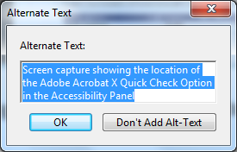
Figure 3-15. Dialog box "Set alternative text" for a figure.
Other three rules are checked in this category but they are related to elements that uncommonly are inserted in documents or presentations. Therefore, they are not explained in this chapter.

Tables
Adobe (n.d.) recommends performing manually the correction of problems detected in a table, due to the complex structure. However, if the tables were created in a word processor like Microsoft Word, no errors should be detected in Acrobat. Anyway, below there is a brief explanation about how to apply corrections in a table using Acrobat.
To check the accessibility of a table, it is necessary before to know their elements and their relation.
In Figure 3-16 the components of a table are shown. Below are described each of them:
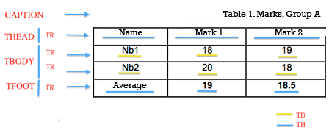
Figure 3-16. Example of a table with its elements.
- CAPTION. Table title.
- THEAD. Table header.
- TFOOT. Table footer.
- TR. Table row. A <TR> element must exist for each row of the table.
- TD. Data cell.
- TH. Header cell.
The first three elements will help users who access the document using a screen reader to know what information contains the table.
Considering these elements, the structure of the table shown in Figure 3-16 would result in the following code:
<table>
<caption>Table 1. Marks. Group A</caption>
<thead>
<tr>
<th>Name</th>
<th>Mark 1</th>
<th>Mark 2</th>
</tr>
</thead>
<tfoot>
<tr>
<th>Average</th>
<th>19</th>
<th>18.5</th>
</tr>
</tfoot>
<tbody>
<tr>
<td>Nb1</td>
<td>18</td>
<td>19</td>
</tr>
<tr>
<td>Nb2</td>
<td>20</td>
<td>18</td>
</tr>
</tbody>
</table>
The following can be observed in the indicated structure:
- From a <TABLE> element, tags <CAPTION>, <THEAD>, <TBODY> and <TFOOT> can derive. Of all the above elements, the latter is optional.
- Elements <THEAD>, <TBODY> and <TFOOT> must contain at least one row tag <TR>.
- Each row element <TR> must contain one or more cell tags <TH> and <TD> if it is a header cell or a data cell, respectively.
Given the above explanation, the correction procedure that can be applied to improve these data structures is explained below. Table 3-7 shows some errors that may occur and the procedure to solve them.
Rule | Checking description
Rows | This rule checks whether each row (TR) in a table is a child, i.e., it is in a header (THead), body (TBody) or foot (TFoot) of the table.
TH and TD | In an adequate table structure, a header cell (TH) and a data cell (TD) are child of a row (TR).
Headers regularity | Each table in a PDF document should have one header.  Tables must contain the same number of columns in each row and the same number of rows in each column.
Correction for the above rules | To solve the detected problems with this four rules do:  - Step 1. Go to pane "Accessibility checker" and determine what checking of rule failed.  - Step 2. Go to pane "Tags", expand the root tag.  - Step 3. Locate the elements tagged with <Table> and perform the following checkings:  - Each table row <TR> must contain header cells <TH> or data cells <TD>.  - Elements <THead>, <TBody> or <TFoot> are under tag <Table>.  - Elements <THead>, <TBody> and <TFoot> contain table rows <TR>.  - Each table row contains table headers <TH>, data cells <TD> or both.  If the tag of the table does not contain those elements but rows, columns and cells appear in the table in the document pane, tool “Retouch reading order” should be used to select and define the table or individual cells.  If the table contains rows that occupy two or more columns, attributes ColSpan and RowSpan should be used in the tagging structure.
Summary. | Table summaries are optional, but may improve accessibility.  To add a summary to a table, do the following:  - Select “Tools → Accessibility → Retouch reading order”.  - Right click on the table that generated the error and select option “Edit summary table”.  Add a summary and click “Accept”.
Table 3-7. Accessibility checks on a table and how to correct them.

Lists
Two rules are checked in this category: “List elements” and “Lbl and LBody”. To understand the possible errors, firstly the difference between a list properly created and another one is explained in Table 3-8.
Errors can be detected when the structure of the list is not respected (“List elements”) or when elements of a list are not created using bulleted or numbered lists (“Lbl and LBody”).
To correct the issues detected in this category, do the following:
- Step 1. Go to pane “Accessibility checker”. In option “List elements”, click the element that provoked the error and select “Show in tag pane”.
- Step 2. Create as many elements as needed, change the type of elements or reorganize the existing ones by dragging them to the corresponding location.
Correct list | Incorrect list
- Element of list 1.  - Element of element of list 1.1.  - Element of tag 1.1.1.  - Element of tag 1.1.2.  - Element of element of list 1.2.  - Element of list 2. | Element of list 1.  Element of element of list 1.1.  Element of tag 1.1.1.  Element of tag 1.1.2.  Element of element of list 1.2.  Element of list.
Table 3-8. Sample lists.

Headers
If an error was detected in this category is because an inconsistency was found on the nesting level of the styles used to mark the sections of the document. To correct the error, do the following:
- Step 1. In pane “Accessibility checker”, right click on the element that appears with an error in “Suitable nesting” and select option “Show in Tags pane”.
- Step 2. In pane “Tags”, create the elements necessary or reorganize the existing elements by dragging them to the corresponding tag.
Following the processes detailed in this section, most of accessibility problems that a PDF document may present should have been solved so that it can also be used by people with disabilities, especially visual.
Once the errors detected by Adobe Acrobat have been solved, a complementary checking of the PDF document is suggested, using PDF Accessibility Checker (PAC) analyzer.
The next section explains how a person who uses a support device (such as a screen reader) will perceive the content of a PDF.

Reading a PDF document using a screen reader
Different software tools can be used to read aloud from a PDF file. One of the most popular is JAWS, however, Acrobat products have also a feature available to do so.
Before using the feature of reading out loud of Acrobat, it is necessary to enable it. To do this, go to menu “View Read out loud Activate read out loud”. From this point, various operations can be performed. Once the reading aloud process has finished, it is recommended to disable this option.
A video which shows how to read a PDF document from Adobe Acrobat Pro or Adobe Reader is available at YouTube (Video2brain, 2013).
The options that can be performed using “Read out loud” are shown in Figure 3-17.
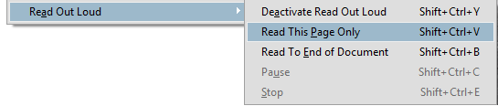
Figure 3-17. Options of “Read out loud” feature.
These actions can be accessed from menu “View” and allow to manage or control the reading sequence.

Creating accessible audiovisual content

Translators:
Eva García López
Antonio García Cabot
University of Alcalá, Spain

Authors:
Mª Carmen Cabrera Loayza
Universidad Técnica Particular de Loja, Ecuador
Luis Bengochea Martínez
Universidad de Alcalá, España

The widely use of virtual classrooms at the universities has become a common space for teachers and students to interact, both in distance courses or in classroom courses as complementary education. This has allowed teachers to include new learning resources, additional to the text document and presentations commonly used.
The use of multimedia learning content provided by animations, simulations or images and explanations recorded in video, which cannot be included in a book, are increasing and the trend is growing up. This is an essential part of the ecosystem of current students, who use tablets and smartphones for accessing the recorded classes taught at universities around the world, as well as all types of educational videos in platforms such as YouTube.
The video and audio educational resources can be included in classroom courses, in virtual classes or in MOOC courses, where they can be showed to the students many times. This provides an extra motivation to the students, increasing their learning performance, contributing both to retention and understanding of complex content (learning), and the application of knowledge to solve new problems (skill).
Although some universities have technical and human teams for producing professional video tutorials and other multimedia content, the creation of educational videos or audiobooks can be done by teachers, using a basic informatics equipment and easy and affordable applications.
Due to the aim of these audiovisual educational materials is completely didactic and their target are the students of a specific course, it is not necessary to use a complex and sophisticated production equipment.
However, the audiovisual materials pose new accessibility issues which are important to be taken into account. It is important that the authors of this content get the knowledge and skill that enable them to provide accessibility to this content. In this way, the content could be accessible to any student.
In this section you will learn the concepts of accessibility in learning content of audio and video, as well as the way to convert text documents into audio files.

What should an accessible video have?
Implementing multimedia educational content (such as videos, which have become a very important supporting material in the training process) has proven to be efficient and useful in education as a means of knowledge transfer. Taking this into account, its creation should consider a special focus for users with sensory impairments, which may be visual and auditory disabilities.
The main criteria to be considered when creating videos are explained in this section, to convert them in accessible educational content (Sama Rojo & Sevillano Asensio, 2012-b):
- Transcript.
- Captions.
- Audio description.
- Interpretation in sign language.
There are also other aspects to be taken into account (Moreno, Ruiz, Martínez, Carrero & Martínez, 2008), which determine the accessibility of this content such as:
- Access to multimedia content should be accessible.
  - Content direct download.
  - Playing content. Techniques:
  - Playing in progressive download (false streaming).
  - Streaming.
- User preferences and usability of access and user interaction with the content.
  - Size of the resource.
  - Duration of the audiovisual content.
  - Speed options and connection type for user preferences.
  - Progress bar.
  - User agent/s associated with playing.
  - Formats (Windows media, Real, QuickTime, Synchronized Multimedia Integration Language (SMIL)).
The criteria to be considered for creating accessible videos are explained in detail below.

Transcript
A transcript is a text file that contains all spoken audio in the video, and which can be downloaded by users. Transcripts can be read as a document or as a real screenplay. As they contain the same information that captions, it could be interesting to save them in a text format and then perform the necessary changes to publish it as a transcript.
It is recommendable to create transcripts in a plain text format to avoid possible accessibility issues. To be able to perform a transcript, both the audio and visual content should be considered, and take into account the following elements:
- Audio content.
  - Identification of speakers.
  - Content of the dialogues.
  - Audio events, such as music, laughter, applause and special effects.
  - All those audio elements that may be relevant to understand the document.
- Visual content.
  - Description of actions.
  - Screenshots, images, diagrams, etc.
  - Description of people.
  - Description of expressions.
  - Description of scenarios and locations.
  - Transcript of the text displayed on the screen.
  - All those visual elements that may be relevant to understand the document.

Captions
Subtitling is adding a text at the bottom of a video at its same frequency. This text improves accessibility of deaf and hearing impaired people, people who speak another language and people with low literacy levels.
Using captions is very usual in audiovisual content, and it is necessary to follow certain standards and accessibility best practices such as the following, which have been taken from the international standard UNE 153020:2005 (Asociación Española de Normalización y Certificación, 2005):
- Captions will contain all audio information of the video: identification of speakers, content of the dialogues and audio events such as music, laughter, applause and special effects. All those audio elements that may be relevant to understand the document or that provide information should also be included.
- Captions should appear at the bottom of the screen occupying two lines or, exceptionally, three. Different lines should be assigned for each character and the text should be centered relative to the box.
- There are certain basic guidelines in the division of captions:
  - No separate words.
  - Separate long sentences as conjunctions.
  - The voice often marks the separations by pauses or inflections.
  - Separate lines or captions matching them with commas and dots.
  - Place three dots at the end of the caption and other three at the beginning of the next.
- Recommended speed by experienced professionals is set around 12 characters per second. In addition, captions’ understanding is improved with a proper synchronization with the audio.
- There are some specific guidelines for captioning such as:
  - Do not play abbreviations.
  - Write numbers from zero to ten with letters, and the rest with Arabic characters.
  - It is better to use parentheses than brackets.
  - Use acronyms and short forms of Institutions or organizations.
  - Avoid buzzwords.
  - Use pronouns whenever possible.
  - Use short forms of names of personalities and posts.
- Captions, insofar as possible, should be literal.

Audio description
Audio description is a tool useful for blind people or people with low vision. It is the same that provides access to the visual aspects of theatre, media, visual art and any activity where images are a critical element.
The UNE 153020 standard about auto description for people with visual disabilities, published in Spain in 2005, defines auto description as "a support system for communication, which consists of a set of technical and applied skills in order to compensate for the lack of uptake of the visual part contained in any kind of message, providing adequate audio information that explains or translates, so that the visual impaired receptor can perceive the message as a harmonious whole and in the most similar way to how a person who can see perceives it".
The narration of the audio description is performed on an audio track different to the audio track of the video, taking advantage of the spaces without dialogue so as it does not interfere with the original audio of the video. In case there is not enough time between the dialogue to include the content of the audio description, an extended audio description can be used (Sama Rojo & Sevillano Asensio, 2012-b).
Audio description contains information on the following elements:
- Description of actions.
- Description of people.
- Description of expressions.
- Description of scenarios and locations.
- Transcript of the text displayed on the screen.
- All those visual elements relevant to understand the document.
The AENOR UNE 153020:2005 explains some requirements necessary to audio-describe:
- Analysis of the work: not all audiovisual works provide a good audio description. Different criteria are analyzed on a first viewing, such as the existence of "message gaps" to insert information, as well as saturation or absence of this information and whether it is performed in the same language than the audio information of the work.
- Writing the screenplay: it is composed of information units included in the "message gaps". For the screenplay is consistent, the standard says that "The audio descriptor should consult the documentation about the environment and the topic of the work". Thus, the information will fit to the type of work and the needs of the public to which it is addressed. There are also other characteristics to be taken into account, such as the plot of the dramatic action, environments and plastic data.
- Reviewing and correcting the screenplay: the necessary corrections made will be helpful to adapt the screenplay to audio description standards. The standard says that they should be reviewed by a person different from the descriptor and including them into the final screenplay.
- Speech: it is performed in the presence of the image described, and the narrator is selected depending on the type of voice and the right tone for the work, so that the voices are always clear to listeners. Also, avoid emotional intonation, trying to make neutral phrases.
- Montage: in the mix, volumes, ambient effects and equalization with the original soundtrack are equated.
It is important to use a clear and precise language and, if possible, use short and easy to understand words. The narration should be placed in the message gaps of the work, in order to not causing saturation of audio and information on the spectator.
The objectivity of the information presented in the audio description is also essential. A direct and simple description should be performed, trying to avoid evaluations or interpretations of what is happening, which may distort what the visual information conveys.

Interpretation in sign language
It is an activity of linguistic mediation that transmits a speech to a sign language, which is composed of gesture-spatial expressions and visual perception. By this interpretation, deaf people can communicate with the social environment, either made by other deaf people or anyone who knows sign language.
With verbal language, communication establishes a vocal-auditory channel, and sign language does it by a gesture-visual-spatial channel. It is noteworthy that in this language each person is assigned a unique and characteristic sign to not have to spell his/her name on signs.
There are several laws and regulations that regulate and normalize the use of the sign language. The requirements proposed by UNE 139804: 2007 (Asociación Española de Normalización y Certificación, 2007) standard are detailed below, the same in which 37 requirements are established for such use divided into several categories:
- General principles:
  - Linguistic sign language criteria defined by the everyday user community should be applied, as well as those fixed or expressed through relevant linguistic research results.
  - The person who makes signs should be a qualified person in sign language.
  - The person who makes signs should participate in the preparation of sign language material.
  - In any situation of interpretation, it is recommended to follow the codes of conduct usually accepted in this field.
  - The signs should be adequate to the characteristics of the target audience.
- Appearance of the person who makes signs:
  - The clothing of the person who signs should have a high contrast with his/her skin color.
  - The clothing of the person who signs should have a uniform color and texture.
  - The clothing of the person who signs should not distort the silhouette.
  - The clothing of the person who signs should not contain elements that highlight.
  - The person who signs should not wear jewelry or other ornaments.
  - The face of the person who signs should be free from unnecessary or superfluous elements that diminish the perception of his/her facial expression.
- Staging and sign language uptake:
  - When having control over the background, it should maximize the understanding of sign language.
  - The frame should be a medium scheme or a medium-long scheme.
  - A good illumination of the face and body of the person who makes signs without excess light should be guaranteed.
  - Illumination should avoid making shadows on the face of the person who makes signs when his/her hands pass ahead of it.
  - Illumination should avoid making shadows in the background.
- Video characteristics with sign language:
  - The video should have 25 images per second minimum.
  - A resolution of 256 x 192 pixels should be used as minimum. A minimum resolution of 352 x 288 is recommended.
  - In compression algorithms, video formats and video transmission techniques, using standards or documents published by relevant international organizations is recommended.
  - Compression algorithms, video formats and video transmission techniques that allow playing on the most used platforms should be selected.
  - A minimum bit rate suitable for the bandwidth of the target audience and the type of transmission should be chosen.
  - Fitness for the use of values chosen of resolution, images per second, bit rate and compression algorithm should be evaluated by tests involving deaf people who use sign language.
  - If dissemination of video is used, facilities of the server should be disabled for, when the connection quality degrades, automatically decrease the frame rate of the video or prioritize the audio.
- Integrating sign language in web pages:
  - On websites, sign language should be offered in one of two ways:
  - Embedded in a fixed area of a web page with additional content.
  - Linked so that it can be played with the corresponding media player.
  - Users should be able to select a full-screen presentation of the content with sign language, if possible with the technology used.
  - All content on a site that has been interpreted in sign language should be accompanied by a representative icon of sign language.
  - The same representative icon of sign language should be used in all pages of the same website.
  - The following representative icon of sign language is recommended to be used.

  - A page on the website should exist, which informs about the technical details of contents in sign language, requirements on the users' computers, requirements on their network connection and links to the players needed.
  - When a video with sign language is embedded, the user should be offered the following controls, if permitted by the technology used:
  - In scheduled or live broadcast: stop and play.
  - In all other cases: stop, pause, play, rewind and forward.
  - When a video with sign language is embedded and a timeout before visualization occurs, the user should be informed about this process.
  - When videos with sign language are offered to be downloaded, the user should be informed about their size and estimated download times for the most common types of connections.
  - When videos with sign language are offered to be downloaded, each video file should have a maximum duration of 2 minutes.
- Incorporating alternatives to sign language:
  - Adding voice and captions in sign language to the content is recommended.
  - If captions are added, they should meet the standard UNE 153010, in all applicable requirements for presentation in digital formats.
- Using computer-generated sign language:
  - When using computer-generated sign language, user testing should be conducted with deaf people who use sign language to ensure their suitability for use.
  - Preparing content for computer-generated sign language should involve qualified people in sign language.

Tools for creating accessible audiovisual content
For creating accessible educational content it is important to know the tools that allow incorporating certain characteristics of accessibility to the resources. Some of the tools are online, other desktop, some are free and some are for a fee, i.e., there is a wide range of applications. Below are described the most commonly used:
- SMIL: developed by W3C. Multimedia presentations created by SMIL are composed of audio, video, images and text elements, which are stored separately and then dumped simultaneously when the presentation is executed. It also allows enabling or disabling captions and audio descriptions.
- Synchronized Accessible Media Interchange (SAMI): a Microsoft specification that allows incorporating captions to Windows Media Player.
- Dragon naturally speaking: a speech recognition tool that generated captions without exporting the text from a text editor.
- Transcribe: a web tool that helps slowing the audio speech to transcribe it more easily.
- Universal subtitles: an open source collaborative web tool that allows subtitling any video published in YouTube or Vimeo. It also allows users to include translations of captions, insert subtitled videos in web pages and download captions in SRT format.
- CaptionTube: a web application that allows creating and including captions in YouTube videos. After importing a video, the user plays it and includes the needed captions. Then, the captions can be exported to different formats or publish them in YouTube. In section 2.6, this application is used to add captions to a video.
- YouTubeCC: a web application that allows creating captions for any YouTube video, and also allows exporting it.
- Overstream: a web tool that allows creating and synchronizing captions with a video available in platforms such as YouTube, Vimeo, Google Video and Myspace, among others, and storing it in the Overstream server.
- Dotsub: a web application that allows creating, translating and including captions in multiple languages in videos available on different platforms.
- Aegisub: software that allows editing captions in different formats, and also creating macros for easy editing. It has lots of options for personalizing captions, such as color, typography, caption format, etc. Free license and it can be used on Windows, OS X and UNIX platforms.
- Subtitle workshop: a tool for creating, editing and transforming captions in practically all existing formats, and performing several tasks related to captions editing. Free license and it is available on Windows platforms.
- Jubler: a tool for editing captions in text format. It allows creating new captions or convert, edit and transform existing captions. It also allows visualizing them in real time, checking spelling, translating them and editing formats, among other features. Free license and it is available on Windows, Linux and MacOs platforms.
- MAGpie: a tool for creating captions and audio descriptions. Free license and it is available on Windows platforms.
- STAMP: a PowerPoint 2010 add-in that allows subtitling multimedia content included in a PowerPoint presentation. Free license.
- FAB subtitler professional edition: one of the tools for professional subtitling. There are several versions according to the needs of production: to produce DVD, to live broadcast of subtitled TV programs, etc. Free license and it is available on Windows platforms.
- WinCAPS Qu4ntum: tool for creating captions in multiple formats and with several options such as AutoTime for an automatic synchronization. Free license and it is available on Windows platforms.

Creating accessible video tutorials

Video tutorials as educational content
The objective of video tutorials is reinforcing concepts and learning of certain areas of knowledge that, by their nature, are very complex to learn with static content such as books, tutorials, diagrams, etc. Currently the use of eLearning platforms facilitates the use of this type of educational content, especially in virtual education.
The idea is that teachers create short video tutorials, also called “training pills” or “knowledge pills” (Maceiras, Cancela & Goyanes, 2010), which are small pieces of educational content, created as learning objects of audio visual content and designed to complement traditional training strategies and to facilitate understanding of some aspects of the content that have greater complexity or difficulty of understanding by students.
Some universities that offer their studies or that have released their content use video tutorials to give a full explanation about the topics of the subjects. For example, Massachusetts Institute of Technology (MIT) has released their content, including audio visual content (called video lectures), through MIT OpenCourseWare, which is the same that can be found in the MIT YouTube channel and is based on recording of lectures.
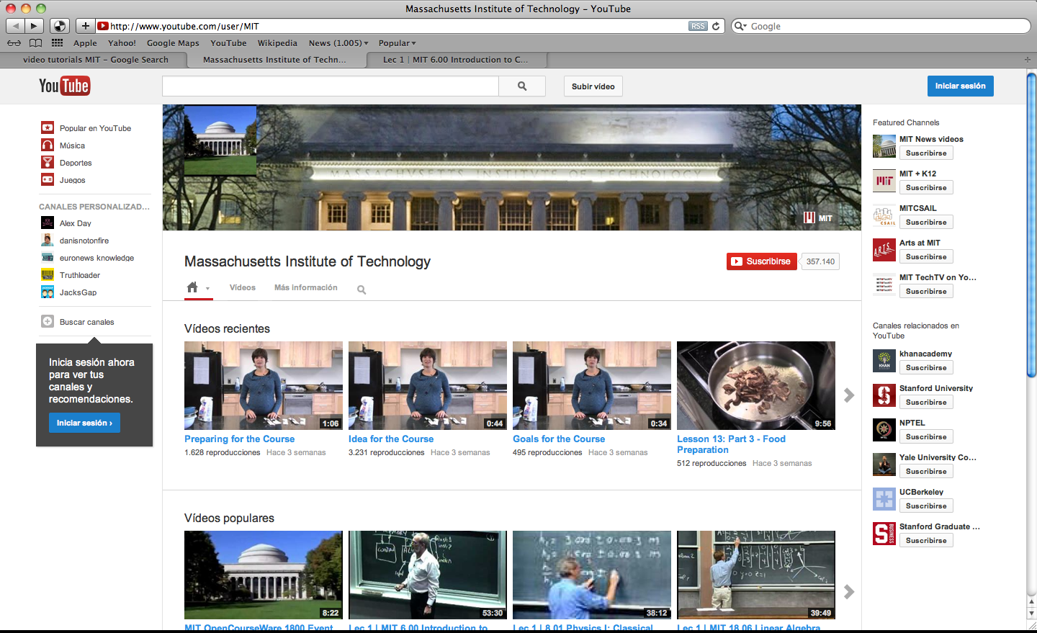
Figure 4-1. MIT YouTube channel.
In some cases, this type of video lectures meets the characteristics that a video tutorial should have, but most of them do not meet the main characteristic, which is the time duration of each video, due to most of them have a duration over 30 minutes (Figure 4-2).
However, many of these video lectures have some accessibility characteristics such as captions, annotations and translations, which allow users with disabilities being able to use this content.
Another example of the use of video tutorials as educational content is that applied in Universidad Nacional de Educación a Distancia (UNED) of Spain. They have created a number of audiovisual pills, oriented to complement training of their students. In the website UNED Abierta (Figure 4-3) several open source initiatives can be observed, such as COMA courses, OCW courses, multimedia library, etc.
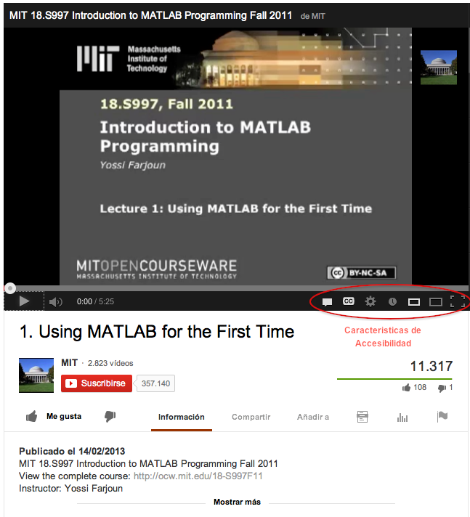
Figure 4-2. Video lecture “Introduction to MATLAB Programming”, developed by MIT OpenCourseWare, which meets some of the accessibility characteristics.
COMA courses are of free access and use the same methodology as MOOCs (Massive Online Open Course): massive courses, online and free. From the start date, the content is uploaded, which consist of small video “pills”, after which a small test can be put to ensure comprehension. Additionally there may be a final exam with a greater number of questions. The courses can start and finish when the students want.
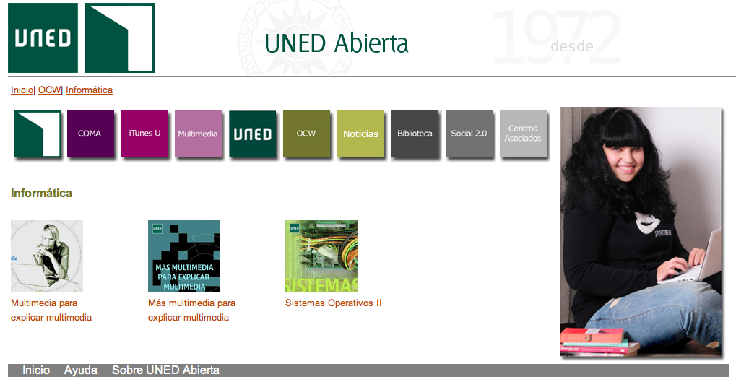
Figure 4-3. Open source initiative – UNED Abierta.
In most of the video tutorials created by UNED as educational content, several accessibility characteristic are met. Among them, the duration of the videos is within the recommended limits, they include captions and the presentation is clear with tutor support.
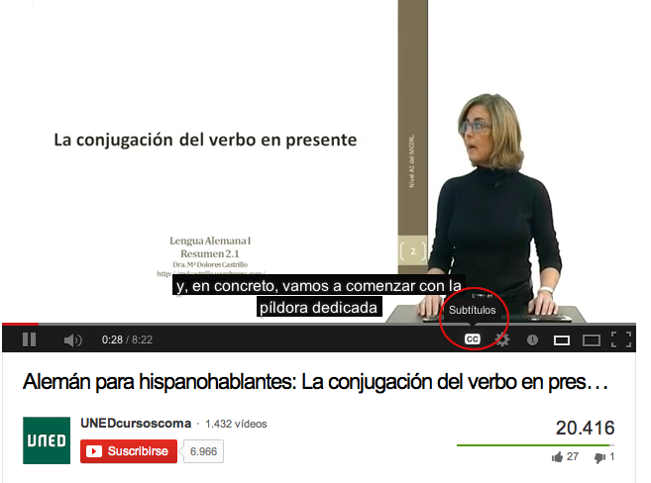
Figure 4-4. Video tutorial of the initiative UNED Courses COMA.

Best practices for creating effective video tutorials
For creating video tutorials, the first thing to be considered is the quality content provided to learning. For this, some mistakes are usually committed, which do not guarantee that the video tutorial that is being created contributes to students. Among the most common mistakes we can mention the following:
- Creating video tutorials with duration of more than 30 minutes is not advisable because students usually do not visualize them completely due to their long duration. Thus, the recommended duration for video tutorials is between 10 and 15 minutes maximum, explaining clearly and specifically the subject to be learnt.
- Recording video tutorials with background music is a common mistake. This is not recommendable because it can interrupt the teacher’s explanation.
- Having many movements in the video tutorial, for example, moving excessively the mouse and opening, maximizing, minimizing or closing windows may cause the users pay more attention to the movements on the screen than to the explanation in the video tutorial.
- At the time of recording, pop-ups should not appear, either of some instant messaging application or Internet windows, as this may distract people who are viewing the video tutorial.
- Sometimes as part of the video tutorial we need to enter our desktop computer, but it is usually disordered: it is advisable to leave only the icons needed.
- To achieve the expected results, do not try to teach more than one thing per video tutorial. Users need to perform previous tasks, and this requires knowledge and practice.
Once the most common mistakes are reviewed, the best practices to ensure a successful creation of quality video tutorials are listed below:
- First of all it is advisable to follow a process of creation, which carries to some specific steps that ensure a better quality of a video tutorial:
  - Planning: before start creating a video tutorial, clarify what you want to explain or transmit with it. The following questions could be asked:
  - What is the topic to be used?
  - What do we want to achieve with the creation of the video tutorial?
  - Will we improve learning by using this educational content?
  - Who is it for?
Once the answers to these questions are clear, we can continue with the creation process.
  - Preparing material: before starting recording the video tutorial, it is necessary to know the materials that will be needed, such as images, videos and chiefly what we are going to tell during this time. For this, it is very important preparing a screenplay, which will contain everything we will do since we start the explanation of the subject until its completion. The following structure is recommended to be followed when creating a screenplay:
  - Topic and greeting: the topic should be clear enough so users can know from the beginning whether it is what they are looking for. A greeting and a brief introduction to the subject are also needed in this first part.
  - Video tutorial objectives: the main objective to be achieved by those who see the video tutorial is specified in this part.
  - Video tutorial content: the content selected for the video tutorial should be specific, since the aim of the video tutorial is clarifying or strengthening a subject, not creating more confusion. This requires that the content is as an explanatory guide where all that users have to know is explained step by step. A clear language has to be used, without ambiguities.
  - Conclusion and data: when the video tutorial is finished, it is recommendable to give some conclusions about the subject or a summary with the key points. It is also advisable to present the contact details (e-mail, blog, web page, twitter account, etc.) for comments or questions about it.
  - Recording: to start the recording of a video tutorial, firstly a tool has to be selected from those that allow recording both video and voice. The following section describes some tools that are specifically designed to create video tutorials.
  - Editing: once the video tutorial is recorded, the same or another video editing tool can be used to add texts, arrows, images, audio, zooming, etc. But it is advisable to try to do all these innovations while recording the video tutorial.
  - Publishing: when the video tutorial is ready, it will be then published in our web site, in our YouTube account, etc. The idea is that after our hard work, this educational content serves to all those who need some explanations about this subject, so it is advisable to publish it in collaborative access and free license sites.
- Create short video tutorials, which can be published on a public website of videos, such as YouTube, or in an institutional channel.
- When creating video tutorials, also consider that they can be visualized on mobile devices such as phones, iPads and tablets, which is an important added value when used as an educational material.
- Check the image quality obtained in each video tutorial, in order that they can be visualized in full-screen mode.
- Prepare the content as a presentation, with the items being highlighted and guiding the subject being explained, so the static material will become a dynamic one.
- Speak clearly and concisely, so as to be heard clearly. Avoid stammer and very long pauses.
- Be sure that the technical equipment to be used is in the best condition. If a video tutorial is created and the audio is not good, it will not do much. So it is advisable to use a good microphone and a good screen resolution.
- Video tutorials should meet some accessibility characteristics (Sama Rojo & Sevillano Asensio, 2012-b) such as those previously studied: transcript, audio description, captions, sign language interpretation and others needed based on the target audience. Depending on the type of material, certain characteristics should be included, such as:
  - Video-only content: this kind of content is only composed of video, with no events or audio content. To ensure the accessibility of this type of content, two accessibility measures should be combined:
  - A transcript.
  - An audio description.
In this case it is common to create a description of the video content as a transcript in text format. The following information should be included: description of actions, people, expressions, scenarios and locations, transcribe the text displayed on the screen or read it aloud, if an alternative in audio format is being performed.
  - Video with sound documents: documents that contain video with sound require a greater number of measures to be accessible because they contain both visual and audio information. In this type of material the following can be observed:
  - If they will be broadcasted live or in recorded format, the content should be subtitled. Interpretation in sign language is also very common, although this option is not required by the standard.
  - If the document will be broadcasted in recorded format, the following measures should be met depending on the level of accessibility that we need to ensure: captions, transcript and audio description.

Basics of video editing
According to Wikipedia, video editing is the process of manipulating video images. They can be created from videos, photographs, graphs or animations. In most cases, audio is also included, which can be music or the characters’ dialogue, but there is also a kind of editing where audio is not used and only visual media is used.
The basic concepts and tools used to create and edit videos are:
- Clip: a piece of audio or video in motion.
- Credits: references to everyone who took part or influenced the creation of an audiovisual project. They are generally included at the beginning and at the end of the video.
- Digital edition: it consists of manipulating, using a video editing application, media such as video files, photos, graphs or animations, and audio. Once the project is created, rendering or recording are performed, thus obtaining the final video, usually generated with MP4, AVI, MPEG2, WMV and MOV formats, among others.
- Frame: the smallest unit of a video. It is composed of one photo or still image. The videos generally consist of 25 frames per second; but cinema movies have 24. In videos with lower quality (or sometimes to create interesting effects), the number may decrease.
- Track: the channel where a clip can be included. It can be audio or video. You can include as many as you want in order to edit and mix resources.
- Pixel: abbreviation for “Picture cell”. It is a sample of the image information. It is the smallest of a television picture element. The more pixels in an image, the higher the resolution.
- Rendering: computer process for creating tasks to generate a special effect, animation or editing effects.
- To trim: process that involves removing parts of a clip, which should not appear in a project without removing them from the originally recorded material. To trim, just adjust the start and end points of a clip.
- Resolution: the number of lines and pixels that make up a video image. The higher the number of lines or pixels, the sharper and more detailed the image is.
- Stop motion: animation generated frame by frame, i.e., still images or photos are taken and then mounted so that they build a story.
- Storyboard: before filming or editing a film, a series of drawings are made by cartoons similar to comics, in order to have a very rough guide about how each decision will be made and how the different pieces are joined.
- Transitions: they may be audio or video transitions. It is the way in which two different clips are hitched. The two most used and basic are “shear” or “melt”.

Tools for creating and editing video tutorials
Nowadays there are several software applications used to create and edit video. The most used tools are presented below.
- CamStudio is an (open source) application that records the screen and audio on a computer and creates a standard AVI video file or a Streaming Flash (SWF) video. Available for Windows systems.
- Jing allows taking screenshots and saving them as video. Text boxes, arrows or rectangles can be added to highlight certain points. Audio can be recorded along with the video using a microphone. The results generated can be sent by Screencast.com, Flickr, a FTP account, Twitter, etc. Available for Windows and Mac OS X.
- Webinaria is an open source application to create screencasts. Available for Windows systems.
- Wink allows creating tutorials and presentations that capture the screen, and also allows adding text boxes, buttons, titles, etc. It supports EXE, FLV, HTML, etc. as output files. Available for Windows and Linux.
- UltraVNC screen recorder is a screen recorder based on CamStudio. It allows saving audio and screen captures. Available for Windows.
- Windows media encoder allows capturing audio and high quality video with high definition multi-channel audio. Available for Windows.
- BB FlashBack express allows recording from a video source, screen and audio. It supports AVI or FLV files and also supports direct upload to known video sharing sites. Available for Windows.
- CaptureFox (Firefox add-on) is a Firefox add-in that can record the screen frame by frame to create tutorials. It also allows recording audio. Available for all operating systems.
- Krut is a Java application (it Works on many platforms) that allows creating screencasts. It saves movie files of selected parts of the screen in QuickTime MOV format, including sound.
- FileLab is a video editor in the cloud that allows basic video editing, but has a very simple and intuitive interface, quite similar to Sony Vegas’, where the videos in which we are working can be seen. A 1 MB plug-in has to be downloaded before using it.
- VirtualDub is a free capturing/edition video software. It works only with AVI files, so this format has to be used to create a video with this application.

Creating video tutorials by capturing screen actions
In this section, a simple way to create video tutorials is explained. During the creation process, images or screenshots may not receive the importance they deserve, and also the actions performed in the computer, i.e., capturing the actions on the screen or screencast.
A screencast is a digital recording of the screen output and sometimes has audio narration. In terms of teaching, educational content can be created by explaining the functionality of certain tools, data management, browsing websites, etc.
As mentioned in the previous section, there are different tools to capture screen actions. Of these, the free tool QuickTime Player has been selected. To explain how to create video tutorials using this tool, a mini video tutorial about how to navigate a search open educational content website is showed, with the following steps:
- Firstly, run QuickTime Player (if it is not installed, download and install it).
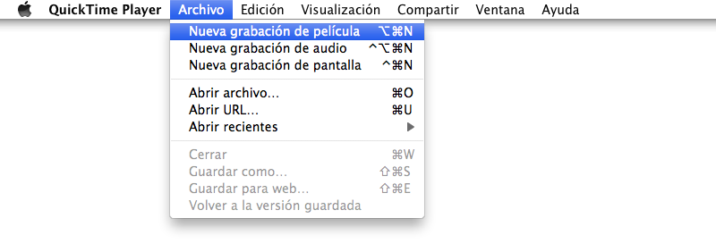
Figure 4-5. Creating video by capturing screen actions with QuickTime.
Select the type of recording to be performed:
  - Film recording: including audio and video.
  - Audio recording: audio only.
  - Screen recording: the actions performed on the screen are recorded, but it does not include audio.
In this case, select the screen recording option to capture all the actions we perform. Before you click on the option to record, what we want to capture has to be ready. In this example, the website is previously ready to start navigating and recording the actions that will be performed.
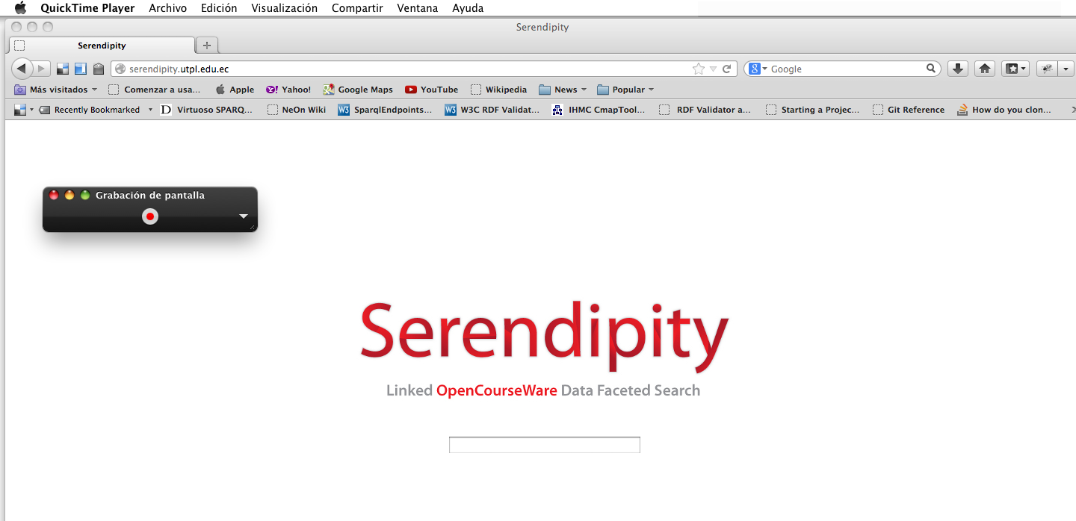
Figure 4-6. Starting recording the actions on the screen with QuickTime.
- When clicking the “Record” button, a warning message will be showed.
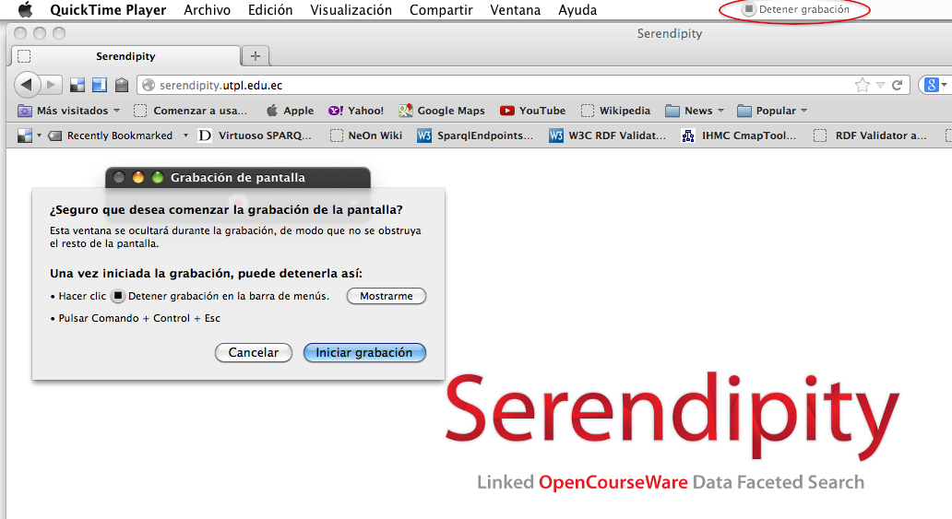
Figure 4-7. Warning message while recording the actions on the screen with QuickTime.
- Click the “Start recording” option and it will automatically start recording what you are doing on the screen. In addition, at the top of the screen the button to “Stop recording” will be enabled.
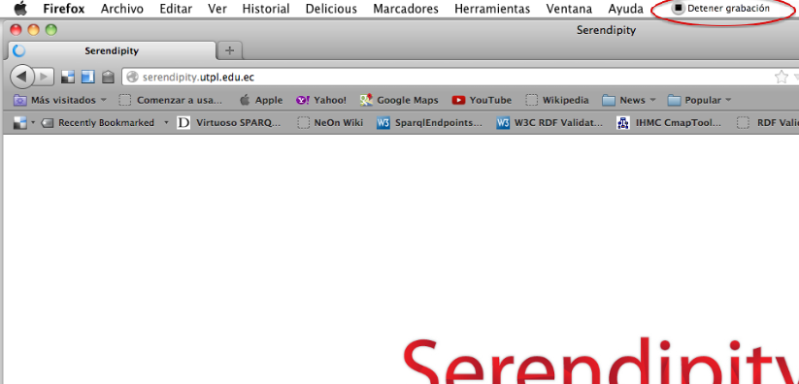
Figure 4-8. Recording the actions on the screen with QuickTime: button to stop recording
- When everything planned for the video tutorial has been captured, select the “Stop recording” option, and then the recording done will be displayed.
- Finally, select option “File Save as”. In the window that appears, enter a name for the video tutorial and the location where the file will be saved.
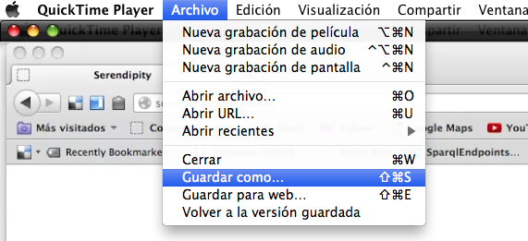
Figure 4-9. Selecting option “Save as…” to save the video file obtained from capturing screen actions with QuickTime.
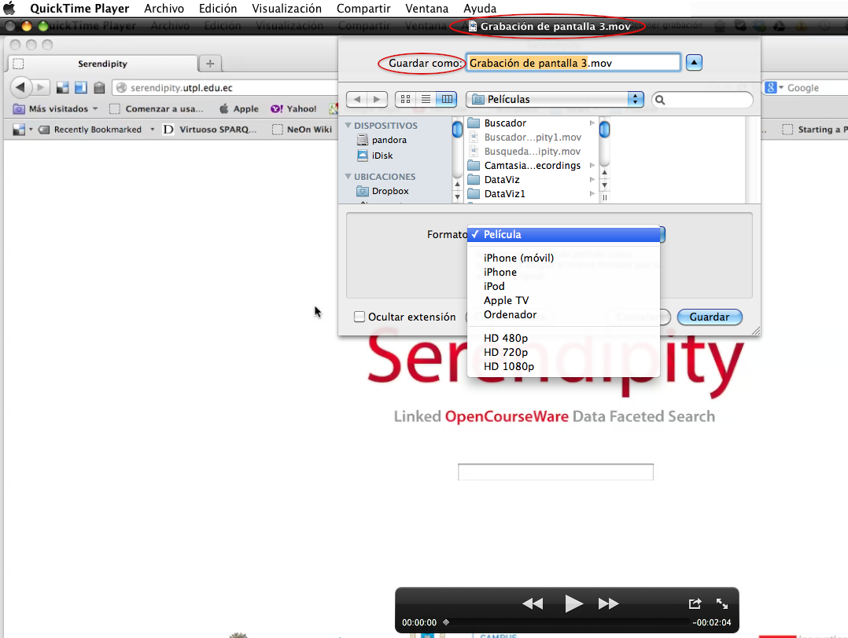
Figure 4-10. Format types that QuickTime supports to save the video tutorial.
- Another option that can be chosen to save the video is “Save for web…”, which allows exporting the file to optimized versions for web distribution, to iPhone and desktop.
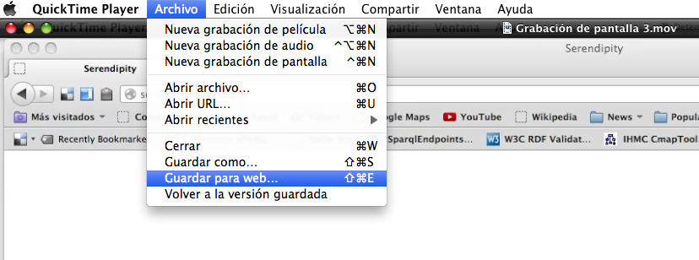
Figure 4-11. Selecting option “Save for web…” in QuickTime.
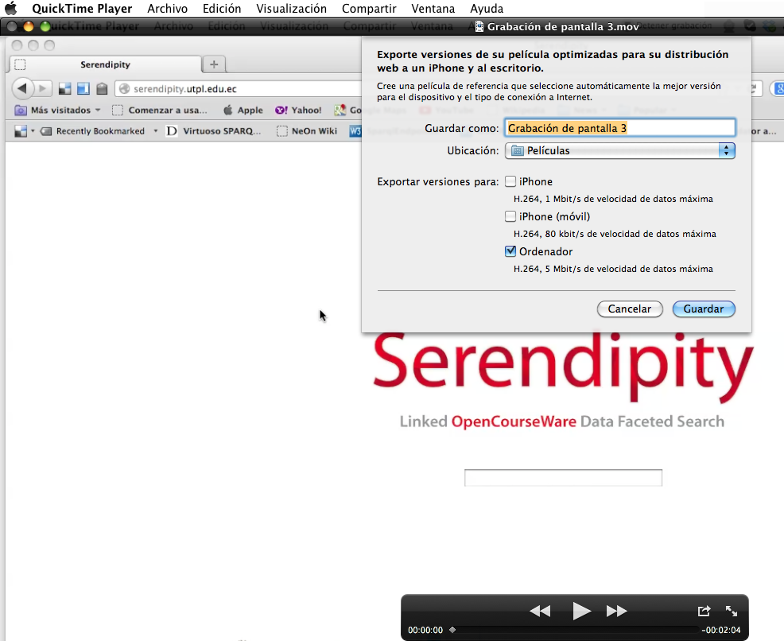
Figure 4-12. Selecting formats in QuickTime for web distribution.
- Most tools for capturing actions allow editing the recording. In this case, in QuickTime the recording time can be shortened according to what needed.
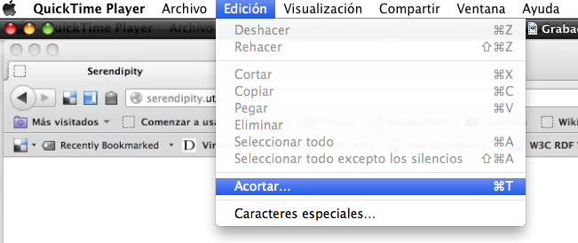
Figure 4-13. Editing video using QuickTime.
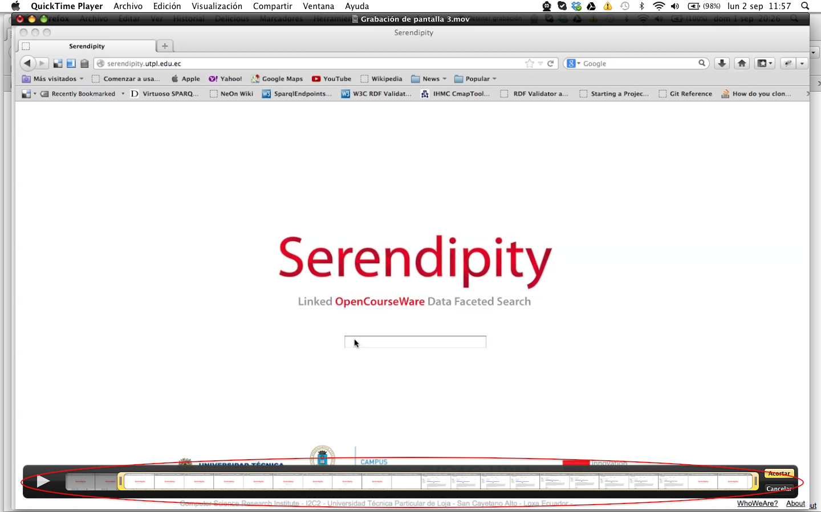
Figure 4-14. Editing video using option of limiting in QuickTime.
- The video tutorial is now ready, in a quickly and optimally way. As a final step, publication in an open format and in a free website or repository is advisable.

Using YouTube as a platform to publish, edit and subtitle videos
YouTube is a website that originally allowed searching and sharing videos for free, but it has now become a large-scale social network with new features, among which are the ability to publish and edit videos, add audio, annotations and captions. Below are explained these features and their contribution for creating accessible videos.

Publishing videos
- To publish videos in YouTube, first a personal account on the website has to be created. Once created, you will have your own channel, where you can upload videos, save favorite videos, access to the history of searches, create playlists, etc.
- A video can be added to the channel selecting “Upload”. You can create videos using a webcam, a slides presentation or live Google+ hangouts.
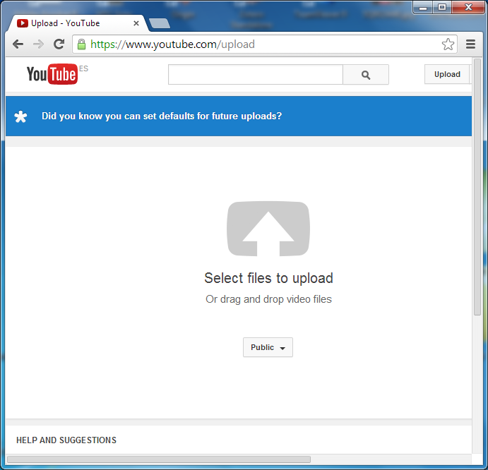
Figure 4-15. Options to create a video.
- If you have a video ready, select option “Select files to upload”, select the video from its location and enter the information required to be published. It is important to verify that one of the following formats is used: .mov, .mpeg4, .avi, .wmv, .mpegps, .flv, 3GPP, WebM.
- Once the video is uploaded to the channel, it can be customized with descriptions, tags or categories, and it can be edited or include annotations, audio and captions.
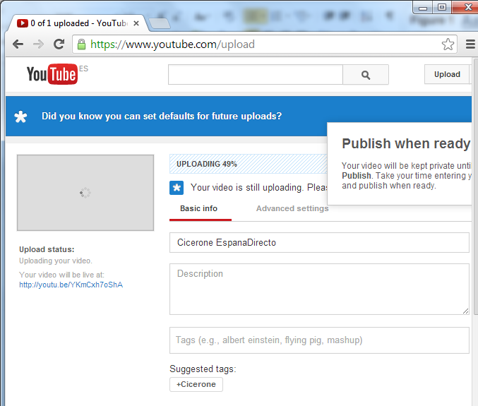
Figure 4-16. Selecting the option to upload a video.

Incorporating improvements
YouTube offers the following options:
- Enhancements, by which “Quick arrangements” can be made, such as trimming video (the start or the end), rotating, image stabilization (if the recording is very moving) or changing lighting, contrast, saturation and color temperature.
- Automatic correction, which automatically corrects color and lighting, according to the YouTube parameters.
- Effects, which allows changing the appearance of the video: black and white, sepia, cartoon style, etc. To test it, click on a filter and see how it is applied to the image.
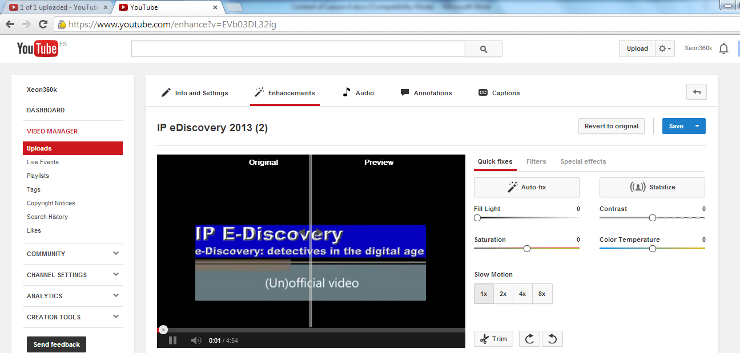
Figure 4-17. Adding improvements to a video using YouTube.

Incorporating audio
- The “Audio” option allows selecting a music track ideal for a video from a list of music tracks.
- To save all changes made to the original video, select the option “Save” and all effects will be saved for the video, or select “Save as” to create a copy of the video with all the effects applied.
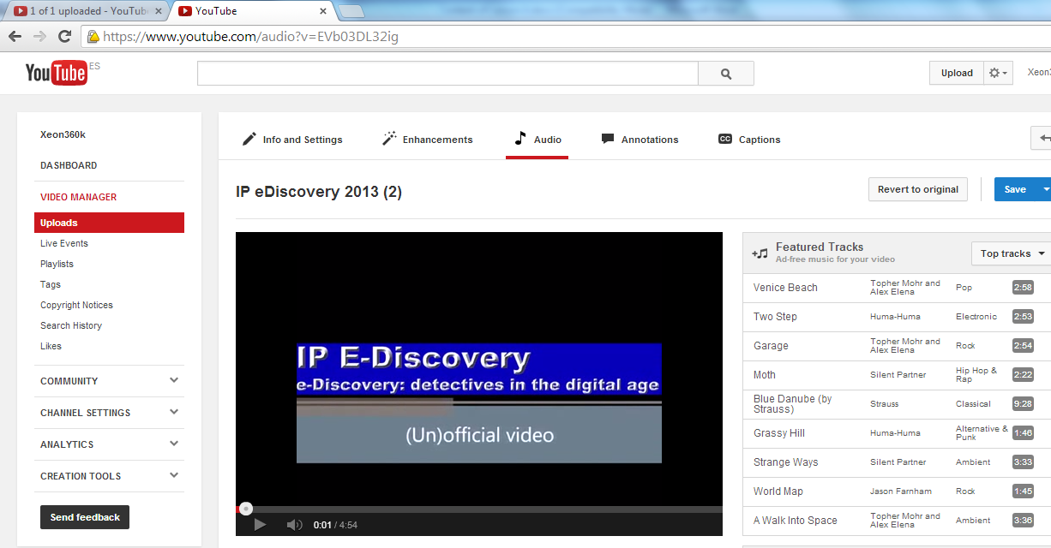
Figure 4-18. Incorporating audio to a video using YouTube.

Incorporating annotations
- Annotations allow adding layers of text, links and active zones to a video, which improves experience of videos by adding information, and interaction and participation options.
- Once the video is uploaded, to create annotations go to menu “Video manager Edit Add annotations”.
- The following annotations are allowed: speech bubble, note, title, spotlight and label.
- Once the annotations desired are created, click “Publish” to display the changes.
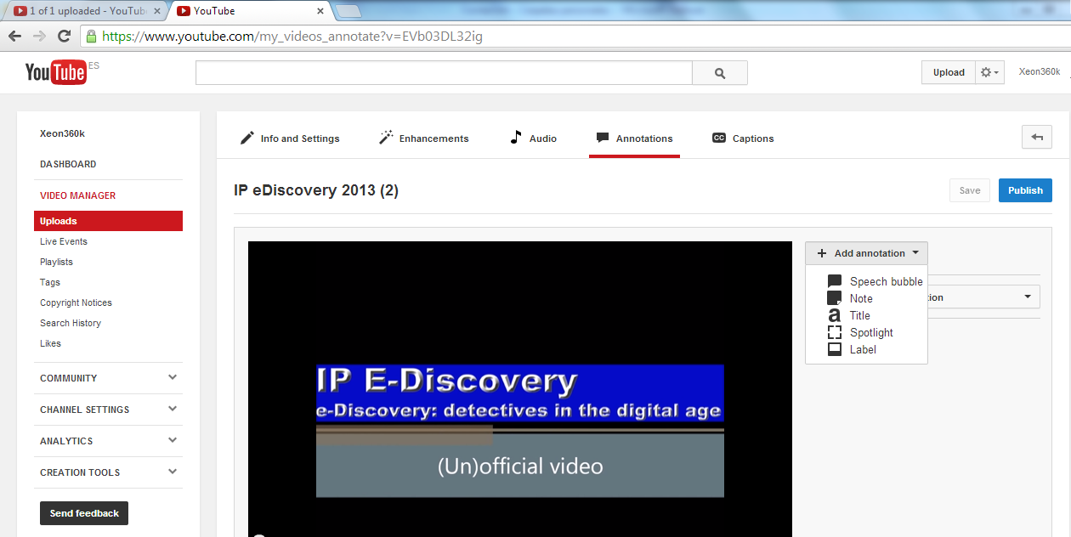
Figure 4-19. Create annotations in a video using YouTube.

Incorporating captions and video transcripts
YouTube allows adding captions to a video using captions file, which contains the text and information about the moment in which each line of text should appear.
Similarly a transcript can be added to the video, which contains everything said in the video and which is independent of the playback time of the video. If the video is in English, YouTube can use speech recognition algorithms to determine the moment in which the words of the transcript should appear.
To add captions to a video, first you should have the file containing the captions or transcript. Then, log in the YouTube account and do the following:
- In the username click option “Video manager” and the videos you uploaded will appear, or you can upload or create a new video.
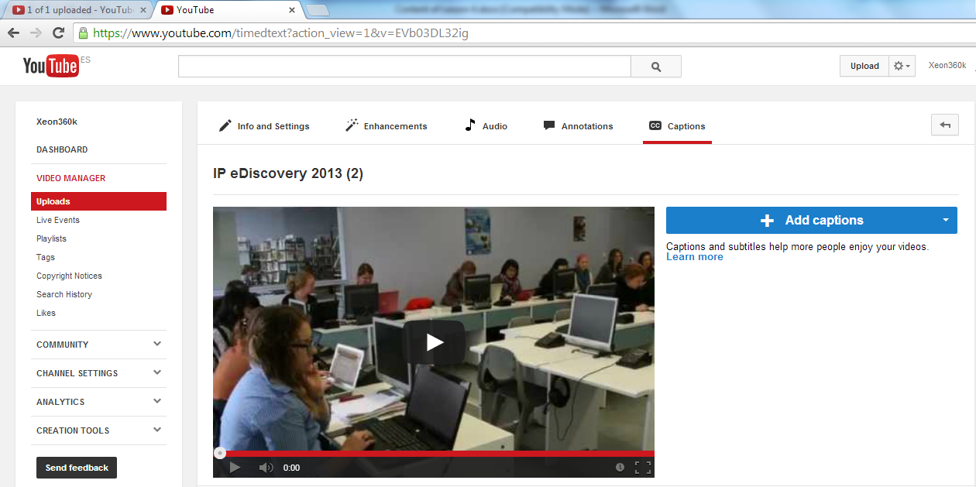
Figure 4-20. Adding captions to a video using YouTube.
- Select option “Edit” in the video and then the “Captions” option in the drop down menu.
- Some options are displayed on the right side of the video. Click the “Add new captions or transcript” button and then the button “Browse” to locate and select the file containing the captions.
- Select a captions file or a transcript. If a transcript is to be uploaded, select “Transcript file”; otherwise select “Captions file”. File types that can be uploaded are *.sbv, *.sub and *.srt.
- Select the appropriate language, assign it a track name and finally click the “Upload file” button.

Configuring captions
- A video containing captions has the icon at its bottom right, and when pressed, the options that can be performed are displayed.
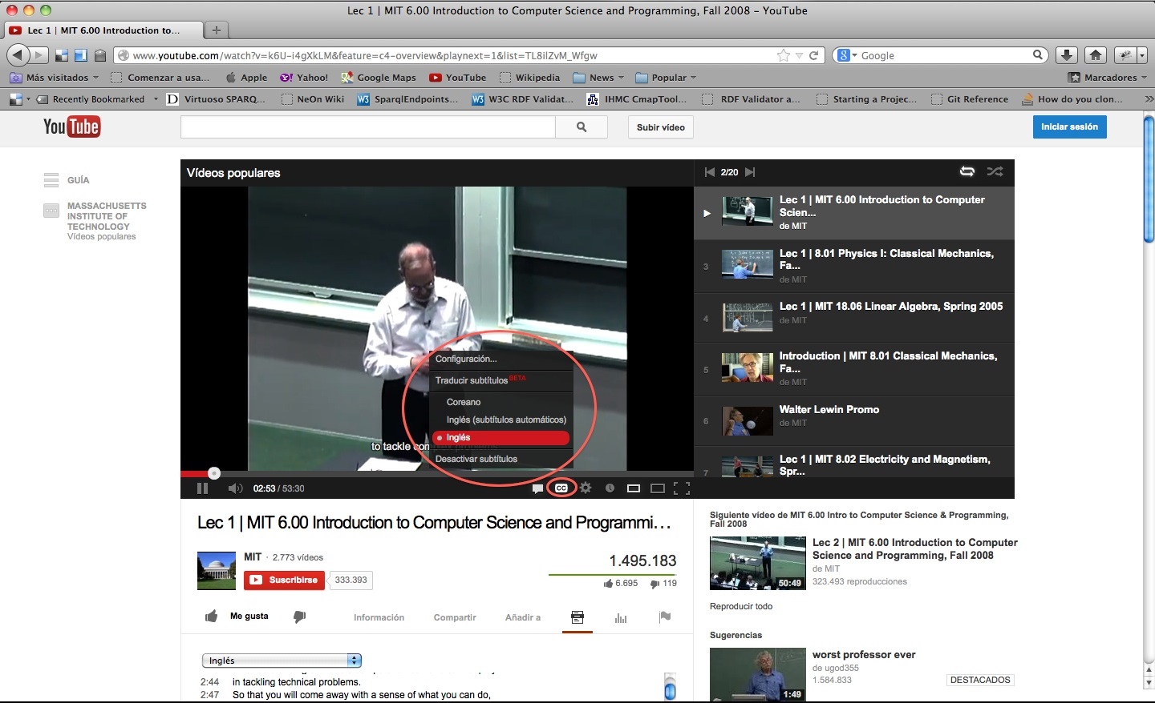
Figure 4-21. Configuring captions in a video using YouTube: captions menu.
- The available options are the following:
  - Configuration: in this option some changes about visualization of captions in the video can be performed, such as font type, font color, background color, etc.
  - The “Captions translation” option is also available to do it in other languages, depending on the original one.
  - Finally, an option to “Disable captions” is also available.
- Captions are only available in videos where the owner added them and in some videos where YouTube provides them automatically.
- If a video contains captions, they can be enabled using the captions icon that appears at the bottom of the video. This icon may look different depending on where you are.
- To change the captions language, click the captions icon. If the language desired is not displayed, you can try with captions translated automatically with Google Translate.
- To enable captions automatically translated, click the captions icon and select “Translate captions”, select the language and press “Accept”.
- To always show or hide captions, access to the “Account settings” webpage, select “Play” in the left menu and check or uncheck option “Show captions always”.
- To disable them, click the captions icon and then select “Disable captions”.
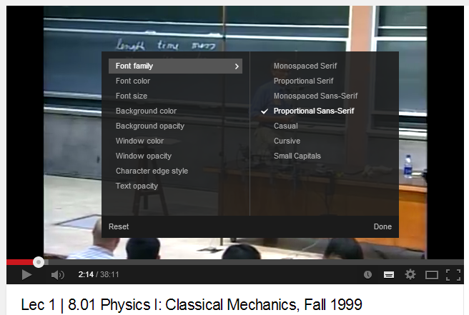
Figure 4-22. Configuring captions in a video using YouTube: captions configuration option.

Display transcripts
- To display the transcripts of a video, click the transcript icon that appears below the video player. The transcript will move to show the current text while the video is being played.
- You can also click on any line of the text to go to that part of the video.
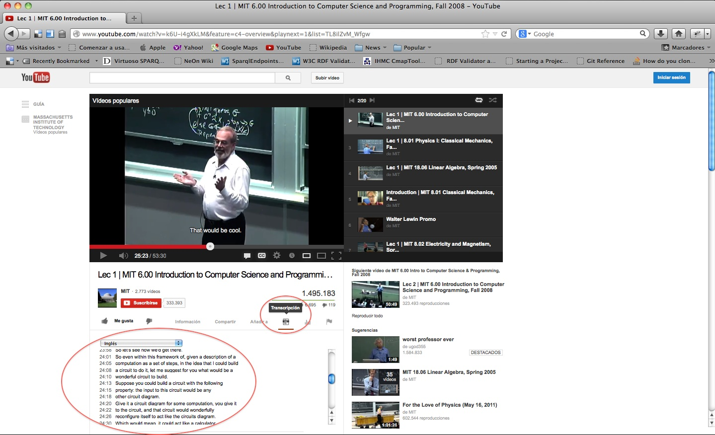
Figure 4-23. Showing the transcript of a video using YouTube.

Educational content with accessible audio
In this section, the accessibility issues that educational content comprising documents with audio may have are studied, and also how to solve them and make them accessible.
Documents with audio are those where an audio recording is contained, performed using a microphone or any other recording medium and that can be played on a device provided with the means. The audio collected may be human or synthesized voices, sounds, music, etc.
Since the purpose of this workshop is creating accessible educational content used in virtual training, only documents with audio recorded in a digital way will be taken into account, thus excluding analog recording such as tapes.

Using audio elements in learning
Including audio educational content in training can be a valuable motivator for students, e.g. by an original recording of the poet who is being studied, a conference of an important person in a certain subject, or a radio podcast with an interview about the subject that is being studied.
The sense of hearing allows perceiving and communicating with the world. An important part of learning occurs through this sense. For people with visual disabilities, screen readers and appropriate descriptions of the images that appear in an educational content may eventually replace the absence of visual information. For people with hearing disabilities, adding accessible audio educational content involves providing valid alternatives, such as a text that contains the full content of the locution included in the audio document.
Although teachers can find educational audio content in learning objects repositories, radio, television, etc. to include it into their course material, the current digital technology allows recording and creating their own audio resources. Although probably they do not reach the quality of a professional recording, it is possible to create audio files with the ideal characteristics for the purpose they serve: learning of their students.

Audiobooks as accessible educational content
The main elements for learning a subject have traditionally been paper books; but with the advent of computers, digital books began to appear. More recently, with the emergence of reading devices with smaller screens, such as tablets and e-book readers, other e-book formats have become popular, and mainly EPUB, which is an open source format in which the content is adapted to different screen sizes of readers.
Another way that books have taken is recording the text read by an announcer or a team of performers who lend their voice to the characters that appear in the text. The books read could be broadcasted by a radio station and reach people who were not able to read, because they had visual disabilities or because they could not read.
Digital voice recording and the ability to save audio in easily distributable files through the Internet have allowed the proliferation of audiobook repositories, in which the main works of literature can be found, ready to be listened. Interestingly, the creation of audiobooks is not directed only to minimize accessibility issues, but to an audience (especially young) who usually carry a playback device with headphones, which allow listening to music but also audiobooks, anywhere and anytime.
Therefore, the advantages obtained when using audiobooks as accessible learning content are:
- It allows students to access the content through the sense of hearing, anytime and anywhere.
- It provides an accessible alternative to textual content for people with visual disabilities.
- People with hearing disabilities can use the textual version of audiobooks.
Leading universities in e-learning provide all written content in audiobooks format, downloadable both in MP3 and DAISY formats.
Logically, when the content of a course is accessible, both the audiobook and the text of the book should be available, because otherwise people with visual or hearing disabilities may not be able to access to it.
Teachers of creators of educational content may not find the audiobook desired on the Internet to include it to their course materials, but the current technology allows creating your own audiobooks and therefore convert written educational content into audio educational content. To do this, only a computer, a headset and a microphone are needed. Installing Audacity is recommended for recording and editing.
Audacity is a free and open source application, which can be installed on Windows, Mac or Linux. It is developed by a team of volunteers and distributed under GNU general public license. Its main features are:
- Recording:
- Recording voice from microphone.
- Recording from multiple input devices, mixing sounds.
- Mixing tracks. For example, to make sound a background music in a speech.
- Correction of volume levels during recording.
- Import and export:
- Import and export WAV, AUIFF, AU, FLAC and OGG audio files.
- Import MPEG audio (including MP2 and MP3 files).
- Export MP3 files with the optional LAME encoder library.
- Import audio from video files.
- Sound quality:
- Supports 16-bit, 24-bit and 32-bit samples.
- Sample rates and formats are converted using high-quality resampling and dithering.
- Mix tracks with different rates or formats, allowing recording them into one file.
- Audio editing:
- Easy editing with Cut, Copy, Paste and Delete.
- Unlimited sequential Undo (and Redo) to go back any number of steps.
- Edit and mix large numbers of tracks.
- Remove static or other constant background noises.
- Set the volume to produce normalized files.
- Accessibility:
- The application can be used with keyboard shortcuts.
- Excellent support for JAWS, NVDA and other screen readers.
Audacity can be downloaded from the official website. For getting output files with MP3 format, download and install the optional library LAME, available on the official LAME library website, as described in the installation manual of Audacity plugins.
The Audacity Graphical User Interface (GUI) shows sounds as graphs in each of the stereo channels.
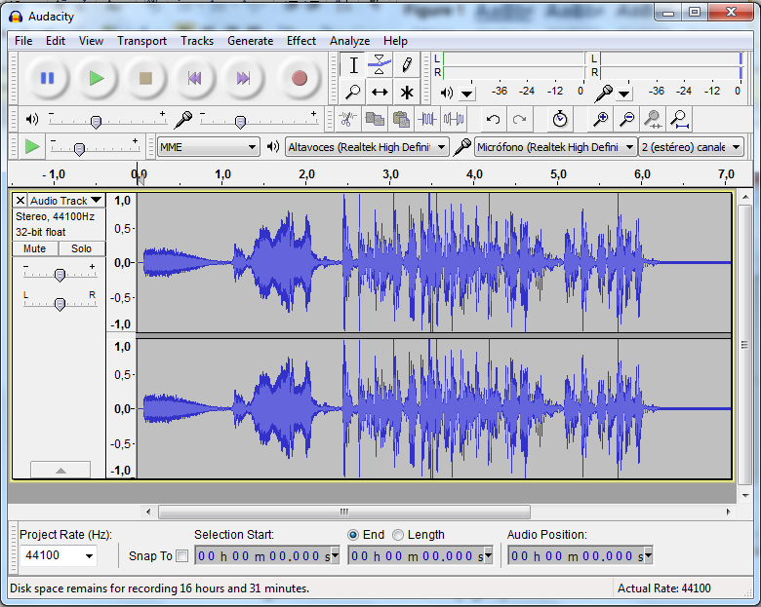
Figure 4-24. Audacity graphical interface.
For example, a sound could be recorded using a microphone and then add a piece of an audio file, and finally export it as an MP3 file.
In this way, new audio educational content can be created to be an alternative to the textual educational content, thus providing accessibility to students with visual disabilities and making them more attractive to students who usually carry an MP3 player.
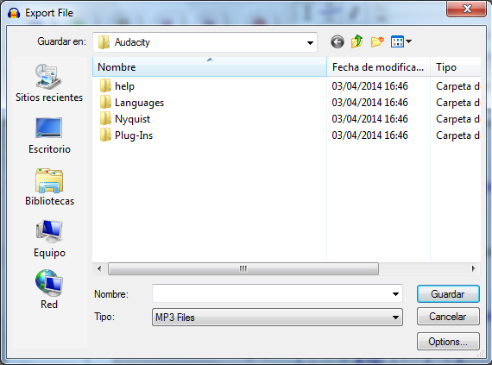
Figure 4-25. Saving as MP3 file an audio edited.

Creating audiobooks from Word documents
It is usually desirable hearing a voice which changes intonation according to the speech or emotions that the book transmits when listening to an audiobook, but this is not always possible because it should have been created in a professional studio. It is also not feasible (due to the large time required) that teachers record with their own voice all the class notes.
An alternative to this problem consists of recording the text using an application that recognizes the words and sentences of the text and, through a voice synthesizer, records them into an audio file.
Logically, the resulting speech will not have the emotional elements of an audiobook read and recorded by a person. In addition, the synthesizer should have into account the pronunciation of the text language because otherwise the result should be hardly intelligible.
Microsoft Word is one of the most used office software to create content by teachers, so in this section how to create an audiobook from a doc or docx document is explained.
To do this, the doc or docx file has to be saved in a special format for creating audiobooks, which allows subsequently be converted into an audio file using a voice synthesizer. This format is DAISY.
DAISY is the standard format for audiobooks and other audible texts. This format allows converting documents ready to be printed into audio documents, and is especially designed for people with visual disabilities or dyslexia. It is based on XML and MP3 formats and provides some additional features to an audiobook, such as searching, placing bookmarks or controlling the reading speed without distorting the voice.
Accessibility for tables and references is also provided, and has six levels of navigation, including embedded objects such as images, graphs or mathematical formulae in MathML.
DAISY is supported by a consortium created in 1996, consisting of international organizations dedicated to develop aids for disabilities and recognized by the NISO (National Information Standards Organization) as the official maintenance agency of the DAISY/NISO standard.

Installing the DAISY add-in in Microsoft Word 2010
DAISY is installed as a Microsoft Word add-in (plugin). First the translator to DAISY XML format has to be downloaded from the sourceforge website. When the file “DaisyInstaller_x86.exe” is downloaded, run it and follow the instructions.
Once it is installed, a new options menu appears in the menu bar of Microsoft Word (Figure 4-27).
In this options menu, the option “SaveAsDAISY” is included (Figure 4-28).
The file can be saved as DAISY XML, which contains the text but not the voice; or as Full DAISY, which shows the only option called “Narrator-DtbookToDaisy” and which converts the document into the final DTB (DAISY Digital Talking Book) format and includes the mp3 file with the speech of the text, using the default voice installed in Windows. These two options are also available to translate various DOCX simultaneously.
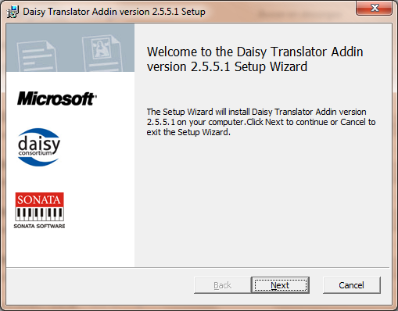
Figure 4-26. DAISY add-in installation dialogue.
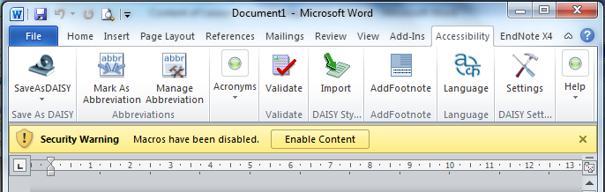
Figure 4-27. New options menu in Microsoft Word: “Accessibility”.
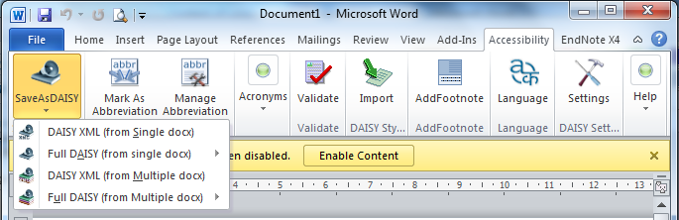
Figure 4-28. Options to save as DAISY in Word.

Installing voices for audiobooks speech
Windows includes an accessibility tool called “Narrator” which allows that a voice synthesizer plays audibly the content displayed on the screen. To access this tool, go to “Control panel”, “Accessibility center” and select “Start narrator”. The button “Voice settings” allows selecting the voice that will read the text.
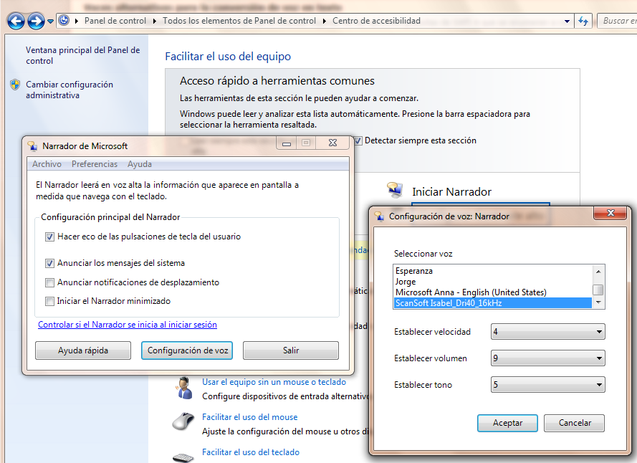
Figure 4-29. Selecting a voice for Windows narrator.
By default, only the “Microsoft Anna English (United States)” voice is installed in Windows 7, which makes extremely annoying and unintelligible the speech in languages different from English, due to its strong English pronunciation.
Also in this window other Narrator parameters can be configured, such as speech rate, volume and tone.
In older versions of Windows (XP and earlier), the SAPI 4 interface was used. The voices that SAPI 4 uses are not compatible with the new SAPI 5 interface, which the latest applications use.
Some voices in other languages can be downloaded from several websites, such as from “AT&T Natural Voices” website, Acapela website or Nuance Vocalizer website. In all cases, marketing is done by NextUp.com and downloads are not free (they cost from 28€ to 36€ each).
Another classic voices provider for Narrators is Loquendo Text to Speech. Today the company Loquendo has disappeared and is part of the company Nuance.
Once the narrator voices have been installed, audiobooks can be created from a Word document.

Creating audiobooks with Daisy
When the narrator voices have been installed and the default voice for Windows has been selected, the creation of audiobooks can start. Before the conversion, the .docx document should be validated because it may have some element that cannot be converted.
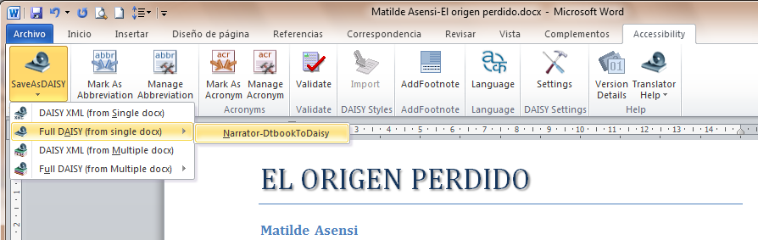
Figure 4-30. Save file as “Full DAISY”.
The plugin asks for some metadata and options for the conversion process (Figure 4-31). After this, the conversion starts (Figure 4-32).
When the process of creating an audiobook has finished, two folders will be created, which contain the files of the audiobook in two different formats:
- Folder Z3986 has the “speechgen.opf” file. Open Packaging Format (OPF) is a standard of the eBook specification and stores metadata such as title, language, creator, etc. This folder also has a XML file containing the text and a MP3 file containing the audio of the audiobook.
- Folder Daisy202 has the same MP3 files but the text is saved in a HTML file.
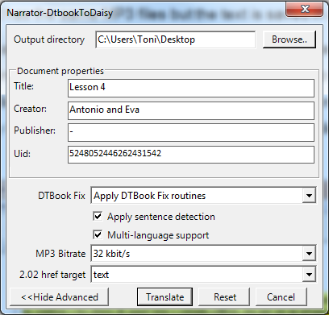
Figure 4-31. Options dialog and metadata for converting to DAISY.
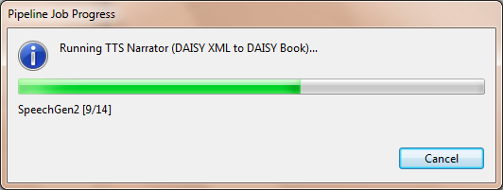
Figure 4-32. Process of creating an audiobook.
In both cases, text and audio are linked, so that with an appropriate reader the text can be followed while listening to it, or selecting the paragraphs you want to listen. A recommended DAISY files reader is Adaptive Multimedia Information System (AMIS), developed by the DAISY Consortium and can be downloaded and installed for free from their official website.
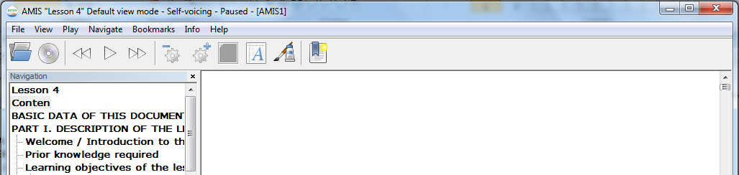
Figure 4-33. Reading an audiobook synchronizing text and audio.
The MP3 file can also be extracted to be used as an independent audio file.

Creating audiobooks using the tool Balabolka
Balabolka is an application for converting Text-To-Speech (TTS). It uses the voices already installed in the computer, which can be checked in Windows in “Control pane Accessibility center”. The application allows choosing the voice to read the text. The text can be saved in any of the most popular formats: WAV, MP3, MP4, OGG or WMA.
The text can also be copied to the clipboard and use Balabolka to read its content. It is also able to extract the text of a document in the following formats: AZW, AZW3, CHM, DjVu, DOC, EPUB, FB2, HTML, LIT, MOBI, ODT, PDF, PRC and RTF; and customize font and background color, control reading from the system tray or using hotkeys.
A version without graphical interface also exists, to create audiobooks from the command prompt using commands.
Balabolka uses various versions of Microsoft Speech API (SAPI), which allows modifying the voice parameters, including speed and tone. Users can define a list of words to improve their pronunciation in the text. This is useful when you want to change the pronunciation of some words. It allows saving audio files with ID3 tags in MP3 files. This facilitates the text is displayed while the sound plays in a suitable device (like MP3 music files).
Balabolka can be installed as a normal application in Windows or using the portable version, which allows running it on any computer without installation.
The graphical interface of the application has a window in which the text is loaded, and a toolbar to work with it. It allows starting reading, changing the voice of the speech, setting speed and tone, etc. (Figure 4-34 & Figure 4-35).
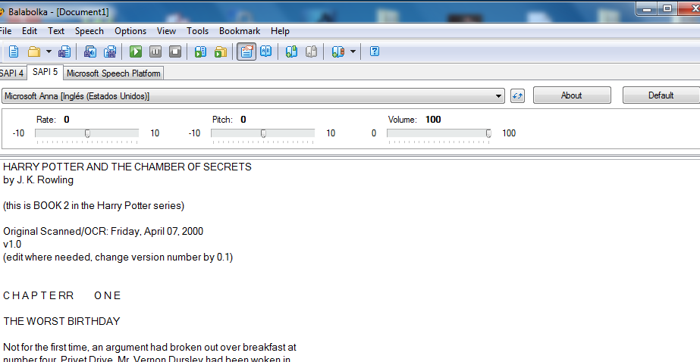
Figure 4-34. Graphical interface of the application Balabolka.
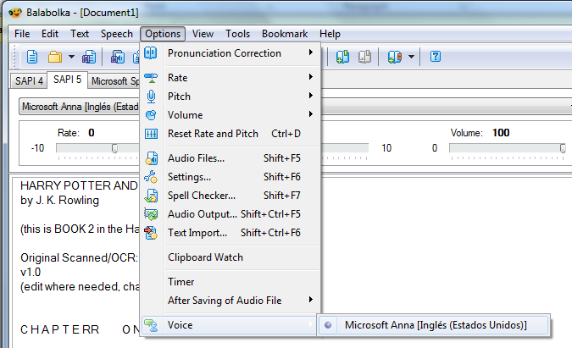
Figure 4-35. Selecting the voice of the speech.

Creating audiobooks with Balabolka
When the reading parameters (voice, tone, speed, volume, etc.) are set and tested with the text, conversion to an audio file in the desired format can start.
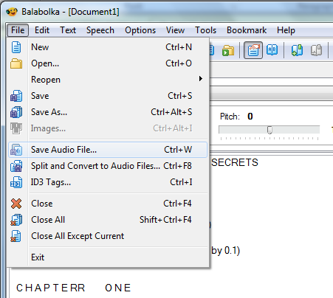
Figure 4-36. Creating an audio file.
If the text is very long (e.g. a whole novel), playing the audio file generated can take several hours. This is a disadvantage when trying to resume the speech after having interrupted: it would be like a musical CD had all the songs in only one track.
To solve this problem, the text document can be divided into smaller pieces, so that each audio unit takes approximately five minutes. For indicating to the application where the file has to be closed and start a new one, use the “Split and convert to audio files” option in the menu.
Marks in the document have to be written in order to indicate the breakpoints. As seen in Figure 4-37, there are several options.
The text read in each track can be included in the MP3 audio file as an ID3 tag, in a similar way to how a song can include an ID3 tag with title, author, performer, genre, etc. and also the song lyrics, which can be viewed on a proper music player.
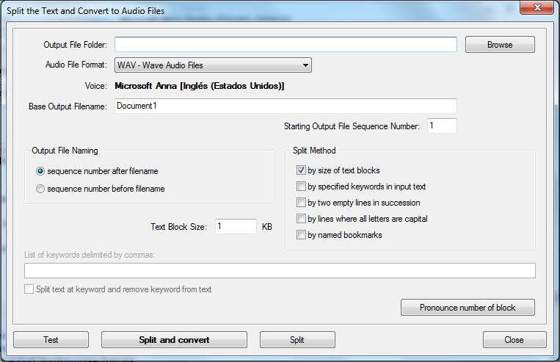
Figure 4-37. Options to divide the output file in various audio tracks.
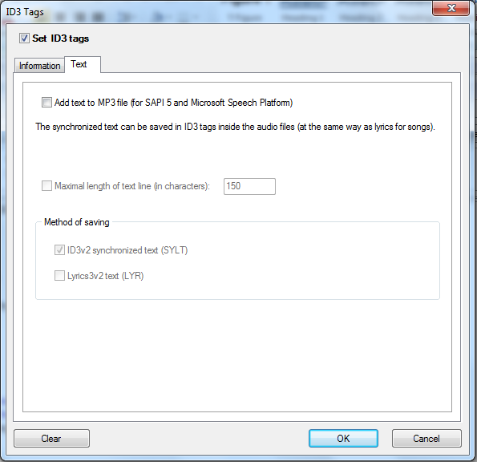
Figure 4-38. The audiobook created can include ID3 tags.

Inserting audio in PDF documents
One of the most important characteristics of PDF files is that they can include embedded multimedia files such as videos, audio or flash, making them more attractive and thus enriching the educational potential of this material when used in training.
The Adobe reader can play directly all H.264-compatible multimedia files. This codec, also known as MPEG-4 part 10, is a video codec that allows high resolution without excessive file sizes. If other non-compatible multimedia files are included in a PDF, users will need to have installed the corresponding playback applications. So, FLV, MOV and MP4 video files can be inserted into a PDF document, as well as MP3 audio files.
Inserting audio in a PDF file allows teachers complementing the textual information of the document and, from the point of view of accessibility, providing an (auditory) alternative to the text reading.
Adobe Acrobat (not just Reader) is necessary to insert audio in a PDF file, which is not free but widely used in many educational institutions.
The editing tool to be used is in menu “Tools Multimedia Sound tools”.
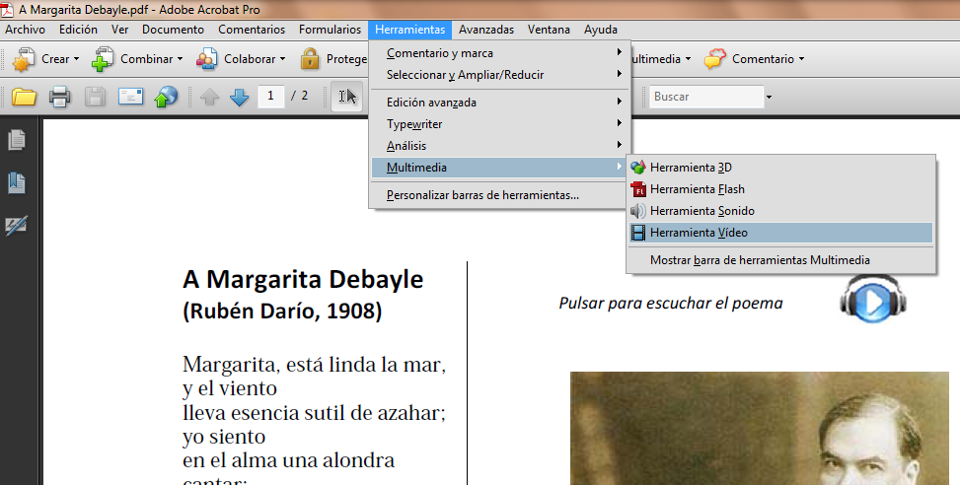
Figure 4-39. Tool for inserting audio in a PDF file.
Previously, when the PDF document was created, an icon could have been included to indicate to users that an audio is associated with the document and where they have to click to listen to it.
With the tool selected, draw with the mouse the activation zone of the audio.
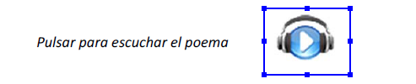
Figure 4-40. Drawing the activation zone of the audio.
Then the data of the MP3 file and the playback options desired are entered. Multiple multimedia files can be included in a PDF document.
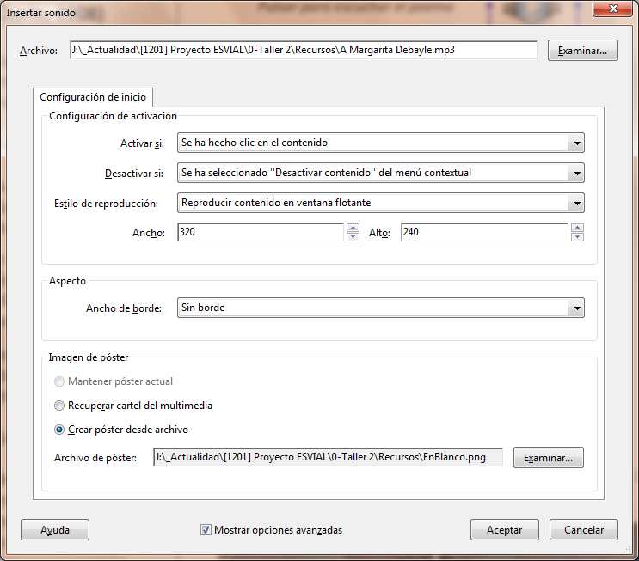
Figure 4-41. Identification of the audio file and selection of playback options.
When the file is saved, it can be distributed as usual and students just need a PDF reader to see it and play the audio associated.
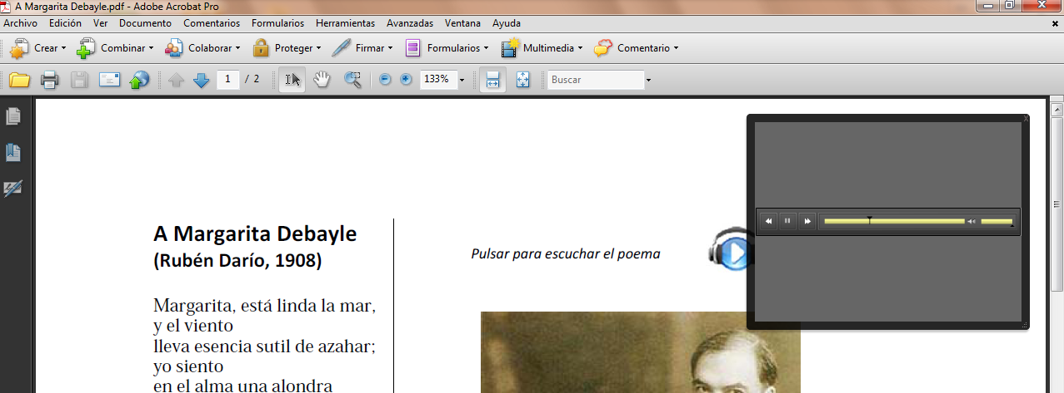
Figure 4-42. When the audio inserted is played, a playback controller is showed.
Another interesting option is including voice comments recorded directly with a microphone and add them to the PDF document. This option is especially useful in the tutoring process. For example, students may request a clarification about the scope or the meaning of the text in a PDF, recording the question in the PDF and submitting it to the teacher. The teacher, in turn, could add a new recording with the answers to students.
To be able to insert comments in a PDF file, the option for commenting has to be enabled in the creation phase. To do this, in menu “Comments”, check the “Enable comments and analysis in Adobe Reader” option.
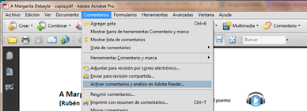
Figure 4-43. Enabling option for adding audio comments in a PDF document.
In the document, now readers can insert a comment recording directly from their microphone.
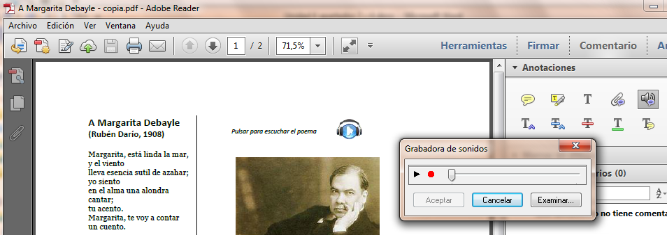
Figure 4-44. The PDF reader can include voice comments.
From that moment, an icon will be visible in the document, with which the voice comment included can be listened.
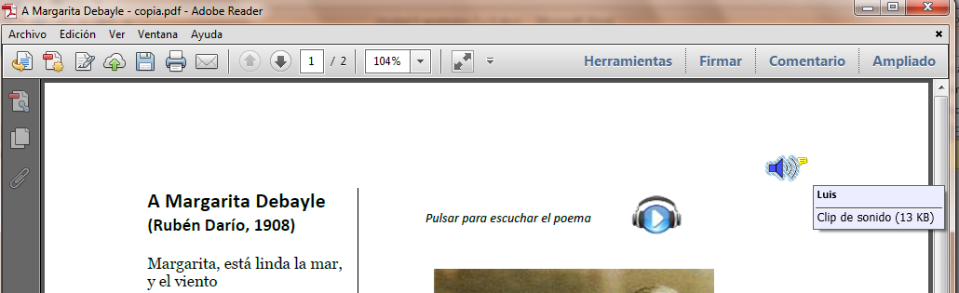
Figure 4-45. All the comments performed will be visible in the PDF document as icons.
Whenever audio is included in a PDF document, a textual alternative should be provided with the audio description or the text of the speech.

Checking accessibility in audio and video files
By and large, accessibility of audiovisual content is achieved by providing accessible alternative elements. It is important to attach audio descriptions to the videos, especially for people with visual disabilities, so that they can follow the sequence of actions in the video, complementing the sound and the original dialogues. For people with hearing disabilities, it is necessary to provide alternative texts and the audio description of the documents.
Using the sign language using an interpreter is also possible, which is the most common in conferences and live events, although an additional window can be inserted in a video to display the sign language interpreter. However, the last option is usually available only at a professional level, reserved for institutional documents, and is not considered as a necessary requirement for accessible educational content created by teachers.
Unlike reading, in which students can set the speed at which a text is read, in audiovisual content the playback speed is set beforehand. This can be an additional barrier to accessibility if, for example, the time to read the captions of a video is not enough. It is therefore necessary that audiovisual educational content used by teachers are played in a window with appropriate controls (pause, continue, restart, etc.). In addition, these controls should also be available through keyboard to allow people with visual or motor disabilities do not have to use the mouse to control playback.
In short, accessible alternatives for audiovisual content can be grouped into five categories:
- Audio and video playback controls with keyboard alternatives.
- Transcript of audiovisual content.
- Captions.
- Audio description.
- Sign language interpreter (reserved for professionals).

Accessibility checklist for audio documents
If audio documents are included as educational content, the following should be checked to ensure their accessibility:
- Existence of alternative text. Check that an alternative text is included for all the audio content. This can be done:
- In the same document. For example, in a PDF file or in a webpage.
- Using a link from the original document to reach the alternative text.
- Appropriate alternative text. Check that the alternative text allows identifying not only the talk but also who is talking, noises (clapping, falling objects, cars moving away, etc.) and everything that helps understanding the meaning to be conveyed with the audio document.
- Playback control. Check that the document can be paused and resumed, restarted, etc.

Accessibility checklist for videos
Videos usually include a soundtrack, so that alternatives to make it accessible should include both visual band and the soundtrack. In the latter case, the accessibility requirements are the same as for other audio files, so the soundtrack should follow the checklist of the previous section.
To ensure the accessibility of videos used as educational content, the following should be checked:
- Existence of alternative text.
(Requirement in common with audio documents).
- Appropriate alternative text.
(Requirement in common with audio documents).
- Playback control.
(Requirement in common with audio documents).
Besides the usual playbacks, the following should be included for videos:
- Resizing the window of the video playback, including the whole window of the device used.
- Enable / disable captions. For captions in several languages, users could choose between them.
- Captions.
Check that the alternative text provided is synchronized with the actions in the video, and appear properly on the playback screen. To do this:
- Captions should correspond to the soundtrack, including dialogue and sounds.
- The text displayed on the screen should not take up more than two lines.
- The time for displaying a caption should be enough to be read comfortably.
- The font size must be appropriate, as well as its color and contrast to the images in which overlies.
Captions can be stored in a different file from the video’s or being embedded in the frames of the video. The advantage of the latter option is that their appearance does not depend on the video player used to play it. However, there are several drawbacks that make it inadvisable, such as:
- It does not allow hiding/displaying captions, as they always appear.
- It does not allow using captions in several languages.
- It does not allow searching by text, which some players have and which facilitates moving to a particular video sequence in which the text searched is, within captions.
- Flashes and flickers.
Flashing or flickering video frames can cause epileptic seizures in people with photosensitive epilepsy. Therefore, special care should be taken when flashes appear in a video or sequences in which very clear images suddenly change by other dark.
As a rule, no more than three flashes per second should appear or take up more than a quarter of the screen. Also, flicker should not appear with a frequency between 4 and 60 hertz.
Free tools such as Photosensitive Epilepsy Analysis Tool (PEAT) (2012) allow evaluating the potential danger of a video for people with this sensitivity.
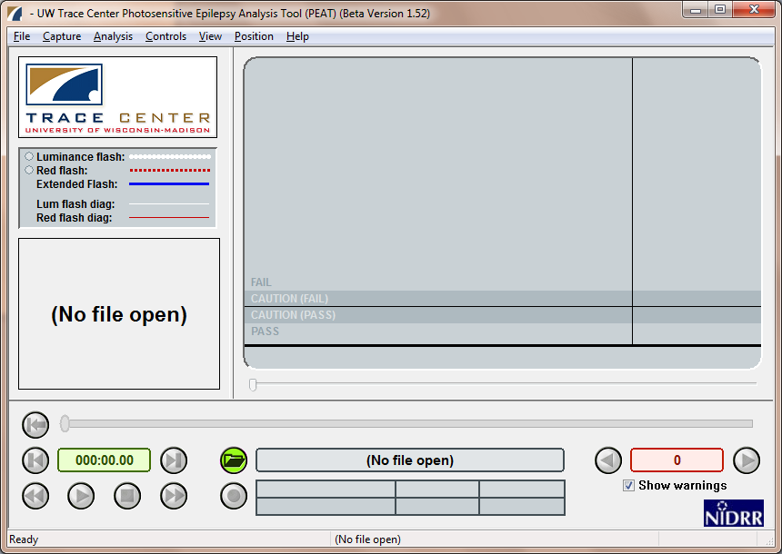
Figure 4-46. PEAT Tool which allows evaluating the potential danger of a video.

Creating accessible web pages

Translators:
Eva García López
Antonio García Cabot
University of Alcalá, Spain

Authors:
Teresa Díez Folledo
María José Domínguez Alda
University of Alcalá, Spain

Accessibility is very important when designing websites and webpages, in order to ensure the use of Internet for all.
In 1994 the international consortium W3C was created, whose mission is to lead the web to its full potential by developing protocols and guidelines that ensure long-term growth. Within this consortium, WAI emerged, whose aim is broadcasting the web accessibility principles to enterprises, governments, institutions, developers and users.
At this moment the WAI recommends using the WCAG 2.0, published in (2008), which will be the basis of the work of this guide, whose objective is not teaching how to create a website or a webpage (this knowledge is considered a prerequisite for this course), but to explain the steps to be followed and the recommended checkings to create accessible webpages.
The tools that can be used to evaluate the accessibility of webpages in a website are also detailed.

Guidelines to create accessible web contents
WAI, entity to disseminate the web accessibility principles within the W3C consortium, recommends developing web content following the WCAG 2.0 guidelines (World Wide Web Consortium, 2008).
These accessibility recommendations are based on four fundamental principles, perceivable, operable, understandable and robust, under which twelve guidelines are established, which provide the basic goals that authors should work toward in order to make content more accessible to users with different disabilities:
- Perceivable:
  - Provide text alternatives for any non-text content so that it can be changed into other forms people need, such as large print, braille, speech, symbols or simpler language.
  - Provide alternatives for time-based media.
  - Create content that can be presented in different ways (for example simpler layout) without losing information or structure.
  - Make it easier for users to see and hear content including separating foreground from background.
- Operable:
  - Make all functionality available from a keyboard.
  - Provide users enough time to read and use content.
  - Do not design content in a way that is known to cause seizures.
  - Provide ways to help users navigate, find content, and determine where they are.
- Understandable:
  - Make text content readable and understandable.
  - Make Web pages appear and operate in predictable ways.
  - Help users avoid and correct mistakes.
- Robust:
  - Maximize compatibility with current and future user agents, including assistive technologies.
These guidelines have become an international standard on which a website should be based from the early stages of design. For each of the guidelines, success criteria are provided, which in turn are divided into three levels: A, AA and AAA.
Finally, five conformance requirements are established, which must be satisfied:
- Conformance level: To achieve conformance with A, AA or AAA levels, a webpage satisfies all the success criteria of the level, or an alternate version conforming to the level is provided.
- Full pages: Conformance (and conformance level) is for full Web page(s) only, and cannot be achieved if part of a Web page is excluded.
- Complete processes: When a Web page is one of a series of Web pages presenting a process, all Web pages in the process conform at the specified level or better.
- Only accessibility-supported ways of using technologies: Only accessibility-supported ways of using technologies are relied upon to satisfy the success criteria.
- Non-interference: If technologies are used in a way that is not accessibility supported, or if they are used in a non-conforming way, then they do not block the ability of users to access the rest of the page.
A detailed description of the aspects of the webpage to be considered for a formal assessment of the level of compliance with the WCAG 2.0 (World Wide Web Consortium, 2008) success criteria in levels A and AA is explained below, both of the webpage and the elements with accessibility requirements included in it.
In each of the sections are described the success criteria that should be met and the recommended checkings for each of them.
Finally, how to perform an overall evaluation of the accessibility of the webpage is explained, both automatically (using the tools available on the web) and manually (installing a free screen reader).

Developing an accessible website

Language of the website
The language of the webpage should be defined correctly so that browsers, screen readers and other devices that work in various languages can identify it and display correctly the information of the webpage. This will facilitate understanding the content to all users, with or without disabilities.
If the content of a webpage are written in different languages, it is necessary to identify the language in each part so that any application can perform the necessary adaptations. For example, a webpage written in Spanish may include a paragraph or quote in English, or a link to the English version of the webpage whose text is in turn in English.
Guideline 3.1 (Readable) contains the success criteria 3.1.1 (level A) and 3.1.2 (level AA):
3.1.1. Language of page. The default human language of each Web page can be programmatically determined.
3.1.2. Language of parts. The human language of each passage or phrase in the content can be programmatically determined except for proper names, technical terms, words of indeterminate language, and words or phrases that have become part of the vernacular of the immediately surrounding text.
The language used, both in the webpage and in each of its elements, is defined using the “lang” attribute on the HTML element of the body of the page or of the corresponding element, if a different language used from the rest of the page. You should check this attribute is defined for the entire webpage and for each element (sections, paragraphs, links, etc.) that uses a different language, and that it is correctly defined; i.e., the language used is accurately identified.
Using Web Accessibility Toolbar by Internet Explorer, option “Doc info Show lang attributes”.

Descriptive title of the webpage content
The title of the webpage allows users to quickly and easily identify the information contained in the webpage. For people with cognitive disabilities and low vision or other difficulties who use audio devices to navigate the web, it is important that the title clearly describes the information in the webpage. On the other hand, this description will appear in site maps or in search results, allowing users to decide whether the webpage fits their needs or preferences.
Guideline 2.4 (Navigable) contains the success criterion 2.4.2 (level A).
2.4.2. Page titled:
- Web pages have titles that describe topic or purpose.
- The descriptive title of an HTML Web page is marked up with the <title> element so that it will be displayed in the title bar of the user agent.
You should check that the title of the webpage that appears in the title bar at the top of the screen describes adequately the information contained on the webpage. The option “Navigation Title” in Web Developer Toolbar by Mozilla Firefox, can be used to check it.

Information structure
The objective of a webpage is to convey its content so that its presentation should not obstruct the access to it. Guideline 1.3 (Adaptable) contains the following success criteria (level A):
1.3.1. Info and relationships. Information, structure, and relationships conveyed through presentation can be programmatically determined or are available in text.
1.3.2. Meaningful sequence. When the sequence in which content is presented affects its meaning, a correct reading sequence can be programmatically determined.
It is recommended to perform the following checkings.

Separation of content from the visual presentation
HTML tags to structure the content and CSS style rules to present the content should be used together. The correct separation of presentation and content can be checked by disabling CSS:
- Using Web Developer Toolbar for Mozilla Firefox, selecting the option “CSS Disable styles All styles”.
- Using Web Accessibility Toolbar for Internet Explorer, selecting the option “CSS Disable CSS”.
Once the style rules are disabled, check that the page content is still understandable and its meaning has not been modified.

Structured content
Content should be structured according to semantic criteria that provide meaning and prioritize information. The elements and sections in the content should be identified, distinguishing lists, headers, paragraphs, links, and data tables. Semantic tags are used, which allow providing an additional meaning to the content (important text highlighted, special text like an e-mail, etc.) and more specifically the elements included in the webpage. This will prevent the content presentation generates accessibility issues. Guideline 2.4 (Navigable) contains the success criterion 2.4.6 (level AA):
2.4.6. Headings and labels. Headings and labels describe topic or purpose.
The following checkings are recommended to be performed:

Headers
Using clear and descriptive headers allows users understanding the structure of the page and finding more easily the information searched. It is recommended to check that the webpage contains headers that identify each section of the content.
- Using Firefox Web Developer Toolbar to check the correct order, option “Outline Outline headings”. With this activation, how the headers are organized can be checked, and so perform an evaluation of their use.

Tags
Using descriptive tags allows users identifying the elements on a webpage. Once each component of the webpage is identified, it is recommended to verify that they are correctly tagged and that the tag clearly indicates its purpose. The recommended checkings are detailed in section B, in which the accessibility requirements of the different elements of a webpage are described.

Coherent, consistent and homogeneous presentation in navigation elements
Navigation elements help users to know where they are within the website, to move between the content and to identify the main information of the webpage, facilitating accessibility.
Guideline 3.2 (Predictable) includes the success criterion 3.2.3 (level AA):
3.2.3. Consistent navigation. Navigational mechanisms that are repeated on multiple web pages within a set of Web pages occur in the same relative order each time they are repeated, unless a change is initiated by the user.
In websites that consist of a large number of pages it is also recommended, for facilitating the overall accessibility, to include a site map or a table of contents in which a hierarchical list is included with all the pages that compose it. This site map should contain the main sections and depict well the structure of the website.
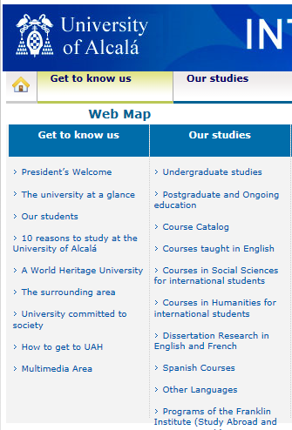
Figure 5-1. Site map.

Correctly using HTML and CSS
Using wrong HTML tags or poorly defined style rules may lead support devices to confusion. Guideline 4.1 (Compatible) includes the success criterion 4.1.1 (level A):
4.1.1. Parsing in content implemented using markup languages:
- Elements have complete start and end tags.
- Elements are nested according to their specifications.
- Elements do not contain duplicate attributes, and any IDs are unique, except where the specifications allow these features.
The following checkings are recommended:
- Check whether the HTML tags format is correct, because improper use of tags can affect screen readers and other support products. Use the W3C official validator (markup validation service).
- Check whether the CSS style sheets format used is correct: Use the W3C official validator (CSS validation service).

Presentation of the webpage

Using color
In relation to the use of color, the perceivable principle contains Guideline 1.4 (Distinguishable) and under it the success criteria 1.4.1 (level A) and 1.4.3 (level AA):
1.4.1. Use of color: Color is not used as the only visual means of conveying information, indicating an action, prompting a response, or distinguishing a visual element.
1.4.3. Contrast (minimum): The visual presentation of text and images of text has a contrast ratio of at least 4.5:1, except for the following:
- Large Text: Large-scale text and images of large-scale text have a contrast ratio of at least 3:1;
- Incidental: Text or images of text that are part of an inactive user interface component, that are pure decoration, that are not visible to anyone, or that are part of a picture that contains significant other visual content, have no contrast requirement.
- Logotypes: Text that is part of a logo or brand name has no minimum contrast requirement.
The following checkings are recommended:

Check that there is an alternative to every information conveyed with color differences in the webpage
It refers to situations in which each color has a meaning, such as forms that highlight with a certain color the mandatory or wrong fields, or links identified with different colors when their target opens in a new webpage. In all cases it should be checked that another mecanism has been included to convey the information, either by an alternative text, in the text label of the field or other options.

Check values of color contrast and test color changes that may improve the contrast
The following tools can be used:
- For Firefox, use the extension WCAG contrast checker.
- Use the online analyzer Web Accessibility Evaluation (WAVE), which allows testing colors to achieve the adequate contrast using the extension “Accessibility evaluation toolbar”.
- Install and use the analyzer Colour contrast analyser, application that allows checking specific points of the webpage.

Text size
About the text size, in the Perceivable principle is included Guideline 1.4 (Distinguishable), which contains success criterion 1.4.4 (level AA):
1.4.4. Resize text: Except for captions and images of text, text can be resized without assistive technology up to 200 percent without loss of content or functionality.
To verify this guideline, using the browser zoom at 200% is recommended, and then checking that both the content and the page functionality are available.

Sound on webpages
In Guideline 1.4 (Distinguishable), success criterion 1.4.2 (level A) can be found:
1.4.2. Audio control: If any audio on a Web page plays automatically for more than three seconds, either a mechanism is available to pause or stop the audio, or a mechanism is available to control audio volume independently from the overall system volume level.
When using a screen reader, it is necessary to be able to disable any sound that prevent or interfere hearing the voice output.
Therefore, you should check that every sound with duration longer than three seconds can be controlled by the user.

Flashes, blinks, movement and automatic refresh
Flashes, blinks or movements in the content of web pages are evaluated in this section. These aspects refer to avoid causing flashes on the screen or rapid changes in luminosity. A flickering or flashing screen may cause attacks to users with photosensitive epilepsy.
First flashes on the screen should be evaluated, by applying Guideline 2.3 (Do not design content in a way that is known to cause seizures) and the success criterion 2.3.1 (level A):
2.3.1. Three flashes or below threshold: Web pages do not contain anything that flashes more than three times in any one second period, or the flash is below the general flash and red flash thresholds (level A).
W3C provides the PEAT (2012) tool. This is software that identifies the risks that web content may have, if flashes, blinks or movements occur. To perform the analysis it is necessary to capture navigation in the website being analyzed, by creating an AVI video file. Once the capture of the page is done, a report about it is written.
Guideline 2.2 (Enough time) contains the success criterion 2.2.2. Pause, stop, hide (level A):
2.2.2. For moving, blinking, scrolling, or auto-updating information, all of the following are true:
- Moving, blinking, scrolling: For any moving, blinking or scrolling information that (1) starts automatically, (2) lasts more than five seconds, and (3) is presented in parallel with other content, there is a mechanism for the user to pause, stop, or hide it unless the movement, blinking, or scrolling is part of an activity where it is essential; and
- Auto-updating: For any auto-updating information that (1) starts automatically and (2) is presented in parallel with other content, there is a mechanism for the user to pause, stop, or hide it or to control the frequency of the update unless the auto-updating is part of an activity where it is essential.
The following aspect to be evaluated is automatic refreshing the webpage. This refers to those webpages that are refreshed at irregular intervals, i.e., without the user requiring this refresh, which can cause the user be disoriented by the refresh. Whenever possible, try to avoid automatic refresh, although sometimes there is no choice but to use them. If necessary, the user should be able to choose the moment when these refresh occur. The Firefox Web Developer Toolbar can be used. This toolbar offers to evaluators the possibility of disabling automatic refresh (Figure 5-2).
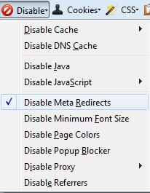
Figure 5-2. Disable automatic refresh in Web Developer Toolbar.
Once the automatic refresh is disabled, you should check whether the webpage keeps all the functionality and aspect without using these techniques.

Limits on the interaction time with the webpage
Limiting the interaction time with a webpage may complicate reading the content or performing functions such as filling out a form to users with low vision or cognitive disabilities, who may need more time. It is recommended to avoid its use whenever possible, allowing customization or extension when the limit is necessary. In Guideline 2.2 (Enough time) is included the success criterion 2.2.1 (level A):
2.2.1. Timing adjustable: For each time limit that is set by the content, at least one of the following is true:
- Turn off: The user is allowed to turn off the time limit before encountering it.
- Adjust: The user is allowed to adjust the time limit before encountering it over a wide range that is at least ten times the length of the default setting.
- Extend: The user is warned before time expires and given at least 20 seconds to extend the time limit with a simple action (for example, "press the space bar"), and the user is allowed to extend the time limit at least ten times.
- Real-time exception: The time limit is a required part of a real-time event (for example, an auction), and no alternative to the time limit is possible.
- Essential exception: The time limit is essential and extending it would invalidate the activity.
- 20 hour exception: The time limit is longer than 20 hours.
It is recommended to check that the user can stop, adjust or extend the existing time limits except in the two exceptions described: when the time limit is due to a real-time event or is longer than twenty hours.

Access via keyboard
In the Operable principle are Guideline 2.1 (Make all functionality available from a keyboard) and 2.4 (Provide ways to help users navigate, find content, and determine where they are), and the success criteria 2.1.1, 2.1.2 and 2.4.3 (level A) and 2.4.7 (level AA):
2.1.1. Keyboard: All functionality of the content is operable through a keyboard interface without requiring specific timings for individual keystrokes, except where the underlying function requires input that depends on the path of the user's movement and not just the endpoints.
2.1.2. No keyboard trap: If keyboard focus can be moved to a component of the page using a keyboard interface, then focus can be moved away from that component using only a keyboard interface, and, if it requires more than unmodified arrow or tab keys or other standard exit methods, the user is advised of the method for moving focus away.
2.4.3. Focus order: If a Web page can be navigated sequentially and the navigation sequences affect meaning or operation, focusable components receive focus in an order that preserves meaning and operability.
2.4.7. Focus visible: Any keyboard operable user interface has a mode of operation where the keyboard focus indicator is visible.
As an initial checking, an exploration of the website will be performed using the keyboard to check whether all the functionality is kept.
Then the use of keyboard to interact with the website should be checked, first verifying that keyboard traps have been avoided, i.e., the user always should be able to exit the application with the tab key without getting “stuck” when he/she finishes navigation. WCAG 2.0 recommends the following checkings:
- It is possible to use the tab key from the start to the end of the content.
- The keyboard focus is not trapped in any of the content.
- If the keyboard focus is trapped in any content, check that the available help information explains how to exit the content using the keyboard.
About Guideline 2.4.3, which refers to the focus order, it is recommended to check that the webpage contains a logical tabulation order and therefor a logical navigation order. The default tab order starts in the first link or control of the document, continuing in the order that these elements appear on the webpage. The Internet Explorer bar, Web Accessibility Toolbal, can be used as seen in Figure 5-3.
When the tab order is enabled, the order of every content while navigating the webpage using the keyboard is showed on the webpage, by numbers, allowing checking whether it is correct.
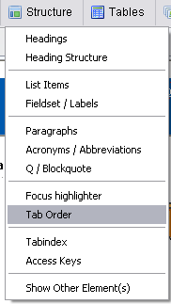
Figure 5-3. Show tab order in Web Accessibility Toolbar.
For checking the success criterion 2.4.7, moving through the webpage using the keyboard is recommended, verifying that there is a visual mechanism that indicates the position of the focus on the webpage. Thus users who rely on keyboard to navigate can visually identify the element with which they are interacting at all times. This mechanism may be, for example, a mark or a highlighted border.

Embedded objects and scripts
Embedded objects such as scripts or Java applets should be fully accessible without the need of an alternative provided the technology used supports accessibility and the object or script has been developed in an accessible way. This method provides dynamic documents and minimizes the workload on Web servers, as part of the work is derived to clients. Accessible alternatives are required, as well as providing information and functionalities included in the programming elements through means which allow their correct interpretation and availability to all users.
In conformance requirements of WCAG 2.0, the following is mentioned (requirement 5):
5. Non-interference: If technologies are used in a way that is not accessibility supported, or if they are used in a non-conforming way, then they do not block the ability of users to access the rest of the page. In addition, the Web page as a whole continues to meet the conformance requirements under each of the following conditions:
- When any technology that is not relied upon is turned on in a user agent.
- When any technology that is not relied upon is turned off in a user agent.
- When any technology that is not relied upon is not supported by a user agent.
To evaluate this kind of technologies, Javascript should be disabled and check that no information of the webpage is lost and it is still navigable. The option to disable Javascript in the browser can be used, or the following tools:
- For Firefox, the Web Developer Extension.
- For Internet Explorer, the Web Accessibility Toolbar.
To disable Javascript using the option of the browser, for example in Firefox, go to the tab “Content” (only in versions prior to Firefox 23).
If using Web Accessibility Toolbar for Internet Explorer, you could simulate that the browser does not support JavaScript as shown in Figure 4.
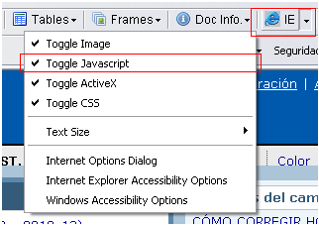
Figure 5-4. Disabling JavaScript with Web Accessibility Toolbar.
Once the technology JavaScript has been disabled, a manual review of the functionality of the website without JavaScript could be performed, and check how this deactivation affects the website functionality. By doing this, although user agents do not support this technology, alternatives to this should be provided for accessing the content.
To validate the embedded objects of the page, as for scripts, it is necessary to disable the technology that supports this type of objects. For this evaluation, the Web Accessibility Toolbar for Internet Explorer is used to disable supporting ActiveX objects, as seen in Figure 5-5.
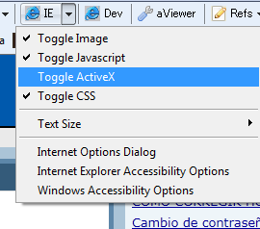
Figure 5-5. Disabling ActiveX with Wed Accessibility Toolbar.

Accessibility of the webpage elements

Images
The accessibility of images on a website is essential for the correct overall perception of the website. To evaluate them, they are divided into alternatives to images and text images.

Alternatives to images
Recommendations related to the accessibility of images are within the Perceivable principle. Guideline 1.1 (Text alternatives) contains the success criterion 1.1.1 (level A):
1.1.1. Non-text content: All non-text content that is presented to the user has a text alternative that serves the equivalent purpose, except for the situations listed below.
- Controls, input: If non-text content is a control or accepts user input, then it has a name that describes its purpose.
- Time-based media: If non-text content is time-based media, then text alternatives at least provide descriptive identification of the non-text content.
- Test: If non-text content is a test or exercise that would be invalid if presented in text, then text alternatives at least provide descriptive identification of the non-text content.
- Sensory: If non-text content is primarily intended to create a specific sensory experience, then text alternatives at least provide descriptive identification of the non-text content.
- CAPTCHA: If the purpose of non-text content is to confirm that content is being accessed by a person rather than a computer, then text alternatives that identify and describe the purpose of the non-text content are provided, and alternative forms of CAPTCHA using output modes for different types of sensory perception are provided to accommodate different disabilities.
- Decoration, Formatting, Invisible: If non-text content is pure decoration, is used only for visual formatting, or is not presented to users, then it is implemented in a way that it can be ignored by assistive technology.
To evaluate whether this guideline is met, displaying the alternative text for each image instead of the image should be enabled, and checking that no information of the webpage is lost and is still navigable. The option to disable browser images should be used, or the following tools:
- In Internet Explorer, using the Web Accessibility Toolbar: option “Images Remove images”.
- In Firefox, using the “Accessibility Evaluation Toolbar” extension. In this toolbar, enable the option to display the alternative text, available at: “Text equivalents Show text equivalents”.
- In Firefox, using the Web Developer Extension. In this toolbar, the following options can be enabled:
- Display alternative text with the image. Option available at: “Images Display alt attributes”.
- Display only alternative text. Option available at: “Images -> Replace images with alt attributes”.
One of the exceptions aforementioned described referred to non-textual content that serve as decoration. These images are used as graphical resources for the design of webpages and do not provide any information or functionality. These kinds of images should be included using CSS style sheets. If included in the HTML code, it should be implemented so as to be ignored by screen readers or similar support devices. To do this, check that no description or alternative text (attribute alt=” “) is included.
For functional images, used to serve as link to a webpage or a file, the alternative text associated to an image should clearly describe the objective of the link. The following is an example of the correct use of the alternative text:
Link to email.

Text images
Text images are considered within the Perceivable principle, in Guideline 1.4 (Make it easier for users to see and hear content including separating foreground from background). Under it is the success criterion 1.4.5 (level AA):
1.4.5. Images of text: If the technologies being used can achieve the visual presentation, text is used to convey information rather than images of text except for the following:
- Customizable: The image of text can be visually customized to the user's requirements. This occurs when the following can be set:
- Font type.
- Size.
- Color.
- Background.
- Essential: A particular presentation of text is essential to the information being conveyed. It is considered essential because if deleted, the information of functionality of the content would change.
An example of these text images can be to include a logotype on a webpage, the logo of a university or a bank. In this case, the success criterion is met because it is essential to include the text of the logotype to convey information.
Figure 5-6 does not allow modifying the characteristics aforementioned, and uses a textual alternative that correctly describes the image but not its functionality. This is an important aspect for allowing its reading using screen readers and making it accessible for users with visual or cognitive disabilities.

Figure 5-6. Image with the logo of the University of Alcalá.

Multimedia (audio, video, presentations)
If a webpage includes multimedia elements, their accessibility should be evaluated according to what explained in Unit 4 of the workshop.

Forms
One of the elements of a webpage where more accessibility issues can be found is forms. The aspects to be taken into account so that these elements are accessible for all users are described below.

Labels of form controls
A label describes the purpose of a control, if correctly defined, allowing all users to know it even when using support devices. In Guideline 3.3 (Input Assistance) and 4.1 (Compatible) are included the success criteria 3.3.2 and 4.1.2 (level A):
3.3.2. Labels or instructions: Labels or instructions are provided when content requires user input.
4.1.2. Name, role, value: For all user interface components: the name and role can be programmatically determined; states, properties, and values that can be set by the user can be programmatically set; and notification of changes to these items is available to user agents, including assistive technologies.

Checking that all controls that require it have a label
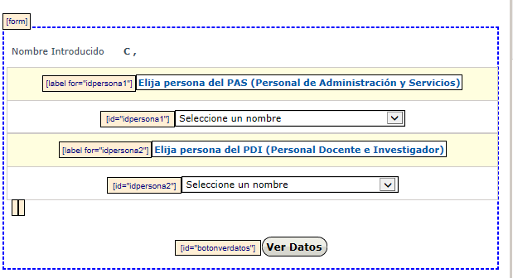
Figure 5-7. Labels highlighted in a form using Web Accessibility Toolbar.
- Using the Web Accessibility Toolbar for Internet Explorer, with option “Structure Fieldset / Labels”, LABEL items can be highlighted (Figure 5-7).
- Using the Web Developer Toolbar for Firefox, option “Outline Outline custom elements”.

Checking that labels are correctly placed
A label should be placed immediately before or after its control, in the same line (or above the control, if the line is different) or the control should be placed within the label (Figure 5-8).
Figure 5-8. Form control label placed before it.
To check the correct placing of the labels, the webpage can be accessed, disabling styles. This checking can be performed using the available options to disable styles in the toolbars:
- Using Web Developer Toolbar for Mozilla Firefox, option “CSS Disable styles All styles”.
- Using Web Accessibility Toolbar for Internet Explorer, option “CSS Disable CSS”.

Required fields
The required fields should be clearly identified. It should also be checked, as explained in page 191, that they are identified in an alternative way to the commonly used visual indicator (color or asterisk) to ensure the accessibility of the form.

Unforeseen changes in the webpage
Accessing or entering data in the form controls should not cause changes in the webpage, except when the user has been previously warned. Guideline 3.2 (Predictable) includes the success criteria 3.2.1 and 3.2.2 (level A):
3.2.1. On focus: When any component receives focus, it does not initiate a change of context.
3.2.2. On input: Changing the setting of any user interface component does not automatically cause a change of context unless the user has been advised of the behavior before using the component.
Therefore, it should be checked that no changes are produced, unless notice, when entering information in the form controls. WCAG recommends including buttons to Send, Confirm and See data, which indicate that this change will occur.
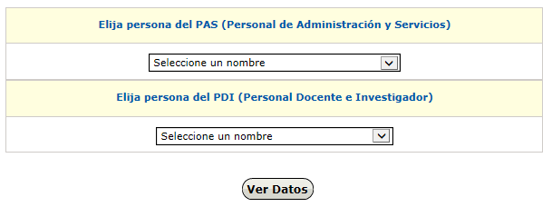
Figure 5-9. Button indicating that a change will occur on the screen.

Errors in data entry
Users should be informed about the errors in data entry, if it occurs. Guideline 3.3 (Input Assistance) contains the success criteria 3.3.1 (level A), 3.3.3 and 3.3.4 (level AA):
3.3.1. Error Identification: If an input error is automatically detected, the item that is in error is identified and the error is described to the user in text.
3.3.3. Error suggestion: If an input error is automatically detected and suggestions for correction are known, then the suggestions are provided to the user, unless it would jeopardize the security or purpose of the content.
3.3.4. Error prevention (legal, financial, data): For Web pages that cause legal commitments or financial transactions for the user to occur, that modify or delete user-controllable data in data storage systems, or that submit user test responses, at least one of the following is true:
- Reversible: Submissions are reversible.
- Checked: Data entered by the user is checked for input errors and the user is provided an opportunity to correct them.
- Confirmed: A mechanism is available for reviewing, confirming, and correcting information before finalizing the submission.
To check it, wrong data will be entered in the corresponding fields, checking whether errors are detected and suggestions are obtained about the correct data entry. These criteria complement criterion 3.3.2. described in 5.3.3.1 about information in form fields.
It should also be checked, in the case of errors described in criterion 3.3.4, that option for confirming, reviewing or resending data has been included.

Using and submitting the form is independent of supporting scripts
A form should not lose functionality if JavaScript is disabled (see section 5.2.6). To check whether a form depends on scripts, the tools for disabling it included in Web Developer Toolbar and Web Accessibility Toolbar can be used.
Check that, once the scripts support has been disabled, the form can be filled out and submitted correctly.

Using and submitting the form is independent of the device used
A form should be usable by any input device, either a stylus or a keyboard or a voice browser. Therefore, in the case of including scripts in forms, device-independent event handlers (also called application triggers: onfocus, onblur, onselect, onchange) should be used.
Web Accessibility Toolbar for Internet Explorer has an option to assist in this task: “Structure Event handlers” (Not in recent versions).
A window appears with the result, allowing to know the number and type of event handlers used and to check that no mouse-dependent (onclick, onmouseover) or keyboard-dependent (onkeypress) handlers are used.

Accessing the form via keyboard
As described in 5.2.5, all the elements of a webpage should be operable only with keyboard. It will be necessary to check that the tab order of the elements in a form is correct.
- A manual checking can be done through the interaction elements of the page and observing that not inconsistent jumps occur between controls and the tab order follows the logical reading order of the page.
- Using Web Accessibility Toolbar, option “Structure Tab order indicator”, the tab order for the interaction elements of a page is showed (Figure 5-10).
- It can also be checked using a screen reader such as NVDA or JAWS (demo).

In complex forms, with lots of input data, the information is correctly grouped
In forms with lots of input data, the controls should be grouped according to their meaning and functionality. To group several controls element FIELDSET is used, and element LEGEND is used for the mandatory group description.
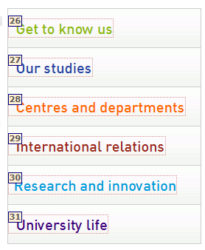
Figure 5-10. Showing the tab order in Web Accessibility Toolbar.
- To check if elements FIELDSET and LEGEND are correct, the following can be performed manually:
- Disabling CSS styles, as described in 5.2.3, and checking that the border representing FIELDSET appears.
- Using Web Accessibility Toolbar for Internet Explorer, option “Structure Fieldset / Labels”.
- Using Web Developer Toolbar for Firefox: “Outline Outline custom elements Fill out with FIELDSET and LEGEND”.

Navigation mechanisms
The consistency and clarity of navigation mechanisms directly influence the ability of identification, recognition and understanding the structure of the website, facilitating that users find what they are looking for, regardless of their capacities. The steps recommended to be followed for checking and evaluating the accessibility of web navigation elements are detailed below.

Bypass blocks
In a website frequently some content blocks are repeated in its different pages, such as the links section or the table of contents or an image common to all pages. Guideline 2.4 (Navigable) contains the success criterion 2.4.1 (level A):
2.4.1. Bypass blocks: A mechanism is available to bypass blocks of content that are repeated on multiple Web pages.
It is recommended to check, manually or using a support device, that there is a mechanism to bypass blocks: either through links at the top of the page that jump this content (leading to the main content), using a proper headers structure that allows to support devices navigating at different levels of header page (5.2.3.2) or defining hotkeys (accesskey). The following checkings can be performed:
- Using Web Accessibility Toolbar, option “Structure Access Keys”.
- Using Web Developer Toolbar, with option “Information Display Access Key”.

The text of links clearly identify their target or functionality
It should be sufficiently clear what resource will be accessed by users when a hyperlink is activated, even when read out of context. Guideline 2.4 (Navigable) includes the success criterion 2.4.4 (level A):
2.4.4. Link purpose (in context): The purpose of each link can be determined from the link text alone or from the link text together with its programmatically determined link context, except where the purpose of the link would be ambiguous to users in general.
The following checking is possible to be performed:
- Using Web Accessibility Toolbar, option “Doc info List links”, a list of the links in the webpage is obtained, indicating the text of each link, its URL, its title and its target (where the link opens).
- Using Web Developer Toolbar, option “Information View link information”, although the information showed is more limited, because only the URL of each link is indicated.
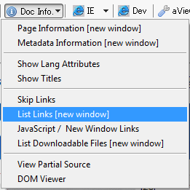
Figure 5-11. Showing the list of links.
If the list of links is not obtained, navigating with the tab key for checking the coherency is also possible, or using a support instrument such as a screen reader, which access linearly to the information of webpages.
If the link is performed through an image, the alternative text should work as the link text, so that you should check that the text is sufficiently descriptive of the functionality or target of the image.

Checking the consistency of links
Two identical links should refer to the same target or resource and vice versa, two links to the same target should be showed similarly. Broken links (wrong or non-existent) should be avoided in a webpage. Guideline 3.2 (Predictable) includes the success criterion 3.2.4 (level AA):
3.2.4. Consistent identification: Components that have the same functionality within a set of Web pages are identified consistently.
W3C Link Checker is an online tool developed by the W3C that allows checking the links of a webpage and generates a detailed report, which contains the line where the link is, the error code obtained and the error description returned by the server. The depth level to which you want to perform the analysis of the links can also be defined.
- Using Web Accessibility Toolbar, option “Check W3C link checker Check current page”, this application can be used.
- Using the “Tools” menu of the Web Developer Toolbar, option “Validate links”, W3C Link Checker can be used.
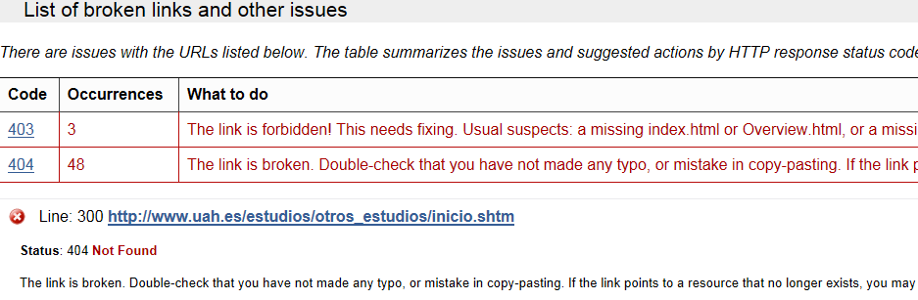
Figure 5-12. Report obtained about the links of a website.

There is more than one path to each of the pages in the website
Different options to visit the pages of a website should be offered. Thus users can navigate selecting the most comfortable and simple way for them: people with cognitive disabilities may prefer a table of contents or a sitemap while others with visual disabilities may navigate easily using a search or exploring the website sequentially, going from one page to another. Guideline 2.4 (Navigable) contains the success criterion 2.4.5 (Level AA):
2.4.5. Multiple ways: More than one way is available to locate a Web page within a set of Web pages except where the Web Page is the result of, or a step in, a process.
WCAG recommends including tables of contents or sitemaps, including a search function that allows locating the content or creating links in the homepage to all other pages of the website and links between related pages.

Figure 5-13. Search function in a website.

Unforeseen changes in the webpage
As aforementioned, unexpected behaviors by users should be avoided, as they may confuse or mislead them, thus impacting in the accessibility of a website. Guideline 3.2 (Predictable) has the success criteria 3.2.1. and 3.2.2. (level A):
3.2.1. On focus: When any component receives focus, it does not initiate a change of context.
3.2.2. On input: Changing the setting of any user interface component does not automatically cause a change of context unless the user has been advised of the behavior before using the component.

Checking whether there are links that open in new windows
On a web page, opening a link in a new window can be performed in two different ways: using the attribute target or using JavaScript.
To check it, in both cases:
- Using Web Accessibility Toolbar, option “Doc info JavaScript / New window links”. This option will show in an alert message the number of links using attribute target and the number of links using JavaScript in attribute href. In addition, it informs with a graphic icon about existing links that open in a new window.
- Using option “Information Display link details” in the Web Developer Toolbar, the content of attributes href and target (if used) of each link in a web document can be observed.
After verifying the existence of links (textual or graphical) that open in a new window, you should check that users are provided with information about it:
- Included in the text of the link or in its attribute title. Using option “Information Display tittle attributes” of the Web Developer Toolbar.
- Including a graphical element that indicates visually to users (and through its alternative) the opening of a new window.
- Including the text "Opens in a new window" in the link and show it as a tooltip using CSS when the focus is on the link.

Checking whether there is automatic redirection
Automatic redirection is directing the user to a different web page without his/her prior consent. This behavior causes disorientation and is a malpractice for accessibility and usability of a website, so it should be avoided.
- Using the Web Developer Toolbar, option “Disable Disable meta redirects”, redirections in the page can be disabled.

Tables
Data tables place information in rows and columns, thus describing a relationship between cells in the same row and/or column. This structure can be easily observed visually, but it should be also conveyed to users who want to access the table in a non-visually way.
Guideline 1.3 (Adaptable) contains the success criteria 1.3.1. and 1.3.2 (level A), and the following is stated:
1.3. Create content that can be presented in different ways (for example simpler layout) without losing information or structure.
1.3.1. Info and relationships: Information, structure, and relationships conveyed through presentation can be programmatically determined or are available in text.
1.3.2. Meaningful sequence: When the sequence in which content is presented affects its meaning, a correct reading sequence can be programmatically determined.
These checks can be performed after differentiating between layout tables and data tables.

Layout tables
To layout and place elements, developers should use style sheets. However, when a table is necessary to layout, the order of the information in the table should be understandable when it is linearly transformed. Success criterion 1.3.1. states that using structural elements in a way that it does not represent the structure or relationships in the content is a failure. Information and implicit relationships in the visual format should remain when changing the presentation format.
- Using Web Accessibility Toolbar by Internet Explorer, option “Tables Linearize”.

Data tables
Data tables allow showing information related between the elements that compose it, being structured in rows and columns so that the relationship is easily understandable both in a visual and non-visual way. Thus, the cells of each row and/or column should be properly identified when creating data tables.
Firstly, tables should have a title, element CAPTION. The title of a table describes its nature. It can be checked:
- Using Web Accessibility Toolbar by Internet Explorer, option “Tables Show data tables”.
- Using Firefox Web Developer Toolbar, option “Outline Outline table Captions”.
To correctly check the accessibility of the elements in a data table, be sure that:
- Row and column headers are properly identified using element TH.
- They are properly associated with their cells using the scope or id attribute.
The table headers can be displayed:
- Using Web Accessibility Toolbar by Internet Explorer, option “Tables Table header”, the existence of headers is checked.
- Using Firefox Web Developer Toolbar, option “Information Display table information”.
Header cells categorize the information in their row or column. To convey that information to users, it is necessary to use mechanisms that allow associating headers with cells of the table. Mechanism scope performs the association. This method is used in headers and indicates the header scope, either row or column or a group of rows and columns.
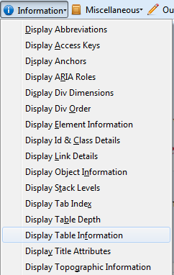
Figure 5-14. Activation of association using scope.
For checking the existence of this association method, Firefox Web Developer Toolbar will be used. To activate this option within the toolbar, do the steps showed in Figure 5-14.
This option also allows checking the existence of a table summary through attribute "summary". A summary of the relationships between cells is very important in tables with nested headers, cells occupying several rows or columns, or other relationships that are not so evident in an analysis of the structure of the table, but that can be visually observed. A summary can also describe the function of a table in the current document.

Frames
Frames are used to organize pages in different areas so that different web pages are displayed in each frame. The web pages can be independent or be related. The use of frames is strongly discouraged, and structuring web pages in different sections is recommended. However, frames are dealt in WCAG 2.0 as any other content, so it is possible to apply accessibility criteria on them. The way to link documents in frames may mislead some users, so they may have difficulty establishing relationships between the content in frames.
Frames evaluation is based on two success criteria in WCAG 2.0. The first one, 4.1.2. (level A) is under principle 4 (Robust):
4.1.2. Name, role, value: For all user interface components (including but not limited to: form elements, links and components generated by scripts), the name and role can be programmatically determined; states, properties, and values that can be set by the user can be programmatically set; and notification of changes to these items is available to user agents, including assistive technologies.
Any component of the user interface must be correctly determined with its name, role and value, so that the content is interpreted by browsers, media players, screen readers, voice recognition software or other devices. You should check that every frame has a title describing its content (title) and the relationship between the frames of the page, using (if necessary) a long description (longdesc) in one of the frames for this purpose.
- Using Web Accessibility Toolbar, option “Frames Frame Name / Title”.
The other success criterion related to frames is 2.4.1 (level A) of Guideline 2.4. Provide mechanisms for helping users with disabilities to navigate, locate content and determine where they are:
2.4.1. Bypass blocks: A mechanism is available to bypass blocks of content that are repeated on multiple web pages.
This success criterion aims to allow web users to directly access the primary content of pages, avoiding unnecessary blocks. The content shown should keep linearity to maintain consistency between the document structure and visual structure. This makes the browser interprets the format of the blocks of the document and users can select some parts to be read. The recommended checking has been described in 5.3.4.
Frames should include an equivalent accessible alternative (tag NOFRAMES) including links to descriptions of the frames of a page and navigation mechanisms to navigate the web site.

Lists
Lists are groups of interrelated elements. They may be Ordered, Disordered (<ul>) or Definition lists (<dl>). Lists should be used for this purpose and not to establish certain formatting effects such as indentation effect.
The main problem with lists is that blind users may be lost in their structure, especially in nested lists and in those that do not specify the nesting level for each list item.
For numbered lists, compound numbers are more informative than simple ones. Thus, a numbered list “1, 1.1, 1.2, 1.2.1, 1.3, 2, 2.2, …” provides more context than the same list without compound numbers.
A text label should be provided before or after the sentence of the list item to ensure that users understand the differences between the items of the list indicated visually. To verify that lists are correctly structured, Web Accessibility Toolbar can be used, option “Structure List items”.
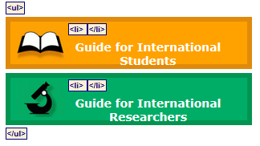
Figure 5-15. Labels identifying a list and its items.
Avoiding images is recommended, containing or not additional information about the content of the list, such as bulleted lists. However, if used, an equivalent text as described in 5.3.1. should be provided.

Overall accessibility evaluation of the webpage

Device independence
Regardless of the device used to access web content, information should always be available and accessible for users. This intends to any user, anywhere and anytime can access to all information using any device, thus avoiding web fragmentation in accessible spaces only for certain devices. In recent years, due to growth in the variety of devices to access the Web, it is important to develop accessible content from any device.
The first checking to be done is an evaluation of functionality and the appearance of the page in the most currently used browsers: Internet Explorer, Mozilla Firefox, Google Chrome, Safari and Opera.
In addition to the manual evaluation using the aforementioned browsers, the automatic tool SortSite can be used. The tool (0) also evaluates the most currently used mobile technologies (iOS, Android and BlackBerry).
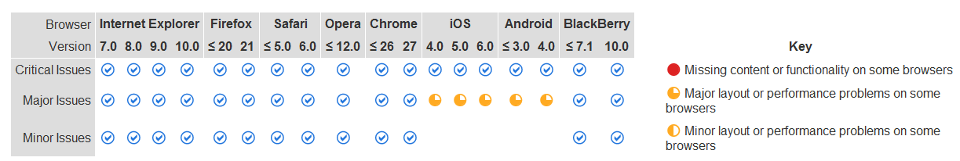
Figure 5-16. Evaluation of browsers and technologies with SortSite.

Functionality of the webpage using a screen reader
NonVisual Desktop Access (NVDA)reads the content shown on the screen for blind people or people with visual disabilities, either by passing the cursor over the page content (with the application enabled) or by using the keyboard by combining a set of keys that allow users to navigate the web content. It uses different sounds to indicate the user what action is he/she performing, e.g. if it is an edition area (enter text) or a button to perform an action.
Using this application allows checking the accessibility of the elements of the page, checking whether all the elements can be read, checking the problems to read a web page with many links and if there is a correct reading order.

Detailed automatic accessibility validation of a webpage according to WCAG 2.0.
Using at least four different tools is recommended because some tools can overcome the limitations that others have.
The four online WCAG 2.0 evaluation tools recommended (you must provide the URL of the page to be evaluated) are:
- TAW.
- AChecker.
- eXaminator.
- Tingtun Ckeckers.

Obtaining an overall rating of the accessibility of the webpage
There are automatic tools to obtain an overall rating of the accessibility of a webpage, such as eXaminator or eGOVMON.
- eXaminator is an online tool that evaluates the accessibility of a webpage, using as reference the techniques recommended by WCAG 2.0, although it does not include all the success criteria, and giving a score between 1 and 10 as a quick indicator about the accessibility of pages.
- Tingtun Checkers (n.d.) is still under development. It evaluates the accessibility of a webpage and generates a list with the evaluated criteria, and the result is a score of the page between 0 and 100.

Bibliography
Adobe. (n.d.). Create and verify PDF accessibility [Acrobat help].
Asociación Española de Normalización y Certificación. (2005). UNE 153020:2005: Audiodescripción para personas con discapacidad visual: Requisitos para la audiodescripción y elaboración de audioguías (p. 12). Madrid: AEN/CTN 153.
Asociación Española de Normalización y Certificación. (2007). UNE 139804:2007: Requisitos para el uso de la lengua de signos española en redes informáticas (p. 29). Madrid: AEN/CTN 139.
Carreras, O. (Sept. 16, 2009). PDF accesibles (2): Metodología [Blog].
Carreras, O. (Jul. 7, 2011). PDF techniques for WCAG 2.0 [Blog].
Centro de Investigación, Desarrollo y Aplicación Tiflotécnica (CIDAT). (2005). Pautas para el diseño de entornos educativos accesibles para personas con discapacidad visual. Madrid: Organización Nacional de Ciegos Españoles.
Centro de Referencia en Accesibilidad y Estándares Web. (2009). Guía de recomendaciones de accesibilidad y calidad web. Madrid: Instituto Nacional de Tecnologías de la Comunicación.
European Blind Union. (n.d.). Making information accessible for all.
European Commission & Directorate-General for Translation. (2011). How to write clearly. Luxembourg: Office of the European Union.
Fundación Universia. (Oct. 25, 2013). Diseño de materiales educativos virtuales accesibles [Course].
Gracia Murugarren, J. (n.d.). Manual de usabilidad. Tipografía.
International Organization for Standardization. (2012). ISO 14289-1:2012: Document management applications - Electronic document file format enhancement for accessibility - Part 1: Use of ISO 32000-1 (PDF/UA-1) (p. 16). ISO/TC171/SC2.
Luján Mora, S. (n.d.). Texto/diseño tipográfico.
Maceiras, R., Cancela, Á. & Goyanes, V. (2010). Aplicación de nuevas tecnologías en la docencia universitaria. Formación Universitaria, 3(1), 21–26.
Moreno López, L. (2011). Consejos de cómo crear un documento Adobe PDF accesible a partir de un documento Microsoft Word accesible: Sistema Operativo Windows. Madrid: Grupo LaBDA: Universidad Carlos III de Madrid, Centro Español de Subtitulado y Audiodescripción.
Moreno López, L. (2012). Consejos para crear un Microsoft Word 2010 accesible: Plataforma Windows. Madrid: Grupo LaBDA: Universidad Carlos III de Madrid, Centro Español de Subtitulado y Audiodescripción.
Moreno López, L., Martínez, P. & González, Y. (2014). Guía para elaborar documentación digital accesible: Recomendaciones para Word, PowerPoint y Excel de Microsoft Office 2010 (1ª ed., Vol. 5). Madrid: Centro Nacional de Tecnologías de la Accesibilidad.
Moreno, L., Ruiz, B., Martínez, P., Carrero, J. M. & Martínez, J. R. (2008). Accesibilidad a los contenidos audiovisuales en la web: Una panorámica sobre legislación, tecnologías y estándares (WCAG 1.0 y WCAG 2.0). Madrid: Real Patronato sobre Discapacidad.
Observatorio de Accesibilidad (2011). Guía de accesibilidad en contenidos multimedia. Madrid: Ministerio de Política Territorial y Administración Pública. Gobierno de España.
Office. (n.d.-a). Check accessibility of a PowerPoint 2010 presentation. [Video].
Office. (n.d.-b). Documentos accesibles para personas con visión reducida.
Office. (n.d.-c). Métodos abreviados de teclado de Microsoft Office Word.
Office. (n.d.-d). Subtitling text add-in for Microsoft PowerPoint (STAMP).
Office. (n.d.-e). Tablas accesibles.
Photosensitive Epilepsy Analysis Tool (PEAT). (2012). (Beta v.1.52). The Trace Centre’s.
Sama Rojo, V. & Sevillano Asensio, E. (2012-a). Capítulo IV: Accesibilidad de documentos PDF. In Guía de accesibilidad de documentos electrónicos. Madrid: Universidad Nacional de Educación a Distancia.
Sama Rojo, V. & Sevillano Asensio, E. (2012-b). Capítulo V: Accesibilidad de materiales audiovisuales. In Guía de accesibilidad de documentos electrónicos. Madrid: Universidad Nacional de Educación a Distancia.
Tingtun Checkers. (n.d.). (Testing version). eGovernment Monitor (eGovMon) Project.
Universidad del País Vasco. (n.d.). Manual de accesibilidad y buenas prácticas: Gestor de contenidos. Leioa, Spain.
Video2brain. (Apr. 11, 2013). Archivos PDF accesibles: lectura en voz alta [Video].
World Wide Web Consortium. (2008). Web Content Accessibility Guidelines (WCAG) 2.0. (B. Caldwell, M. Cooper, L. Guarino Reid & G. Vanderheiden, Eds.). W3C Working Group.
World Wide Web Consortium. (2014). Understanding WCAG 2.0: A guide to understanding and implementing Web Content Accessibility Guidelines 2.0. (M. Cooper, A. Kirkpatrick & J.O. Connor, Eds.). W3C Working Group.
World Wide Web Consortium. (n.d.). List of checkpoints for web content accessibility guidelines 1.0. (W. Chisholm, G. Vanderheiden, & I. Jacobs, I. Eds.). W3C Working Group.

Optional bibliography
Chapter 2
JISC TechDis (n.d.). PowerPoint presentations.
PowerPoint 2010 presentations pt.1 of 2 [Video] (Jun. 30, 2012).
PowerPoint 2010 presentations pt.2 of 2 [Video] (Jun. 30, 2012).
Sama Rojo, V. & Sevillano Asensio, E. (2012-c). Capítulo III: Accesibilidad de documentos PowerPoint. In Guía de accesibilidad de documentos electrónicos. Madrid: Universidad Nacional de Educación a Distancia.
Sama Rojo, V. & Sevillano Asensio, E. (2012-d). Plantillas de comprobación de accesibilidad. In Guía de accesibilidad de documentos electrónicos. Madrid: Universidad Nacional de Educación a Distancia.
Texas Governor's Committee on People with Disabilities (2012-a). Adding tables, charts, images, & shapes [Video].
Texas Governor's Committee on People with Disabilities (2012-b). How to make accessible tables [Video].
Texas Governor's Committee on People with Disabilities (2012-c). Make a presentation accessible [Video].
Web Accessibility Initiative (2012). How to make presentations accessible to all. World Wide Web Consortium.
Chapter 3
Acrobat. (n.d.). (Version 7). Adobe.
Centro de Investigación, Desarrollo y Aplicación Tiflotécnica (CIDAT). (2009). Guía para realizar documentos de Word accesibles en formato PDF con Adobe Acrobat. Organización Nacional de Ciegos Españoles.
Observatorio de Accesibilidad (2010). Guía de accesibilidad en documentos PDF. Madrid: Ministerio de la Presidencia. Gobierno de España.
Office. (n.d.-f). Crear PDF accesibles.
PDF Accessibility Checker (PAC). (n.d.). (Version 2). Access for all.
PDF Reader. (n.d.). (Version 3). WebbIE.
Video2brain. (Apr. 11, 2013). Archivos PDF accesibles: retocar orden de lectura [Vídeo].
Capítulo 4
Audacity tutorial básico [Spanish] HD. (May 23, 2011). [Video].
Bariffi, F., Barranco, M. del C., Moreno, L., Palacios, A., Utray, F. & Vida, J. (2008). La accesibilidad universal en los medios audiovisuales de comunicación. Madrid: Real Patronato sobre Discapacidad.
Bengochea Martínez, L. (2011). Píldoras formativas audiovisuales para el aprendizaje de Programación Avanzada. In Actas de las Jornadas de Enseñanza Universitaria (JENUI 2011) (pp. 257-263). Sevilla, Spain: Universidad de Sevilla. Escuela Técnica Superior de Ingeniería Informática.
Bengochea Martínez, L., Budia, F. & Medina, J. A. (2012). Videotutoriales subtitulados, un material didáctico accesible. In L. Bengochea & J. R. Hilera (Eds.), Actas del III Congreso Iberoamericano sobre Calidad y Accesibilidad de la Formación Virtual (CAFVIR 2012) (pp. 120-127). Alcalá de Henares, Spain: Universidad de Alcalá.
Colour Contrast Analyser for Web Pages. (n.d.). (Version 2.2.). Vision Australia.
Román, J. (Nov. 19, 2011). Manual para subtitular vídeos: Guía paso a paso para aprender a subtitular videos y pegar o unir los subtítulos permanentemente [Blog].
World Wide Web Consortium. (2014-a). Audio description (pre-recorded): Understanding SC 1.2.5. In M. Cooper, A. Kirkpatrick & J.O. Connor (Eds.), Understanding WCAG 2.0: A guide to understanding and implementing Web Content Accessibility Guidelines 2.0. W3C Working Group.
World Wide Web Consortium. (2014-b). Sign language (pre-recorded): Understanding SC 1.2.6. In M. Cooper, A. Kirkpatrick, & J.O. Connor (Eds.), Understanding WCAG 2.0: A guide to understanding and implementing Web Content Accessibility Guidelines 2.0. W3C Working Group.

Glossary
Accessibility checker: Tool for checking whether a PowerPoint presentation includes any aspect that may be a trouble for users with disabilities.
Accessibility status report: The accessibility report summarizes the results of the accessibility checking. It contains links to tools and documentation that help to solve problems.
Accessibility: Accessibility means, as stated in ISO/TC 16027, “the usability of a product, service, environment or facility by people with the widest range of capabilities”.
Accessible PDF: PDF document that has been subjected to a process of accessibility checking and has passed technical checkings.
Accesskey: Keyboard shortcuts for common tasks.
Alternative text: Text that appears when the mouse is over a figure or an object, and helps people who use screen readers to understand the content of the figures in the presentation.
Alternatives to images: Text describing the image and appears on the location of the image when it cannot be displayed.
Assistive products: According to the 2007 version of ISO 9999, “an assistive product is any product (including devices, equipment, instruments, technology and software) especially produced or generally available, for preventing, compensating, monitoring, relieving or neutralizing impairments, activity limitations and participation restrictions”. Assistive products are those created to allow or facilitate a person with disabilities performing certain tasks and that, due to his/her functional limitations, may need to be compensated. In the case of assistive products for communication and information, this standard defines them as “devices for helping a person to receive, send, produce and process information in different forms”.
Attribute: Some additional information can be added in some HTML elements. That information is called attribute.
Audio video Interleave (AVI): A multimedia container for audio and video that allows simultaneously storing a data stream of video and multiple audio streams, and it is played by an external program called codec.
Audioblog: A blog variant, in which authors regularly publish audio files.
AVI: Acronym for Audio Video Interleave.
Captcha or CAPTCHA: Acronym for Completely Automated Public Turing test to tell Computers and Humans Apart.
Cascading Style Sheets (CSS): Technology developed by W3C in order to separate structure and presentation. CSS style rules define the presentation of the webpage, allowing defining different rules for different devices.
Check accessibility: Process by which a tool checks whether a document meets certain accessibility standards.
Completely Automated Public Turing test to tell Computers and Humans Apart (CAPTCHA o Captcha): It is a challenge-response test used in computing to determine when the user is human or not.
Contrast: Relative difference in intensity between a point of a figure and its surroundings.
Create accessible PDF files: A predefined action that automates may tasks, it checks the accessibility and provides instructions for those elements that require manual corrections. Locate and correct quickly problematic areas.
CSS: Acronym for Cascading Style Sheets.
DAISY: Acronym for Digital Accessible Information System.
Design for all or universal design: The condition which must be ensured by environments, processes, assets, products and services, also by objects or instruments, and tools and devices, must be understandable, usable and practicable by everybody, with security, comfort, and autonomy and in natural conditions, without having to make or adaptations or specialized design.
Digital Accessible Information System (DAISY): Is the standard format for audiobooks and other audible texts.
E-book or electronic book: The main feature of readers is that they use an ink technology without backlight, so that they do not fatigue sight. When using books in EPUB format, readers can set the font size, thus reconfiguring automatically the pages of the book to avoid scrolling on the screen.
Electronic PUblication (EPUB): An open source format for electronic books aimed to be read in an e-book reader. In format EPUB, the content adapts to different screen sizes.
Element or tag FIELDSET: Tag used to define logical groups of form elements. It is jointly used with tag LEGEND, which names those groups.
EPUB: Acronym for Electronic PUblication.
Event handlers: Functions performing specific actions when an action happens on the page (a mouse click, a key is pressed, the mouse is over, an image is loading, etc.).
eXtensible Markup Language (XML): Is a meta tag language used to store data in a readable way.
Headers: HTML tags defining special paragraphs, formatted as titles, for which a larger font size and bold text are set. There are various types of headers, which differ in the font size used: <h1> for larger headers, <h2> for second level headers and so on until <h6>, which is the smallest header.
HTML: Acronym for HyperText Markup.
HyperText Markup Language (HTML): The most used markup language to describe the structure and information when creating web pages.
JavaScript An interpreted programming language that allows improving the user interface and dynamic web pages.
Keyboard shortcuts: Key combinations for common tasks.
Logical event handlers or device independent: Functions performing actions when an action happens and does not depend on a specific device (a page is loading, an element receives focus, an option is selected, etc.).
Luminosity: Also called clarity, it is a property of colours. The darker the colour, the weaker the luminosity.
Magnifier: It is software that expands images and texts. This type of application allows zooming the text characters and other content shown on the screen to sizes set by the user. Currently, computers have added this accessory known as a magnifying glass or screen magnifier to the/their accessibility tools.
Moving Pictures Experts Group 2 (MPEG2): A group of audio and video codification standards for transmission signals, which include digital terrestrial, satellite or cable television.
MP3: Compressed digital audio format with loss. It is part of standard MPEG-1 audio layer. Due to the low file size and the ability to adjust the quality, it has become a standard and is supported by most players.
MP4: A multimedia container format standard specified as a part of MPEG-4. It is most-commonly used to store digital audio and digital video streams, especially those defined by MPEG, but also can be used to store other data such as subtitles and still images.
MPEG2: Acronym for Moving Pictures Experts Group 2.
Narration: Story recorded about the content of the presentation.
Navigation elements: Navigation systems are the elements of an interface that allow navigating the different sections and pages of a website.
Outline view: PowerPoint tool that shows the structure of the slides in a presentation and their text as an outline.
PDF document: A file that may contain text, figures and tables, published in one of the most used formats to distribute files on the web.
PDF: Acronym for Portable Document Format (see PDF document).
Photosensitive epilepsy: Type of epilepsy in which the attacks are caused by visual stimuli such as flashing lights or alternating images.
Podcast: Free audio file, which contains interviews, speeches, music, tutorials, etc. and which can be downloaded and listened in a computer or music player. They originally appeared as audible versions of blog posts and were distributed by RSS. Today, many radio stations and television include on their websites podcasts with programs already released, so that they can be downloaded by users and listened on demand.
Reader: It is a software tool that enables people with visual disabilities to navigate and interact with the operating system and its applications, including web browsers. This software application attempts to identify and interpret what is displayed on the screen. Then this interpretation is showed to the user via text-to-speech synthesizers, sound icons or a braille output.
RGB: Colour model based on additive synthesis. It allows to represent a colour by admixture of the three primary colours of light: red, green and blue.
Screen readers: Software that allows using the operating system and applications by using a speech synthesizer that “reads and explains” what is displayed on the screen, which helps people with severe visual disabilities or completely blind people.
Script, applet or Java object: It is a program that can be embedded in a HTML document, i.e., in a webpage, incorporating improvements. The program will be automatically downloaded and will run on the user’s machine.
Selection pane: PowerPoint tool that shows all objects in a slide and the order in which they will be read by a screen reader.
Semantic tags: Tags making up the semantic web, some tags do not truly provide new functionalities but are used to compose sites indicating what are the code blocks of a web (header, article, section, footer), rather than how they should be depicted.
SMIL: Acronym for Synchronized Multimedia Integration Language.
SRT: The format extension of software SubRip, which is free and open source software, whose main function is to rip or extract the captions and their synchronization time of a video.
STAMP: Acronym for Subtitling Text Add-In for Microsoft PowerPoint.
Subtitling text add-in for Microsoft PowerPoint (STAMP): Subtitling Text Add-in for Microsoft PowerPoint. It is a Microsoft PowerPoint add-in for editing captions.
Synchronized Multimedia Integration Language (SMIL): W3C standard for multimedia presentations. Language SMIL allows integrating audio, video, images or text with proper synchronization using XML files.
Tags or HTML tags: Marks used to indicate the beginning and end of a page element. All tags have the same format, starting with the less-than sign "<" and ending with the greater-than sign ">".
Target attribute: The HTML target attribute is used to open a link in a target different than the current window.
Timed Text Markup Language (TTML): File format of synchronized text markup language used to create captions.
Tooltip: Visual aid that appears when the cursor is placed over any graphic element, providing additional information about it.
TTML: Acronym for Timed Text Markup Language.
Usability: The extent to which a product can be used by specified users to achieve specified goals with effectiveness, efficiency and satisfaction in a specified context of use.
WAV: Digital audio format without data compression, developed by IBM and Microsoft. It was widely used at the beginning of the digital age, but nowadays its use has declined.
WCAG: Acronym for Web Content Accessibility Guidelines.
Web Content Accessibility Guidelines (WCAG): Document that explains how to create accessible web content for people with disabilities.
Windows Media Audio (WMA): Is an audio format owned by Microsoft, similar to MP3.
Windows Media Video (WMV): A generic name given to the set of compression algorithms located in the set of video technologies developed by Microsoft, which is part of the framework Windows Media.
WMA: Acronym for Windows Media Audio.
WMV: Acronym for Windows Media Video.
XML: Acronym for eXtensible Markup Language.

The key may change when using versions of Microsoft Office previous to 2013.
In other versions of Acrobat, it may be located in menu “Advanced” instead of in “Tools”.
In other versions it can be located in “View Navigation panels Order”.
In other versions, it can be located in “View Navigation panels Tags”.
In other versions, it can be located in “View Navigation panels Bookmarks”.
In other versions it can be located in “View Navigation Panels Content”.
In other versions it can be located in “Advanced” instead of in “Tools”.
A list structure is correct when the list has the following hierarchy: a list element (LI) must contain elements of elements of list. Elements of elements of list only can contain tag elements (Lbl) and body elements of elements of list (LBody).
It may be not seen due to the CSS style rules used. It will be checked when they are disabled or by viewing the source (check the existence of the tag <title> describing the page content).

